In the picture below (Figure 1) you can see the position of the Analog Temposonic in the actual configuration
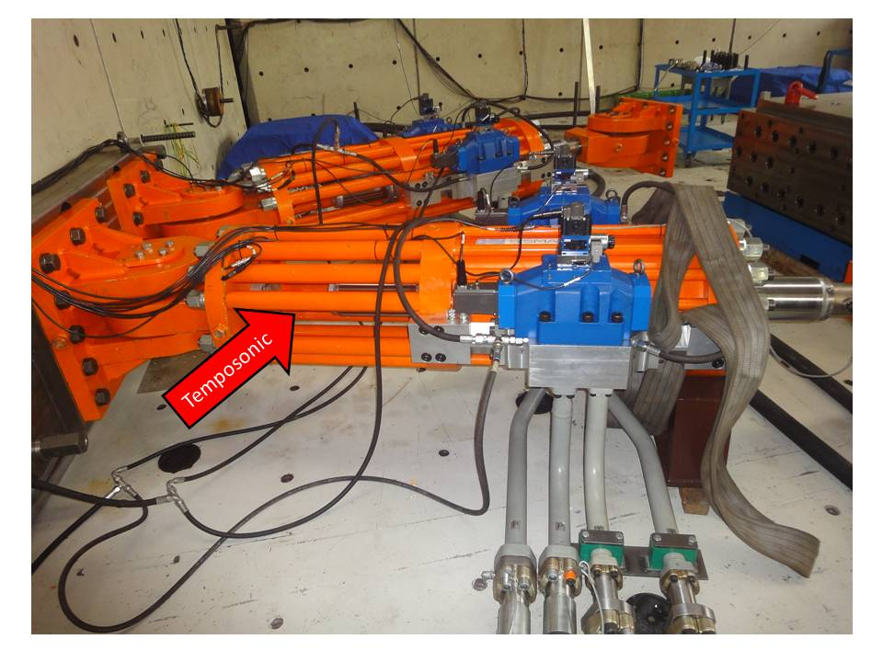
Figura 1
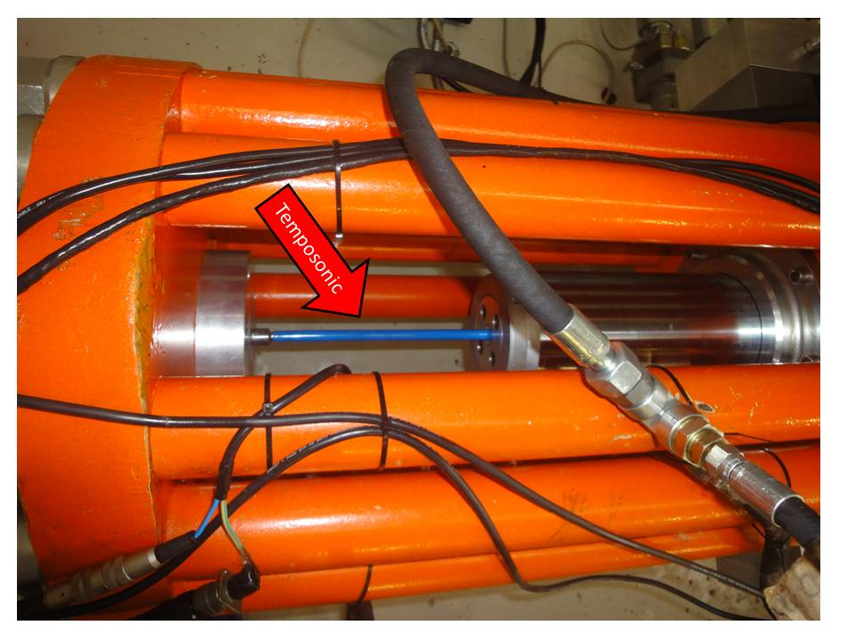
Figura 2
In Figure 2 you can see a detail picture of the Analog Temposonic, the blue part is the rubber tube we used to try to damp the vibration on the device. The rod of the temposonic, slide in to a Teflon cylinder housed in to the piston, when the piston moves.

In Figure 3 you can see where we want to install the SSI Temposonics
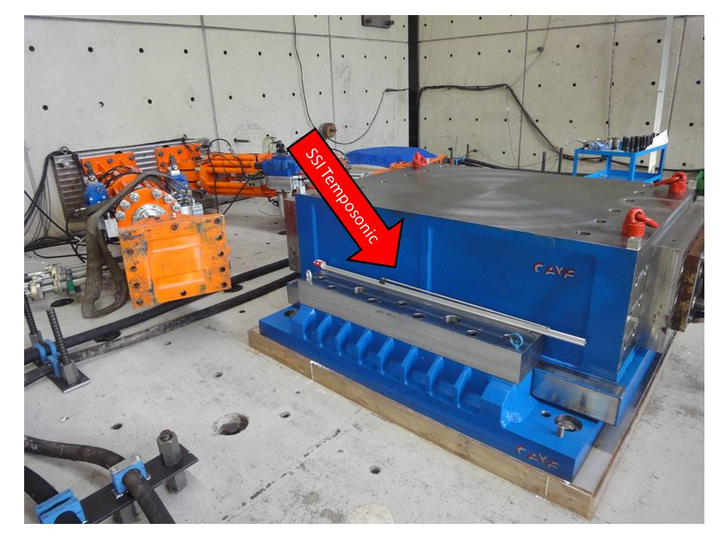
Figura 3

