- HPU warm up

- Servo valve warm up procedure
  - Operating windows
- Main 469D Digital Seismic Controller
- Function Generator
- Digital Oscilloscopes

  - Steps
    - Turn on supercharge pump
    - Turn on pilot pump
    - Set function generator: 0.05g and 1Hz for all direction (Long., Lat., Vert.)
    - Set digital oscilloscopes to observe each valve control and feedback.
    - Run the table for 15 min (Table should be no movement)
    - Stop the table
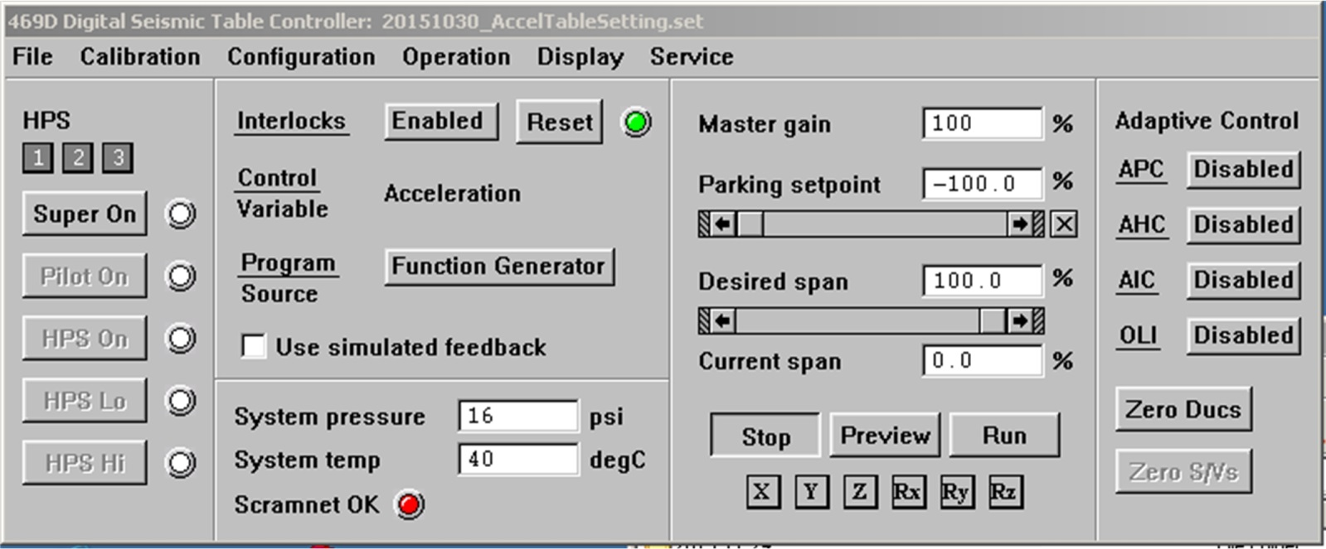
    - Zero S/Vs for 2-3 times (Valve control and feedback signal synchronized)

- Servo valve testing procedure
  - Operating windows
- Main 469D Digital Seismic Controller
- Force Balance Controller
- 3-Stage Servo Valve Controller
- Digital Oscilloscopes
- Data Recorder

  - Steps
    - Warm up HPUs.
    - Warm up Servo Valves. (see Step 2.2.1 – 2.2.7)
    - Turn on HPU to high pressure, set table parking set point to 0.0, and charge the static lift.
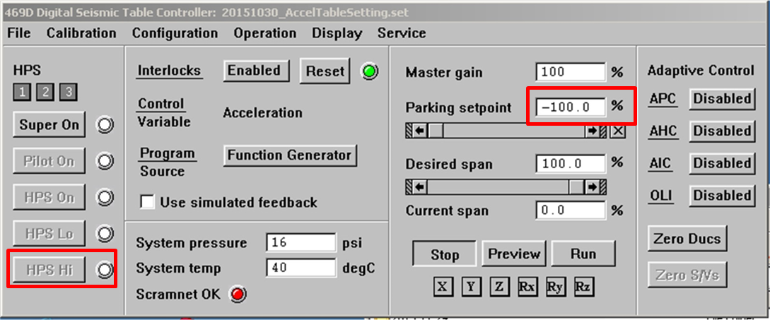
    - Hard copy the balance voltage and spool zero voltage of each valve on the 3-Stage Servo valve controller. (Form 3.1) 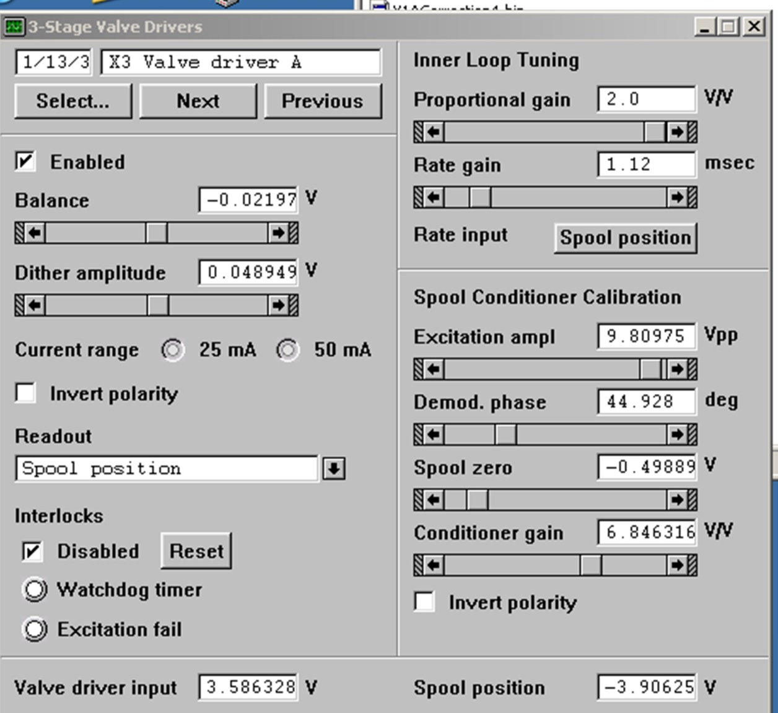

    - Set Valves of target direction to Group B on Force Balance controller
(e.g. X1, X2, X3, X4 for X-direction; Y1A, Y1B, Y2A, Y2B, Y3A, Y3B, Y4A, Y4B for Y-direction …etc.)
Make sure there is only valve of target direction is set to group B
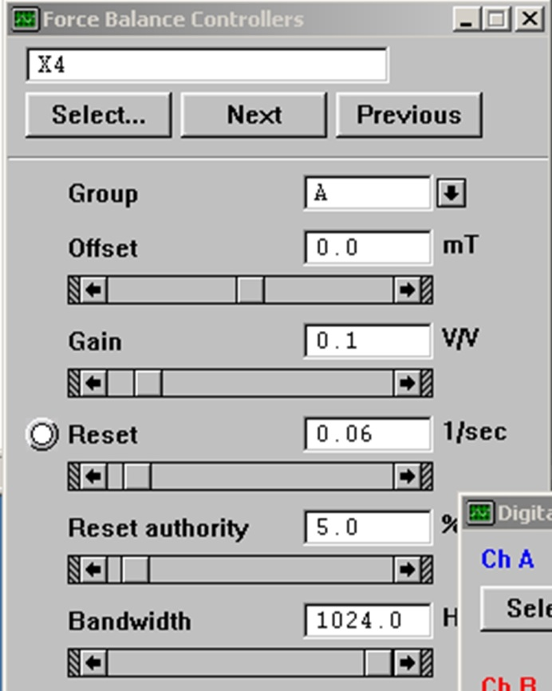
Set gain to 0 V/V, and reset to 0.0 1/Sec for group B

    - Set data recorder to record feedback and force feedback of each target actuator
(e.g. X1 valve fbk / X1 Force fbk for X1. Y1A valve fbk, Y1B valve fbk / Y1 Force fbk for Y1.)

    - Set Digital Oscilloscope to monitor force of target and its opposite actuator
(e.g. Y1 force fbk / Y2 force fbk, X1 force fbk / X2 force Fbk)

    - Set the upper and lower limit of servo valve balance to +/- 5V for target valve on 3-Stage servo valve controller
+/- 5V range
    - Uncheck the Enable on the 3-Stage Servo Valve controller
    - Drag balance voltage to the limit, and observe if the force move to its limit as well
    - Start data recording
    - Use arrow on 3-Stage Servo valve controller to smoothly adjust the balance voltage from upper/lower limit to lower/upper limit respectively and back to start.
    - Stop data recording.
    - Restore the balancing voltage by the hard copy and Enable the balance.
    - Switch to the next valve, and repeat procedure 3.2.6 – 3.2.14
    - While finished testing all the of one direction, restore the group and gain / reset settings.
(Gain should be 0.1 V/V, and reset should be 0.06 1/Sec)

    - Start from step 3.2.5
    - After test all valves, park the table, bring down static lift and set the pressure back to pilot.

- Servo valve balance adjust procedure
  - Operating windows
- Main 469D Digital Seismic Controller
- Force Balance Controller
- 3-Stage Servo Valve Controller
- Digital Oscilloscopes
- Data Recorder
  - Steps
    - Plot and observe the Force-position curve (from recorded Valve force fbk / valve fb data) of each valve.
The curve center should be on 0-force/ 0-position point. If it is not, evaluate the offset value.
    - Restart the testing steps form 3.2.1 – 3.2.9
    - Adjust the spool zero voltage to make force of target and opposite actuators be the same and around zero.

    - Restart test steps 3.2.10 – 3.2.14
    - Plot and observe the Force-position curve again for changes, and restart from 4.2.1 if needed.
    - If the curve center is on 0/0, then switch to next valve and repeat 4.2.1 – 4.2.5
    - If all the valve of target direction is balanced, do 3.2.16, and start from 4.2.1.
    - If all the valves are balanced, do 3.2.18.
- Swivel Testing
  - Accelerometer installation

Install the accelerometers on these areas of each actuator:
Table、actuator-rod、actuator-base、Foundation

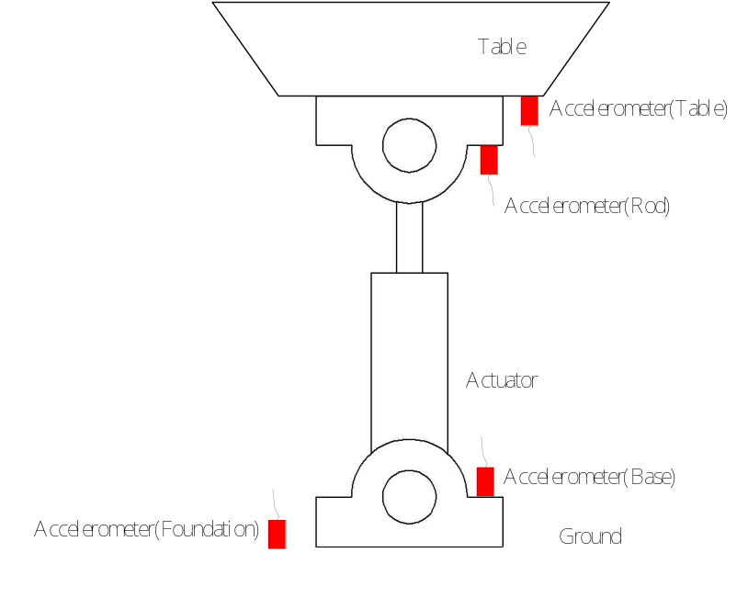

  - Operating Windows
- Main 469D Digital Seismic Controller
- Function Generator
- Analog Inputs
- Data Recorder
- Digital Oscilloscope

  - Steps
    - Edit analog inouts
Edit analog input channel of each accelerometer, and calibrated by adjusting offset and gain.
If the accelerometer is mounted horizontally, the readout should be 0 G.
If the accelerometer is mounted vertically, the readout should be 1.0 G or -1.0G.
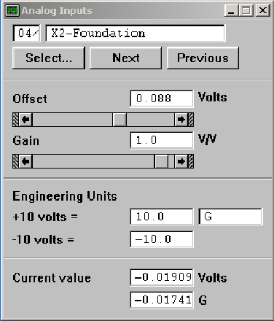

    - Edit data recorder
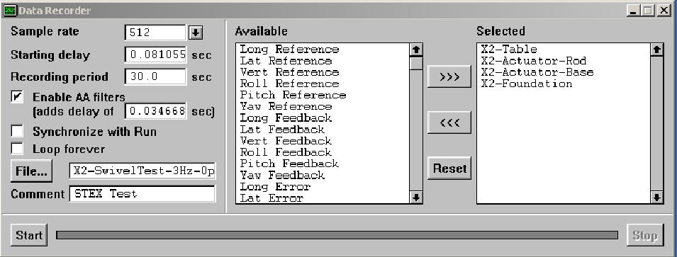
Sampling rate: 512 Hz
Record period: 30 sec
To record the signal of analog inputs (accelerometer)

    - Edit function generator
For three directions, the function generator set up is:
Sine wave
Amplitude: 0.3g
Frequency: 3Hz
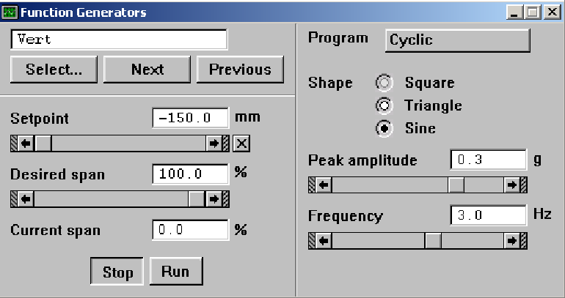

    - Run the table, and start record data.
    - Quick Check
From the digital oscillscope, compare the signal between table and actuator rod.
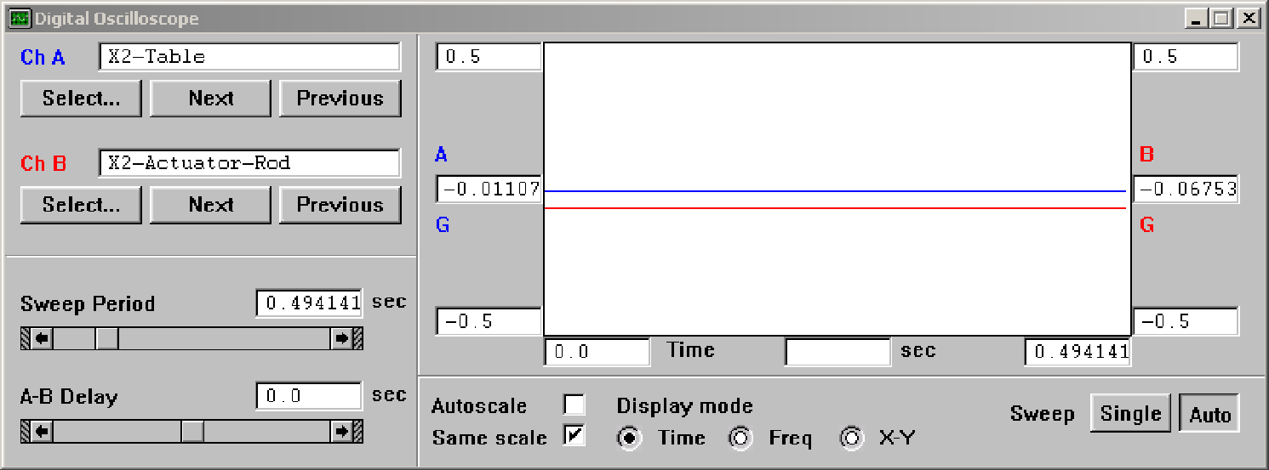
For signal between actuator base and foundation, the signal should be very small, and both near 0.

