University of Philippines, Diliman Facility Inspection
July 8, 2013
On July 2, 2013 an on-site inspection of the University of the Philippines, Diliman Campus Seismic Test Facility took place. There are photos of the packing crates for the shaking table equipment and the structural actuators as well. Measurements were taken on the shaking table actuator foundation attachments and the linear bearings to foundation attachments.
The first photos here show the packing crates for the shaking table equipment without the table itself. That is stored outside on its own. These crates were in a structure that was well protected from the rain. There was absolutely no indication of water leaking onto the crates. To the contrary, the crates had dust on top of them that showed no water had been present. The crates were NOT placed directly on the floor, but were placed on small steel pipes that kept the wood from contacting the cement floor.
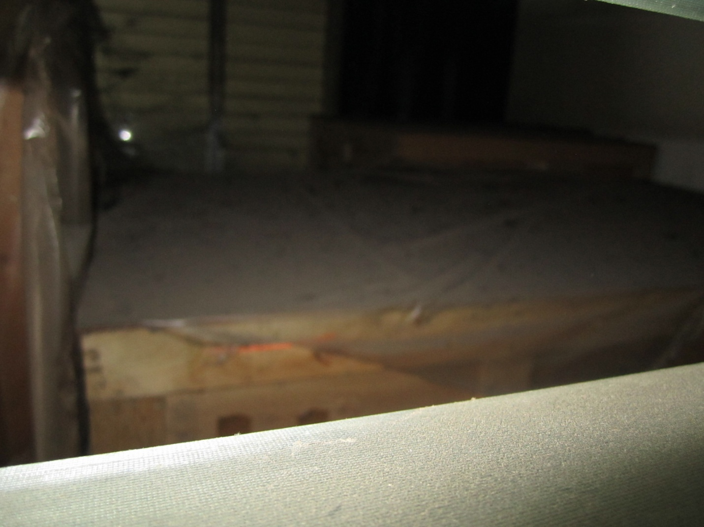
Figure 1: Top of crate in the back.

University of Philippines, Diliman Facility Inspection
July 8, 2013
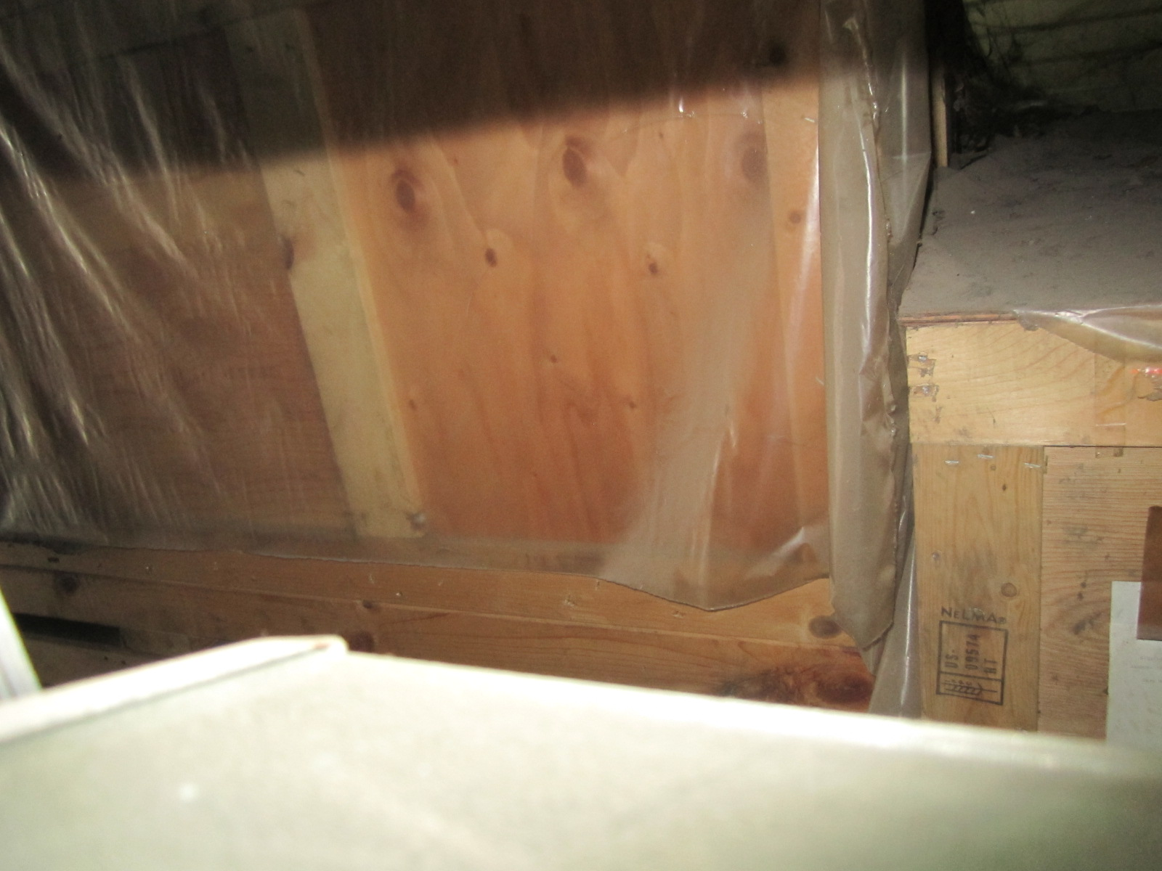
Figure 2: Larger crate in front of small crate in storage rear.

University of Philippines, Diliman Facility Inspection
July 8, 2013
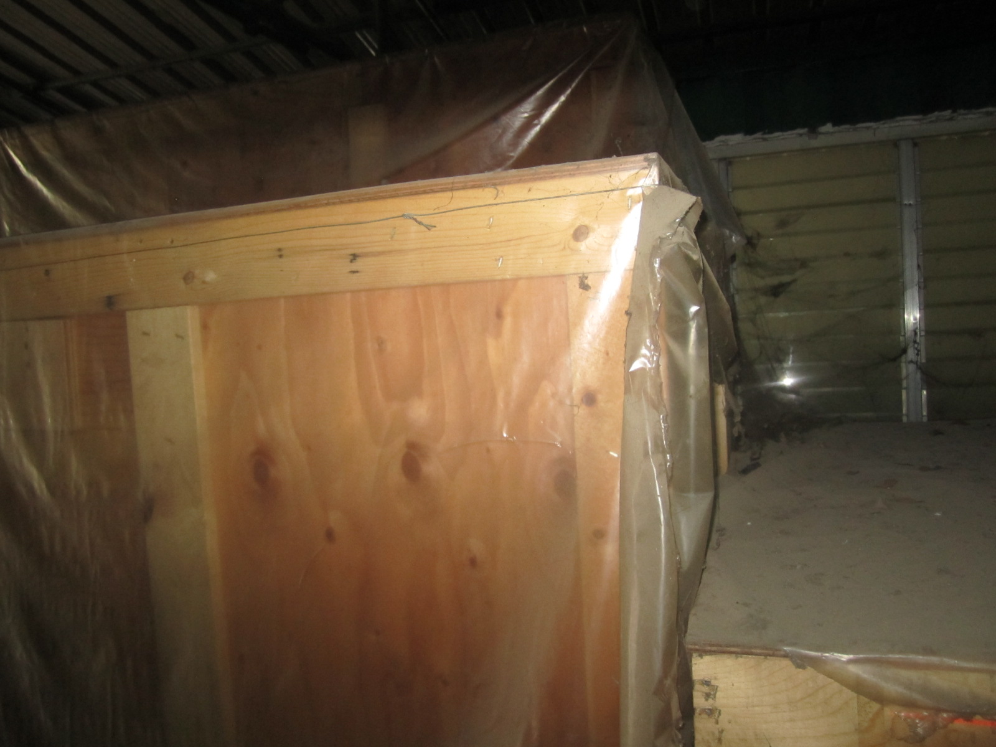
Figure 3: Top of larger crate.

University of Philippines, Diliman Facility Inspection
July 8, 2013
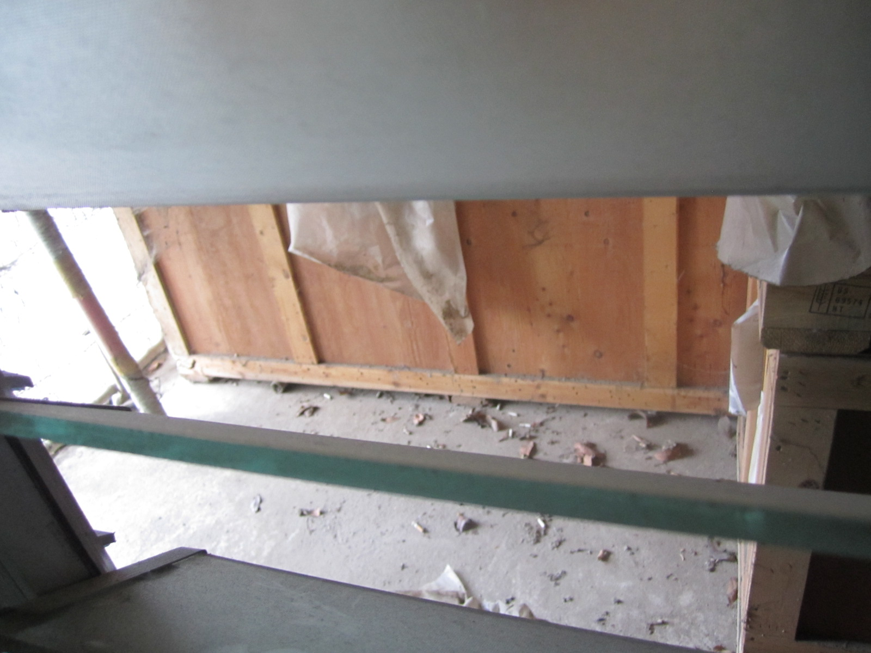
Figure 4: Bottom of large crate, showing pipes under bottom.

The crates are closed in the structure. The door is open in these photos to allow light enough for photos and inspection. The structure is not sealed, however, so there could be condensation. It is considered unlikely that this is a concern here.

University of Philippines, Diliman Facility Inspection
July 8, 2013
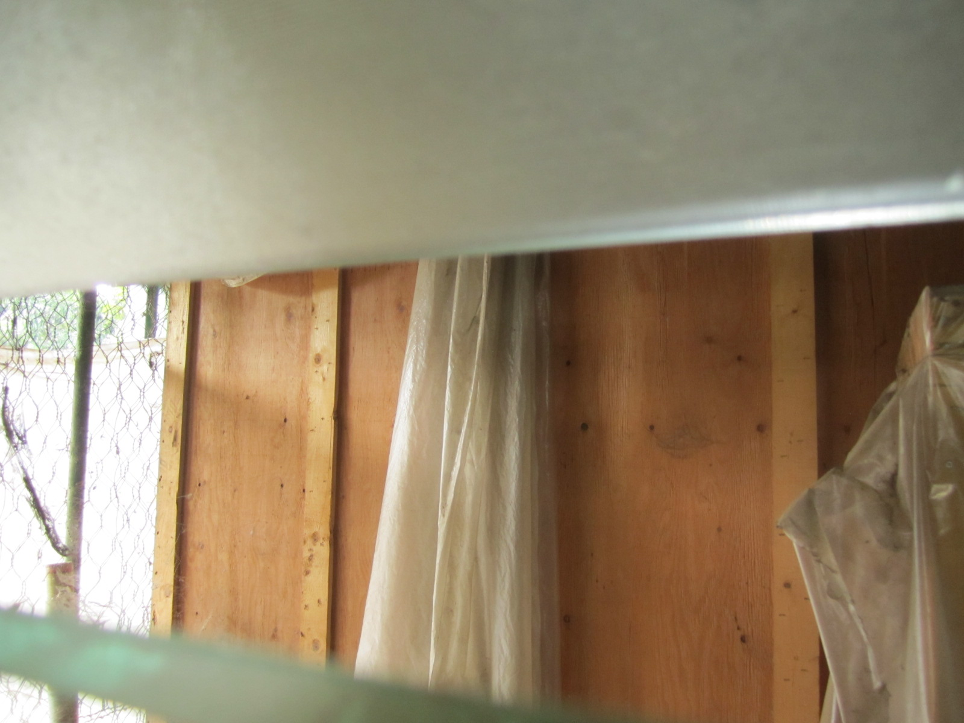
Figure 5: Side of large crate towards the front of the enclosure.

University of Philippines, Diliman Facility Inspection
July 8, 2013
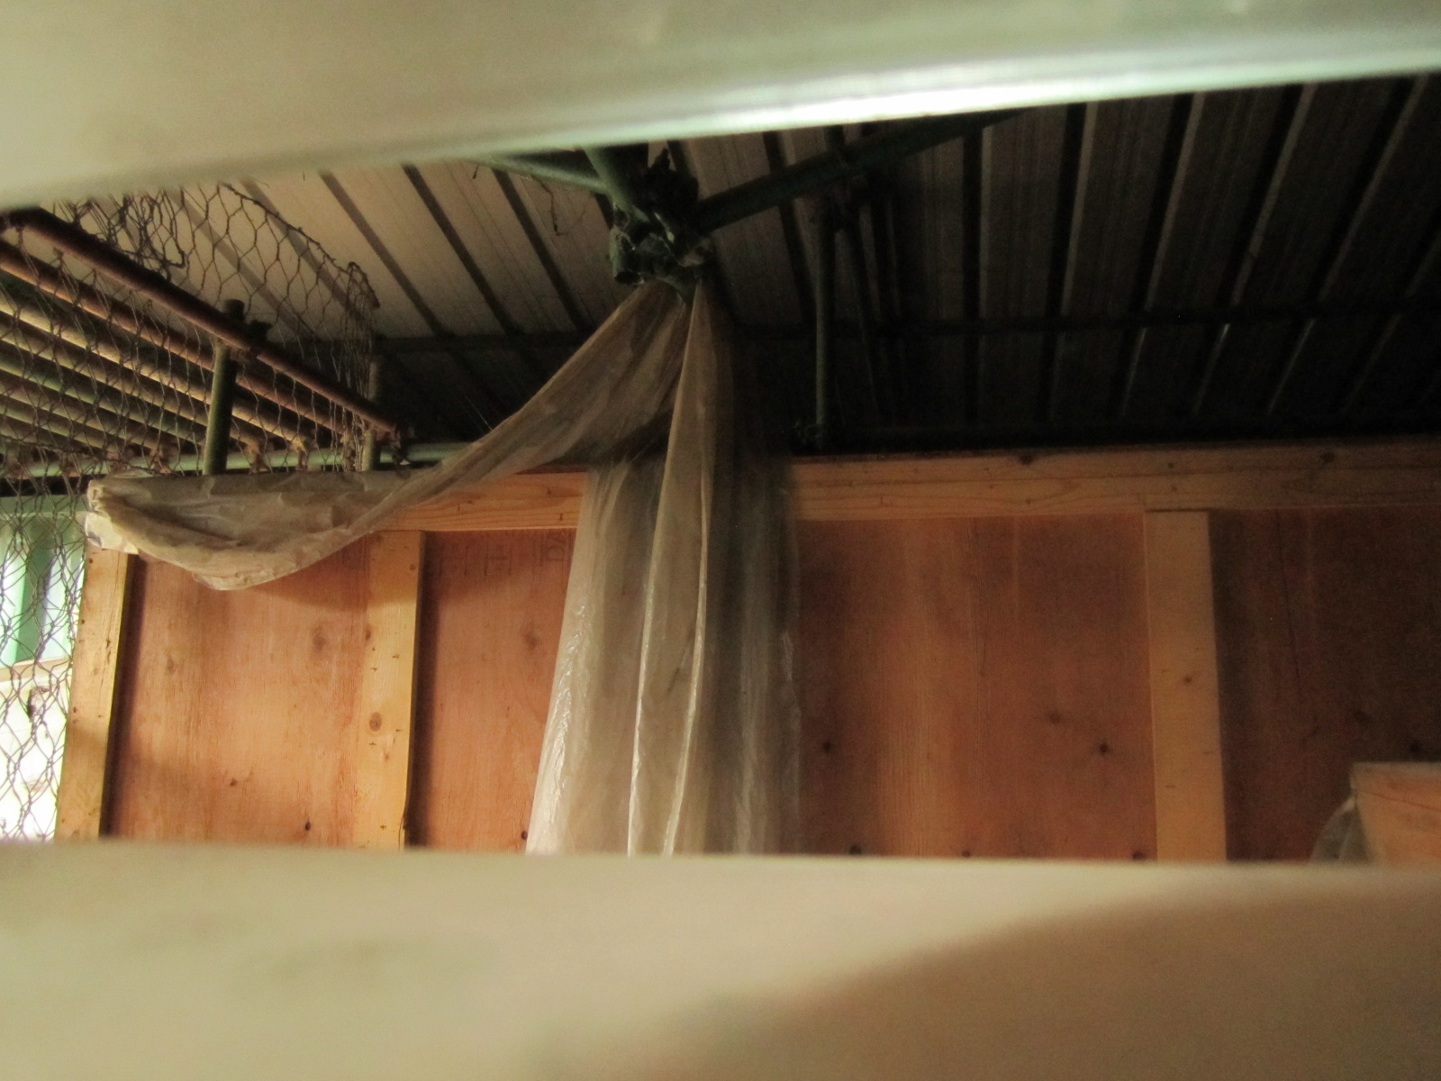
Figure 6: Top of large crate towards the front of the enclosure.

University of Philippines, Diliman Facility Inspection
July 8, 2013
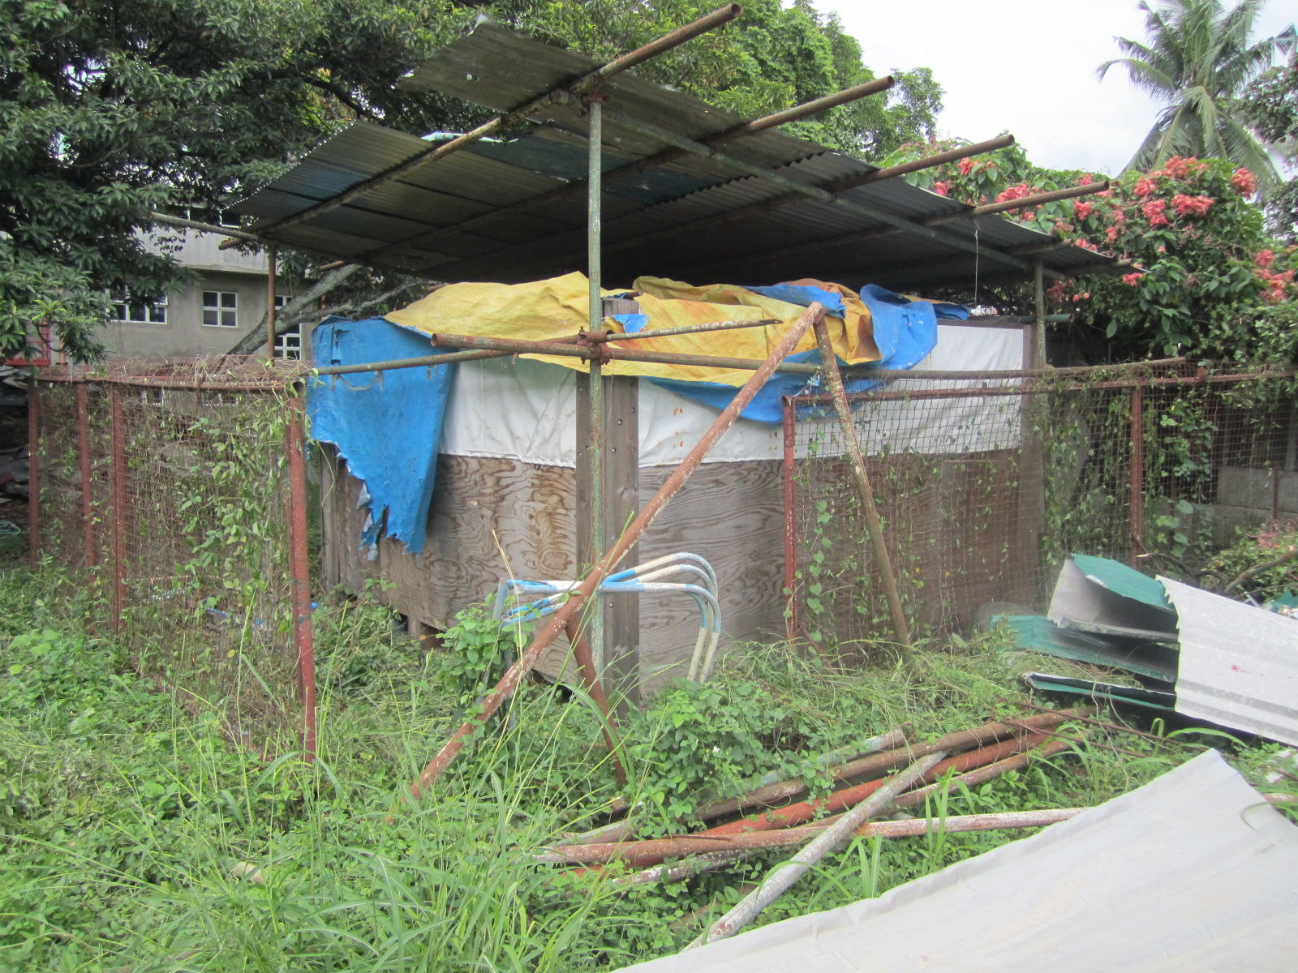
Figure 7: Shaking Table storage.
Unfortunately, it does not look like the shaking table itself has been stored as well. It is very likely that there has been moisture intrusion inside the crate, resulting in a lot of rust. It will require clean-up and re-painting. There does NOT seem to be any standing water that has been on top of the crate, but the extreme weathering of the crate indicates a very high moisture environment.

University of Philippines, Diliman Facility Inspection
July 8, 2013
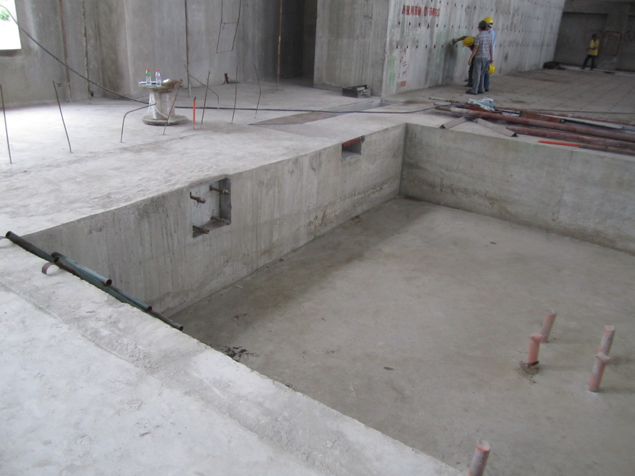
Figure 8: Shaking Table pit left side.
The actuator mounting plate is shown on the left imbedded in the wall. There ARE tubes around the bolts as required. After clearing the concrete flash around the bolt, it was found that there was considerable motion possible for the head of the bolt (>10 mm). The mounting bolts go back to the left to where the re-bar is sticking out of the floor (about 1.5 meters). The floor mounting bolts for the linear bearings have tubes around them as well, allowing for about 20 mm motion. In all cases, the tubes go to the other end of the mounting bolts.

University of Philippines, Diliman Facility Inspection
July 8, 2013
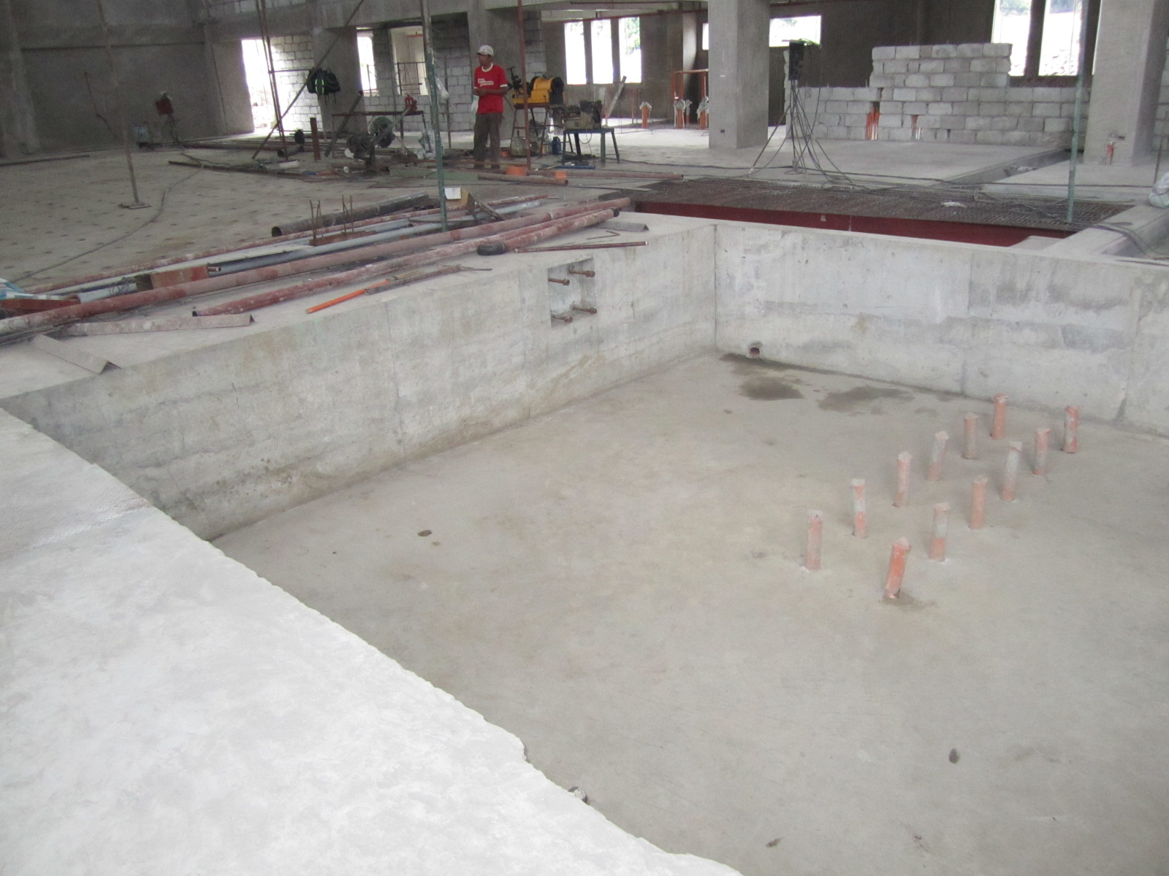
Figure 9: Shaking Table pit far side.
This view of the shaking table pit shows the other actuator attachment point and some of the linear bearing mounting bolts in the floor. The actuator plate bolts have tubes as well as the one shown before. Similar wobbling of the bolts is possible (>10mm).

University of Philippines, Diliman Facility Inspection
July 8, 2013
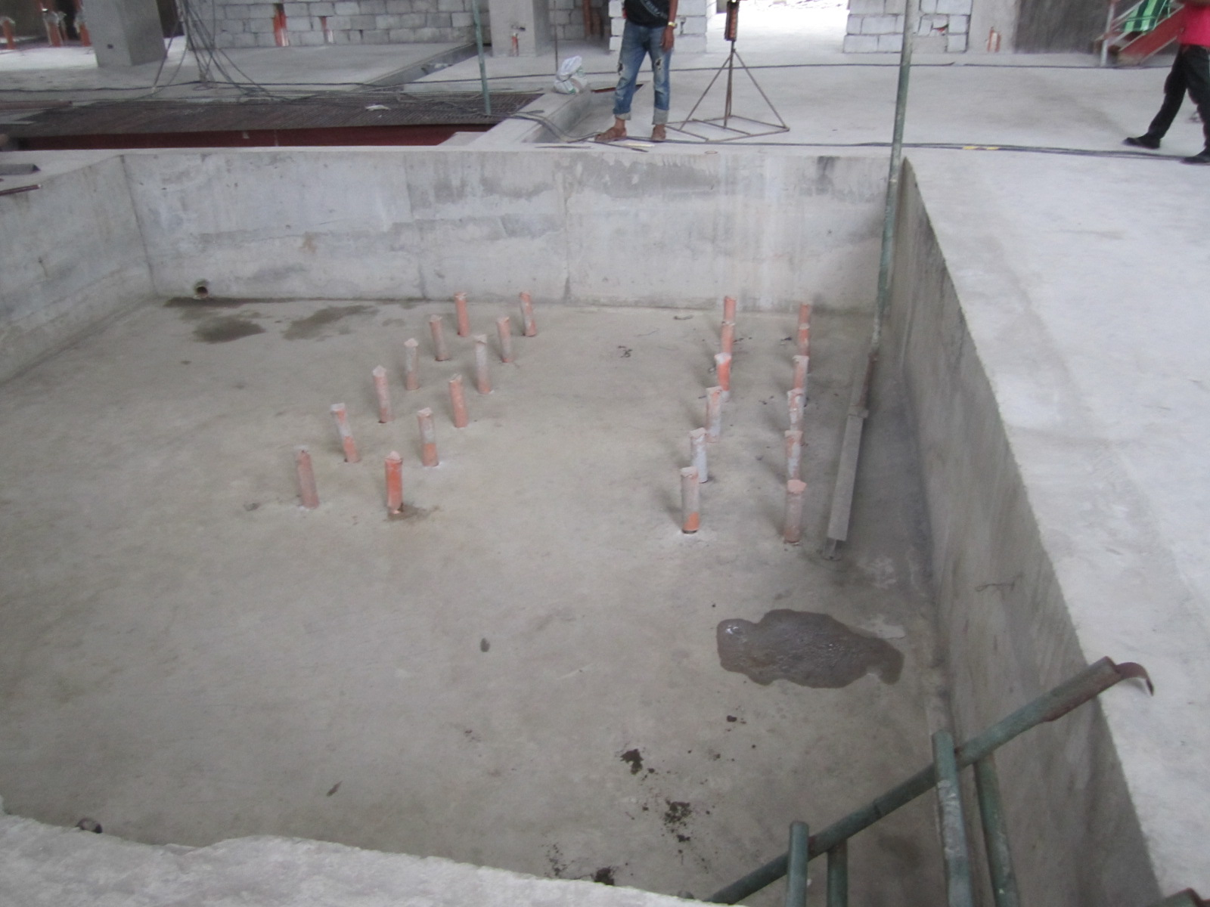
Figure 10: Shaking Table pit linear bearing mounting bolts.
All of the linear bearing mounting bolts have the required tubes around the bolts all the way to the bottom nuts. Tightening the bottom nuts has moved some of the bolts out of center-of-tube position slightly (~10mm)

University of Philippines, Diliman Facility Inspection
July 8, 2013
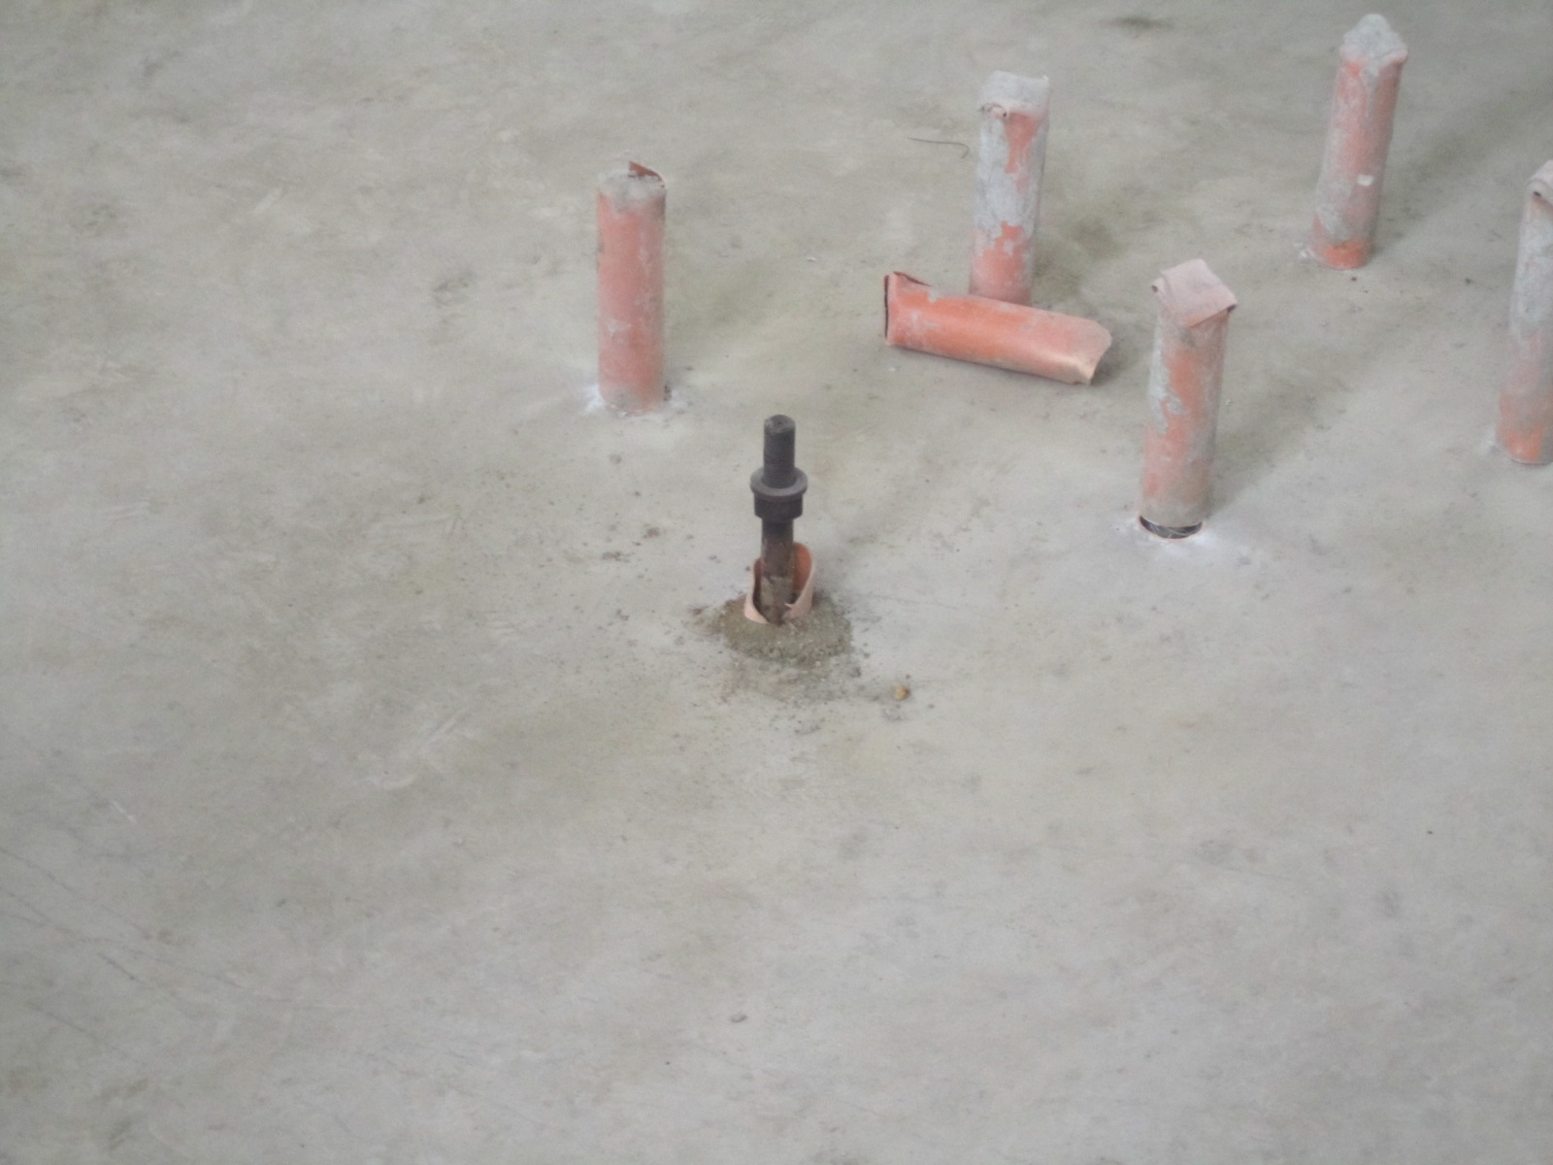
. Figure 11: Closer photo of pit linear bearing mounting bolts.
Detailed measurements on the bolt patterns are included at the end of this document. They show that the bolts should be in the right position for installation. As an aside, it was recommended that the customer install concrete steps into the pit area. It is a safety measure that will pay dividends down the road. Customer did agree that it was a good idea and agreed to add it to the work order to be completed before installation.

University of Philippines, Diliman Facility Inspection
July 8, 2013
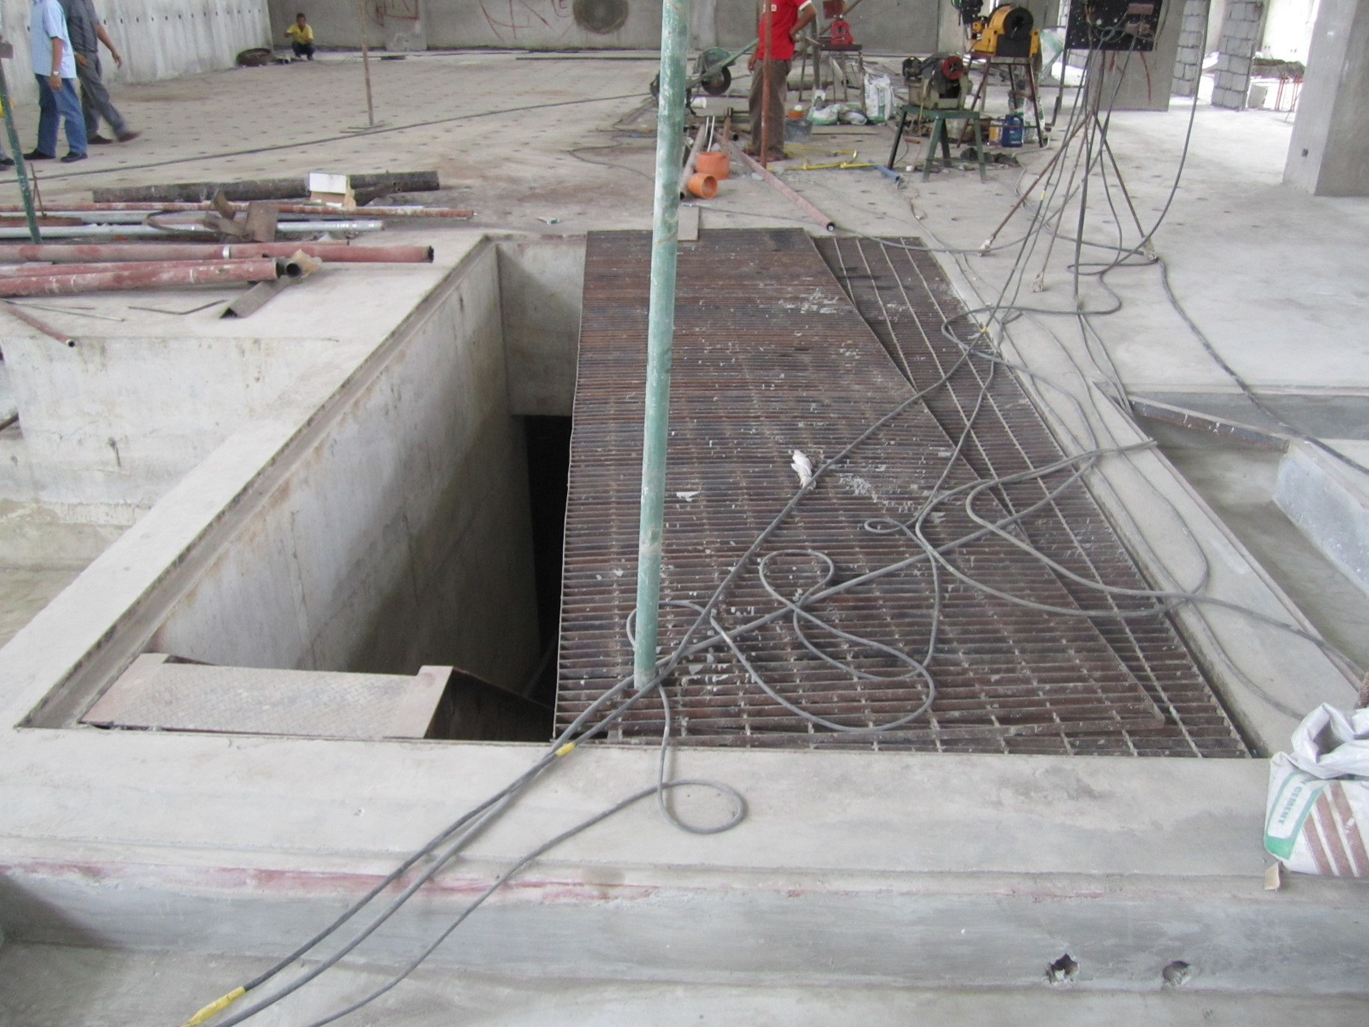
. Figure 12: Photo of opening for lowering the pump into basement.
The opening in the floor is approximately the right dimension for lowering the pump. A long tape measure was not available, but the estimate using the short tape seemed ok.

University of Philippines, Diliman Facility Inspection
July 8, 2013
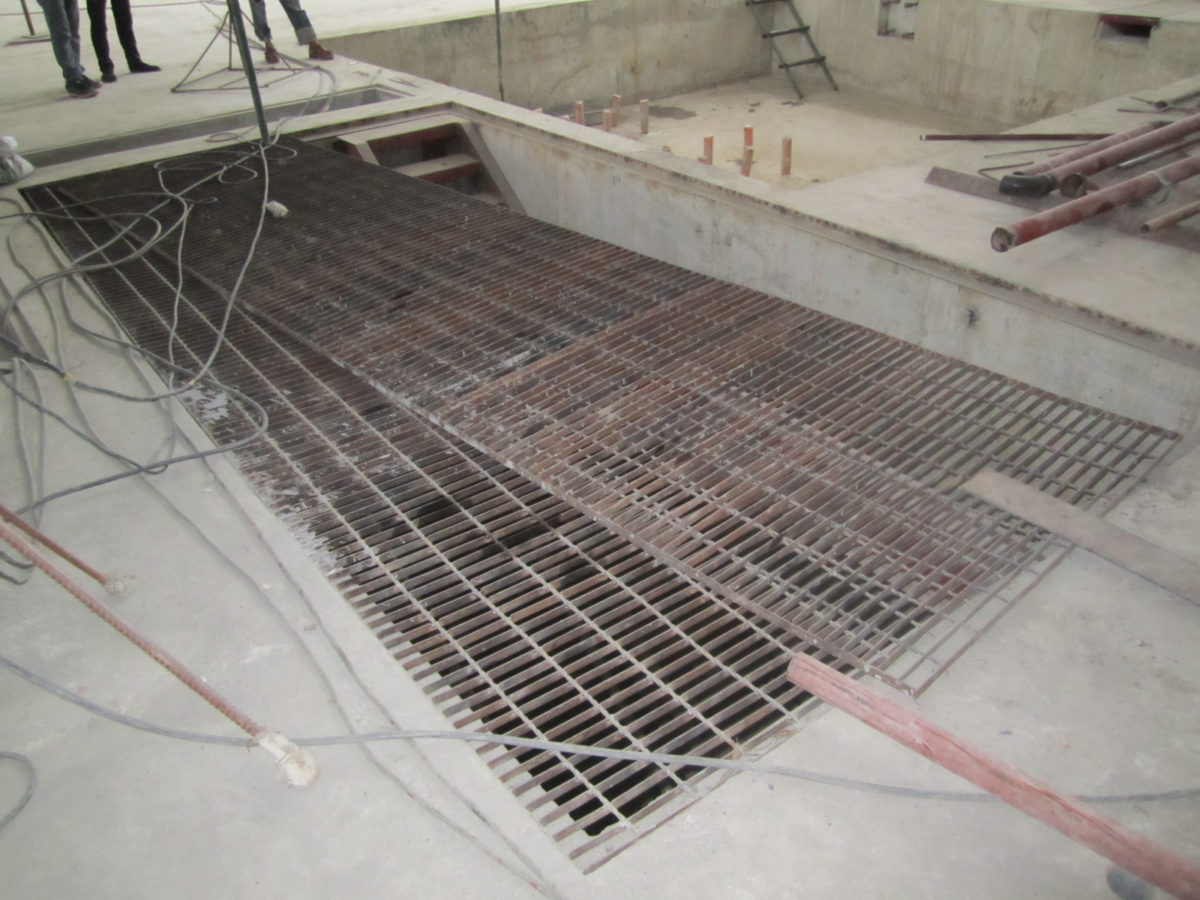
. Figure 13: Photo of floor opening into basement from other side.
The metal stairs on the other side of the opening is easily removable if extra space is required for access.

University of Philippines, Diliman Facility Inspection
July 8, 2013
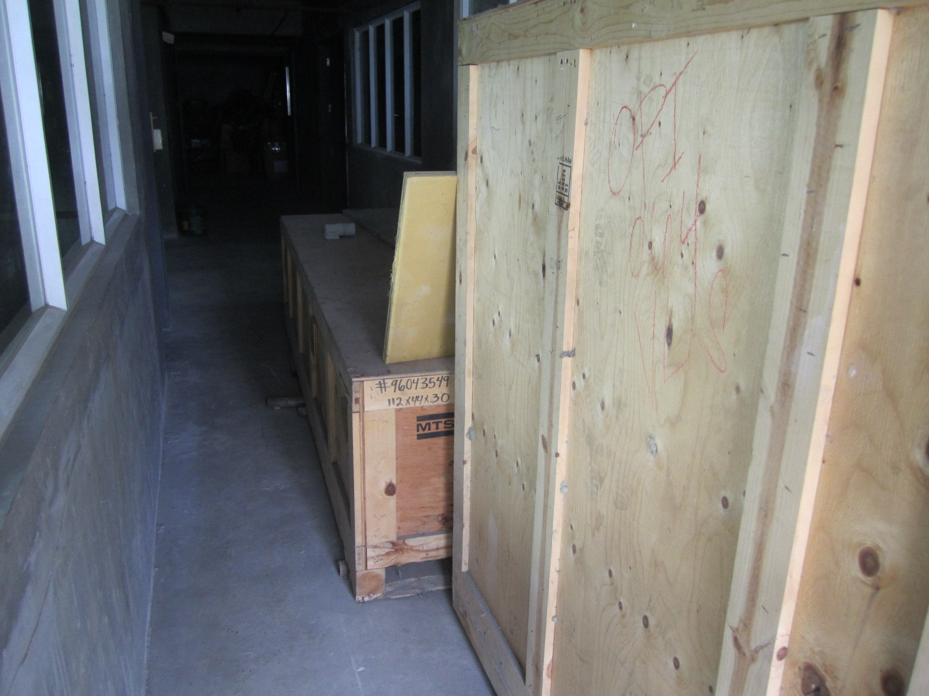
. Figure 14: Structural Actuator crates stored inside shaker table building.

University of Philippines, Diliman Facility Inspection
July 8, 2013
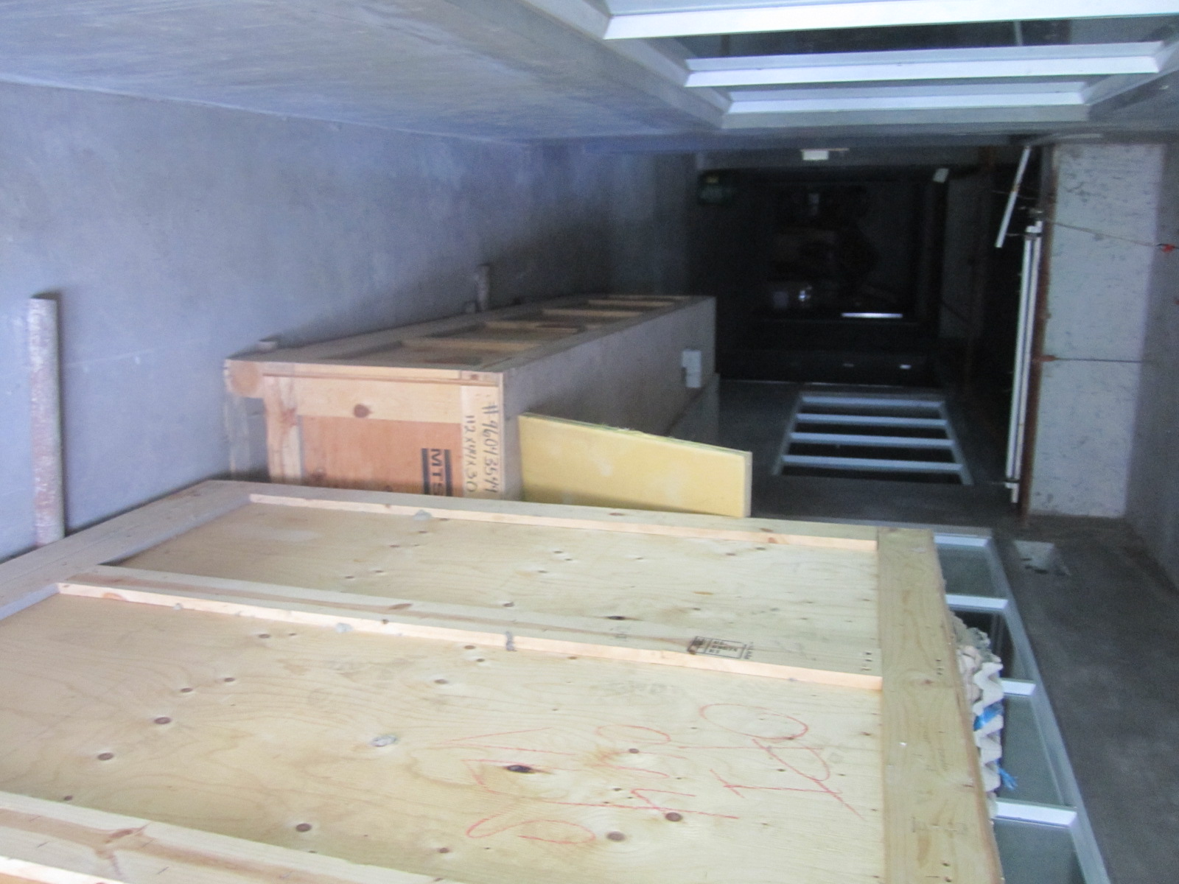
Figure 15: Structural Actuator crates stored on top of pipes on floor.
University of Philippines, Diliman Facility Inspection
July 8, 2013
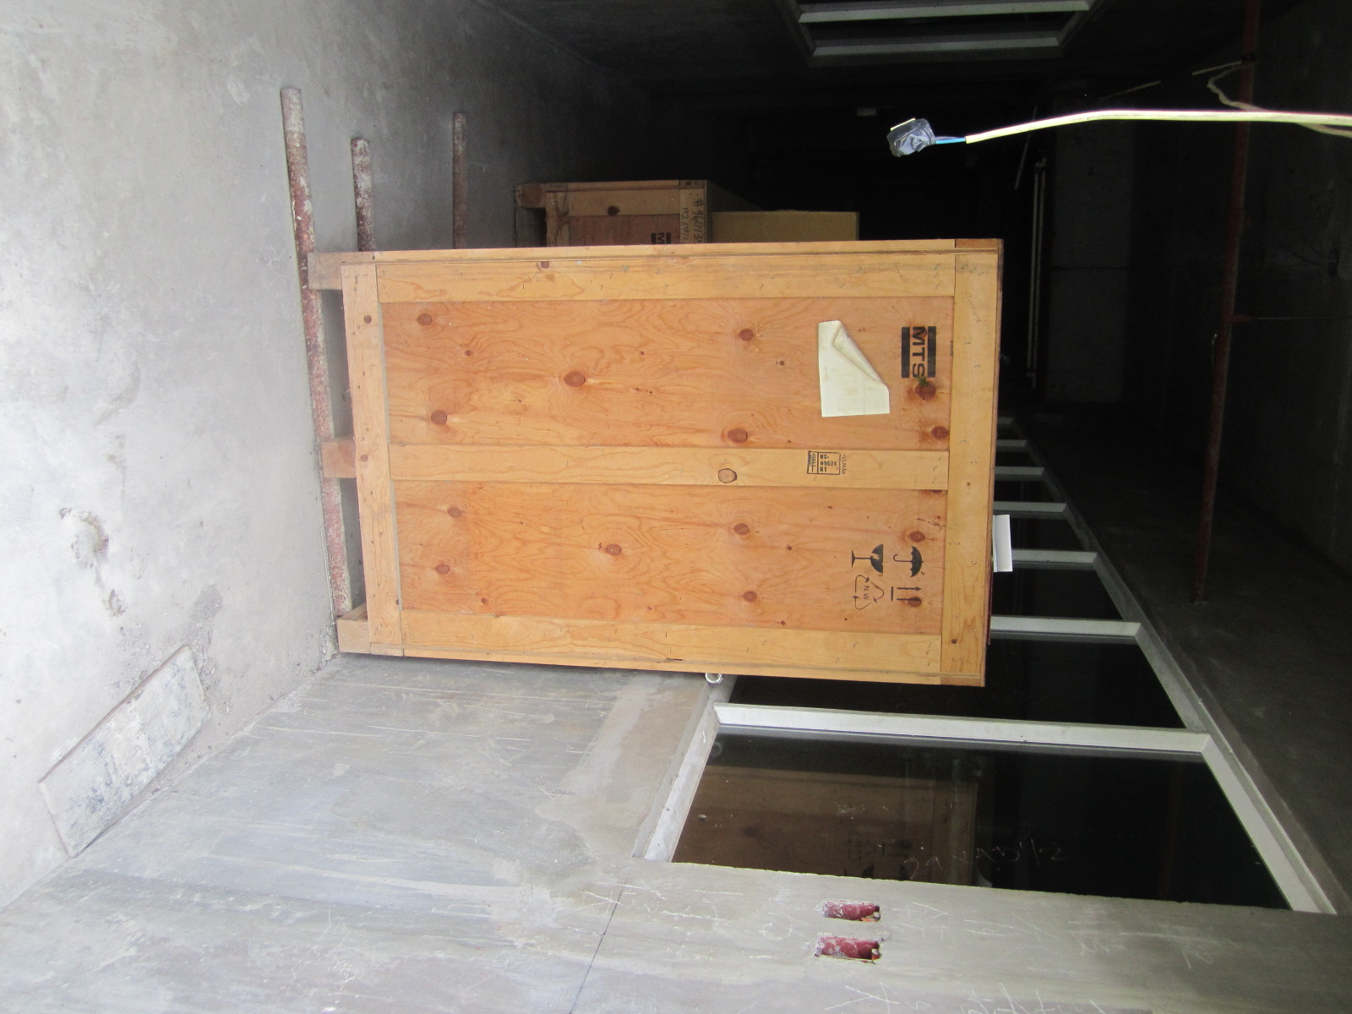
Figure 16: Structural Actuator crates back from open entrance to building
. University of Philippines, Diliman Facility Inspection
July 8, 2013
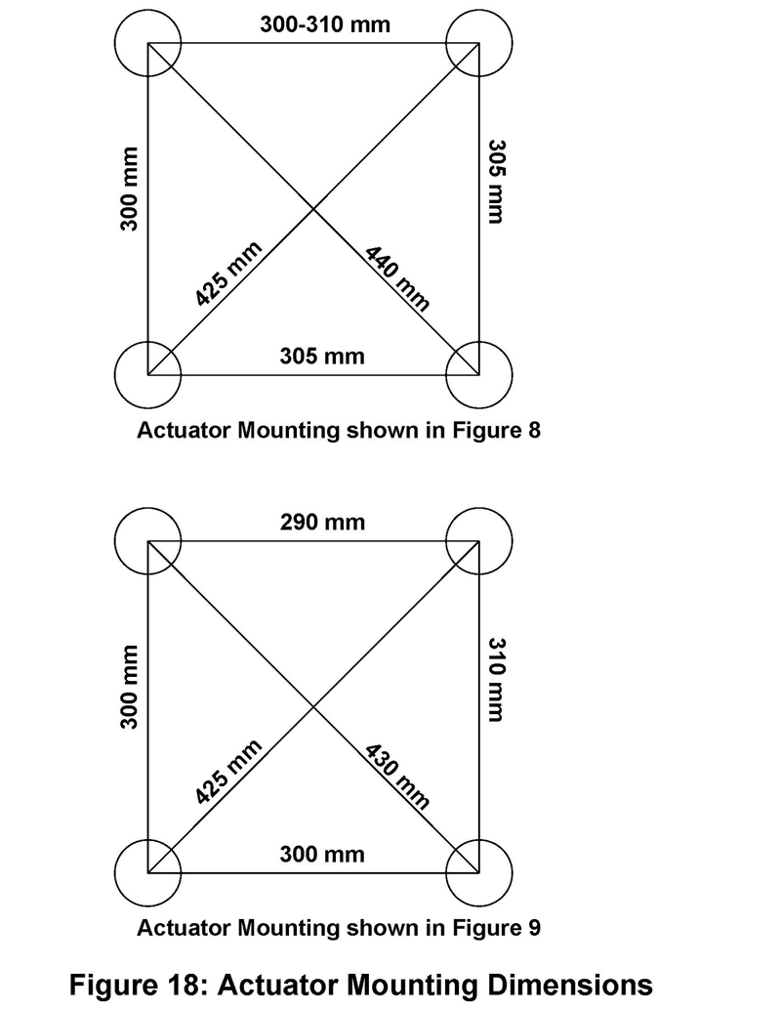

The actuator bolts were free to move approximately +/-10 mm in any direction that complicated exact measurements.
The floor mounted bolts for the linear bearings were on an equal sided box of 500 +/-10 mm on each side for all sections of the 2 rows of boxes in the floor. See Figure 10.
The overhead crane had a sign that indicated a 10 ton load limit and the travel included all of the shaking table pit area and the floor opening for the basement access.

