Waveform for the ceremony on Nov. 21st
(Run-through on Nov. 4th)
H. Kumagai

1st candidate: 3D sine wave

Displacement amplitude: mm
Frequency: Hz
Duration: sec

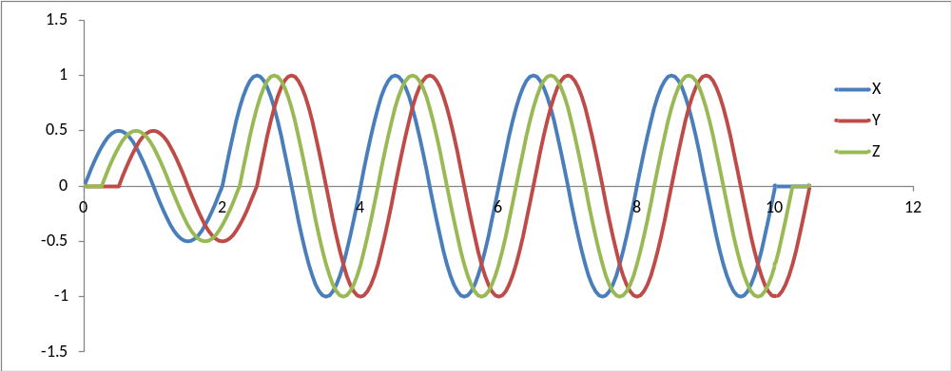
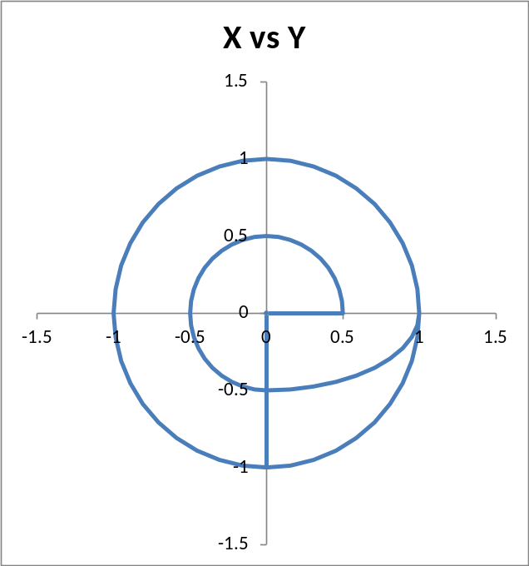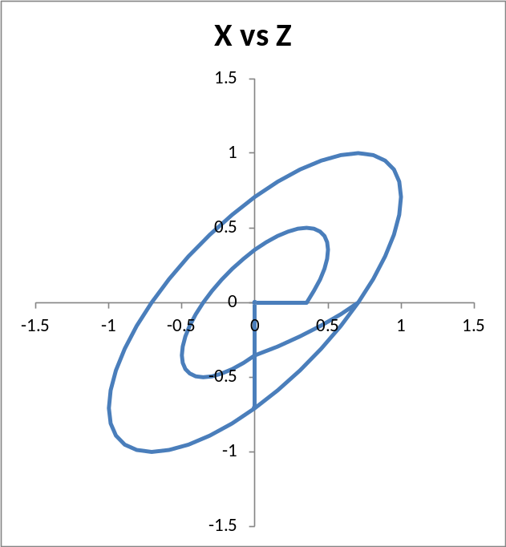

2nd candidate: JMA Kobe

Reduction factor: %
Lead time: sec

