中国建筑80MN多功能试验机招标文件

CSECE 80MN Multi-function test rig bidding document

技术说明

Technology requirement

中国建筑股份有限公司技术中心

2013年5月30日

目 录
1. 概述general 1
1.1 项目目标 project purpose 1
1.2 项目分类 project items 1
1.3 运输和安装shipment and installation 2
1.4 调试 commissioning 2
1.5 验收 acceptance 3
1.6 人员培训 training 4
1.7 售后服务、技术支持与保修after sale service, technology support and maintenance 4
1.8 备品、备件spare parts 4
1.9 其他 others 5
2. 80MN多功能试验机基本功能要求介绍 80MN multifunction test rig basic function reuiqrment 6
2.1 橡胶支座实验 elatomer supporter test 6
2.2 结构构件实验 structure test 7
2.3 试件示意图 test illustration 9
3. 80MN多功能试验机加载框架技术要求 80MN multifunction test rig load frame technoogy requirment 12
3.1 基本要求 basic requirement 12
3.2 刚度控制指标 stiffness controlled parameters 14
3.3 加载空间 load frame space 14
3.4 可移动横梁 movable crossbeam 14
3.5 横梁移动机构movable beam structure 14
3.6 加载平台基本要求 platform basic requirment 14
3.7 加载平台运动方式load frame platform motion style 16
3.8 外框架立柱 outer frame column 17
3.9 外框架底座 outer frame base 17
3.10 复杂节点实验要求 complicated node point test requriment 18
3.11 其他miscellaneous 18
4. 80MN多功能试验机液压和控制系统技术要求 80MN multifunction test rig hydraullicand control system technology requirement 19
4.1基本要求 basic requirement 19
4.2 加载平台作动器配置要求platform actuators configuration requiremnt 20
4.3 空间梁柱节点附加设备 space beam column node point accessory 22
4.4 数字控制系统 digital control system 22
4.5 控制软件要求 control software requirement 26
4.6 液压油源和分油系统HPU and HDS system 27
4.7 蓄能器 accumulator 27
4.8 液压分油系统要求 Hydraulic distribution system requirement 28
4.9 液压管路系统要求hydraulic pipe requirement 28
4.10 液压软管连接hydraulic hose connection 30
4.11 液压油hydraulic oil 30
4.12 液压分油系统压力测试hydraulic distribution system pressure test 30

1. 概述

General introduction

1.1 项目目标 project purpose
中国建筑股份有限公司所规划筹建的80MN多功能试验机主要用来进行大型橡胶支座和结构构件在静力、动力荷载作用下的响应和破坏模式研究。其主要功能要求参条款2“80MN多功能试验机基本功能要求介绍”中的描述。
CSCEC is planning to build the 80MN multi-function test rig for big size elastomer supporter and structure, under static and dynamic load, response and damage mode study. The main function see the description in clause 2 80MN multifunction test rig basic function requirement

1.2 项目分类 project classification
中国建筑80MN多功能试验机分为两个分项：
There are two classification of the 80MN multifunction test rig
⑴ 分项1：80MN多功能试验机加载框架（参图1.1），包括其运输和安装方案。
Item 1: 80MN multi-function test rig load frame, see picture 1.1, including transportation and installation plan.
⑵ 分项2：80MN多功能试验机液压和控制系统（参图1.2、1.3），包括其运输和安装方案。
Item 2: 80MN multi-function test rig hydraulic and control system, see picture 1.2 and 1.3, including transportation and installation plan.
“分项1：80MN多功能试验机加载框架”和“分项2：80MN多功能试验机液压和控制系统”必须协调统一，共同完成条款2中规定的各项功能。
Item 1, 80MN multi-function test rig load frame, and Item 2, 80MN multi-function test rig hydraulic and control system must coordinate to realize various function listed in clause 2

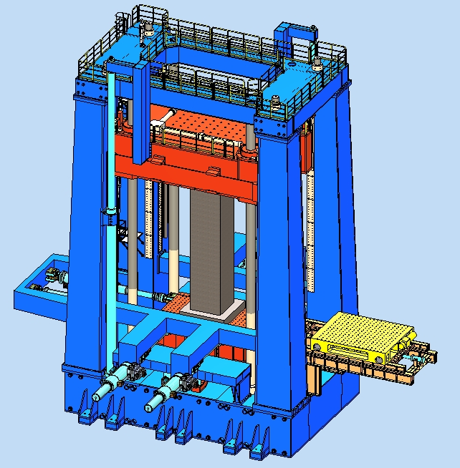
图1.1 中国建筑80MN多功能试验机—加载架示意图
Picture 1.1 80MN multi-function test rig load frame of CSCEC
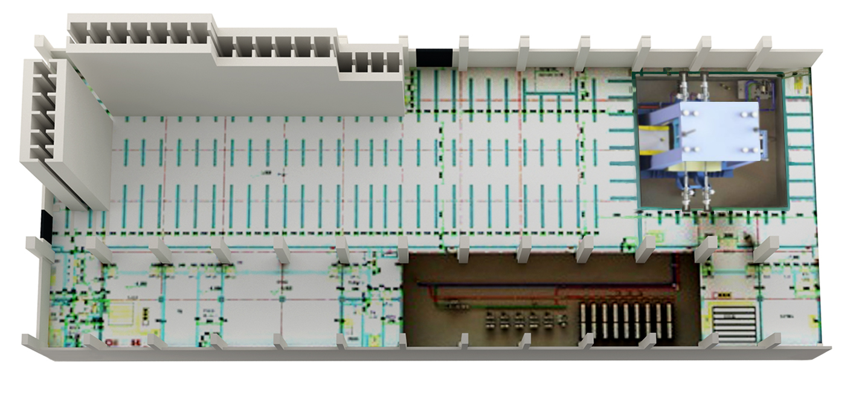
图1.2 中国建筑80MN多功能试验机—液压和控制系统示意图（1）
Picture 1.2 80MN multi-function test rig hydraulic and control system
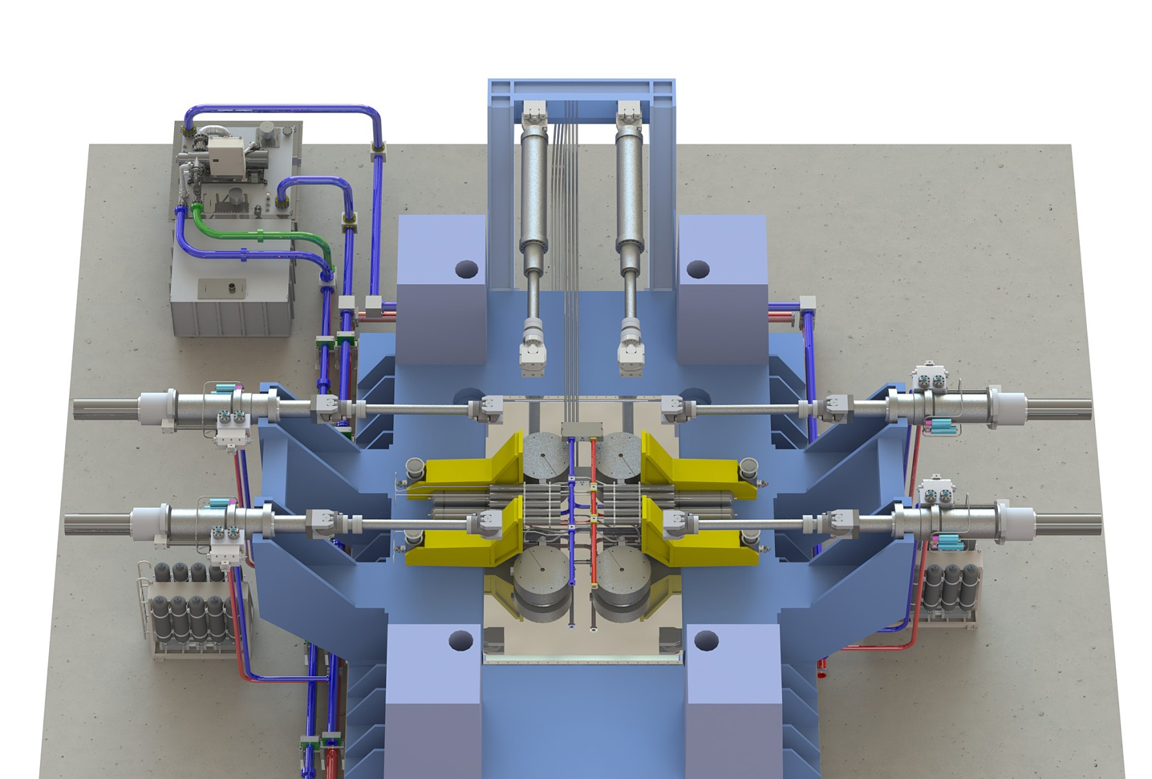
图1.3 中国建筑80MN多功能试验机—液压和控制系统示意图（2）
Picture 1.3 80MN multi-function test rig hydraulic and control system

1.3 运输和安装 shipment and installation
运输和安装是指从生产制造工厂运输到中国建筑股份有限公司技术中心结构试验大厅，然后在结构试验大厅内部组装成整体设备，投标方必须给出运输和安装的详细方案与报价。
The shipment and installation means from manufacturer factory to CSCEC structure test hall, and assemble in the hall into a complete system. The bidder shall deliver the complete transportation and installation plan and quotation.
中国建筑股份有限公司技术中心内部场地及结构试验大厅布置参图“附图1：总平面图”、“附图2：结构实验大厅地下室布置图”和“附图3：结构实验大厅一层布置图”。
For the CSCEC internal place and hall, please see the attached drawing 1 general plane view, drawing 2 , basement layout drawing, drawing3 structure test hall layout.
结构试验大厅有两台50吨吊车可以使用。
There are two sets of 50 ton crane in the hall.

1.4 调试 commissioning
投标方负责设备的安装后调试工作。
The bidder is responsible for the commissiong after installation.

1.5 验收 acceptance test
投标方应该给出设备验收的详细方法，包括：垂向作动器加载能力的验收、水平向作动器加载能力的验收、水平向摩擦系数的验收、加载架和移动横梁刚度的验收等等。
The bidder shall deliver the detail system acceptance methods, including vertical actuators loading capacity acceptance test, horizontal actautors loading capacity acceptance test, horizontal friction co-efficiency acceptance method, load frame and movable beam stiffness acceptance test.
设备的验收采用实际加载方式进行，主要进行下面几种实验工况（参条款2，试件由买方提供）：
The system acceptance test will be real loading method, includes the following work conditions( refer to clause 2, specimen is delivered by the buyer)
1.5.1 橡胶支座的单向高频试验：Elastomer supporter single direction high frequency test
● 实验基本情况：试件最大尺寸为2m（直径）×1m（高度），要求垂向（Z向）力为40MN（保持不变），同时加4MN单向往复水平（Y向）力，水平（Y向）力加载频率为0.5Hz，完成6个满循环，加上开始时的半个循环和结束时的半个循环，共完成7个循环，水平方向（Y向）行程为±0.5米。
The test conditions are as follows, the max specimen dimensions are diameter 2 meterX1m height, the required force on Z direction is 40MN kept, in the mean time, 4MN single direction reversal Y direction force, Y direction force frequency is 0.5Hz， complish 6 full cycle, there are half cycle for start and half cycle for end, the total is 7 cycles, horizontal Y direction stroke is ±0.5m.
● 主要验收数据：垂向（Z向）力保压情况、水平力保压情况、水平向速度、水平向加速度、垂向作动器与加载架底座之间的摩擦系数等。
Main acceptance test data: Z direction force kept, horizontal force kept, horizontal speed, horizontal acceleration, friction co-efficiency between vertical actuator and base of load frame.
1.5.2 橡胶支座的单向准静态、大位移试验： elastomer supporter single direction quasi static, big displacement test
● 实验基本情况：试件最大尺寸为2m（直径）×1m（高度），要求垂向（Z向）力为60MN（保持不变），同时加6MN单向往复水平（X向）力，水平（X向）力为准静态，水平方向（X向）行程为±1.5米。
The test conditions are as follows, the max specimen dimensions are diameter 2 meterX1m height, require 60MN vertical force kept, in the mean time apply 6MN reversal force on X direction. X direction force quasi static, stroke is ±1.5m
● 主要验收数据：垂向（Z向）力保压情况、水平力保压情况、水平向速度、水平向加速度、垂向作动器与加载架底座之间的摩擦系数等。
Main acceptance test data: Z direction force kept, horizontal force kept, horizontal speed, horizontal acceleration, friction co-efficiency between vertical actuator and base of load frame
1.5.3 巨柱单向压缩试验： giant column single direction compression test
● 实验基本情况：试件最大尺寸为2m×2m×10m（高度），要求垂向（Z向）力最大加载能力不小于80MN。
The test conditions are as follows, the max specimen dimensions are 2m×2m×10m(height), require the vertical Z direction loading force not less than 80MN.
● 主要验收数据：垂向（Z向）力保压情况，加载平台位移、移动横梁位移、加载架外部立柱位移等。
The main acceptance data: vertical Z direction force kept, work platform displacement, movable crossbeam displacement, outer column of load frame displacement.
1.5.4 巨柱压剪实验（双向剪切）：giant column shear test ( double direction shear)
● 实验基本情况：试件最大尺寸为2m×2m×6m（高度），要求垂向（Z向）力为60MN（保持不变），同时加6MN往复水平双向（X向和Y向）力，水平双向（X向和Y向）力为准静态，水平双向（X向和Y向）行程为±0.5米。
The test conditions are as follows, the max specimen dimensions 2m×2m×6m( height). Require the vertical Z direction loading force is 60MN, in the meantime, 6MN reversal horizontal double direction force( X and Y direction), horizontal double direction ( X and Y direction) forces are quasi static force, double direction ( X and Y direction) stroke is ±0.5
● 主要验收数据：垂向（Z向）力保压情况、水平力保压情况、水平向速度、水平向加速度、垂向作动器与加载架底座之间的摩擦系数，加载平台位移、移动横梁位移、加载架外部立柱位移等。
Main acceptance data: vertical direction force kept, horizontal force kept, horizontal speed, horizontal acceleration, friction co-efficiency between vertical actuator and base of load frame, work platform displacement, movable crossbeam displacement, outer column of load frame displacement.
1.5.5 巨柱压、剪、扭、转实验：gaint column compression, shear, twist, rotation test
● 实验基本情况：试件最大尺寸为2m×2m×10m（高度），要求柱底端部在水平双向（X向和Y向）位移为±0.1米时，柱底端部同时具有绕水平轴（X、Y轴）转动角度为±5°，绕垂直轴（Z轴）扭转角度为±10°的能力。
The test conditions are as follows, the max specimen dimensions2m×2m×10m(height), at the bottom of the column double direction (X and Y direction) ±0.1m dispplacement, at the bottom the column there is also ±5° rotation angle around horizontal axises( X and Y axis), twist angle ±10°around the vertical axis.
● 主要验收数据：垂向（Z向）力保压情况、水平力保压情况、水平向速度、水平向加速度、垂向作动器与加载架底座之间的摩擦系数，加载平台位移、移动横梁位移、加载架外部立柱位移等。
Main acceptance data: vertical direction force kept, horizontal force kept, horizontal speed, horizontal acceleration, friction co-efficiency between vertical actuator and base of load frame, work platform displacement, movable crossbeam displacement, outer column of load frame displacement.

1.6 人员培训 training
现场培训：投标方应提供不少于四名买方人员测试系统的操作及维护培训。
On site training: the bidder shall deliver not less than 4 buyer’s engineers measurement system operation and maintenance training
培训时间：培训应当在不迟于安装后一个月后提供，但早于最终验收，最好在最终安装和验收阶段进行。培训时间不少于2周（14天）。
Train period: training shall be done not later than one month after the installation but before the final acceptance, it is preferred to be done during final installation and acceptance phase, the training time shall not be less than 2 weeks.
培训内容：投标方应提供系统操作培训，着重于橡胶支座试验和结构构件试验的数字伺服控制器的应用；设备的维护与保养等。
Training content: the bidder shall provide the system operation training, focus on the elastomer elastomer supporter and structure components digital servo controller application, equipment maintenance and repair.

1.7 售后服务、技术支持与保修 after sale service, technology support and maintenance
1.7.1 技术服务响应时间不超过48小时。
Technology service response time shall not be more than 48 hours.
1.7.2 在正常使用中，由于设计失误而带来的维护费用，包括零部件的更换、人工和维修费用都应该由投标方承担。
During normal operation, for maintenance cost caused by design flaw, including components replacement, man power and cost of maintenance shall be born by the bidder.
1.7.3 质保期为买方验收合格后五年之内。第三方软件和硬件也具有买方验收后的五年质保期。
Warranty shall be five years after the buyer’s final acceptance, the third party software and hardware shall also be with 5 years warranty.

1.8 备品、备件 spare parts
1.8.1 系统正常运行所需要的基本零部件的备件应当包含在投标报价中。
The basic spare parts shall be included in the bidding price.
1.8.2 投标方应当提供推荐的备件列表给买方，以便买方将来好维护保养设备。备件表应当明确供货商零件号，推荐的数量，供货期、和推荐的部件价格。
The bidder shall provide the recommended spare parts list to the buyer to bring convenience for the maintenace. In the spare parts list the component No., recommended quantity, delivery, price shall be listed.
1.8.3设备安装、调试和维护所必须的专用工具及附件应当包含在投标报价中。
The specail tools for installation, commissioning, and maintenance shall be included in the bidding price.

1.9 其他 miscellaneous
1.9.1 设备标示：设备的每一个主要部件都应当有一个永久铭牌，明确标示出生产商名称、类型、型号等，该铭牌安全地安放在显著位置。
Each major component of equipment shall have the manufacturer's name, type and model number on a permanent plate securely attached to the item in a conspicuous location.
1.9.2 安全和防护：① 所有的电力线路和接头应当满足生产国的国家电力标准；所有电力和电子部件应当是高质量的，满足相应的行业标准；② 所有的传送带、滑轮、齿轮、耦合器、突出的螺钉、键和其他旋转部件应当完全密闭或者适当保护，任何接近的人员都得到安全防护；③ 在控制室和测试区的几个区域应该设置整体关机按钮。
Safety and protection: 1） All electrical wiring and connections shall comply with national electrical codes of country of manufacture. All electrical and electronic components shall be high quality and comply with appropriate industrial standards. 2） All belts, pulleys, gears, couplings, projected set screws, keys and other rotating parts shall be fully enclosed or properly guarded located so that any person that can come in close proximity will be safely shielded. 3） An emergency “global” shutdown switch or “kill” button shall be located in the control room and at several areas of the test floor.
1.9.3 设备的标定：投标方应该给出设备的标定（测量）方式，以便证明所提供的方案满足招标文件中的规定要求。
Equipment calibration: the bidder shall provide the equipment calibration methods to prove its solution meet the bidding requirement.
1.9.4 图片：本招标文件中所给出的有关80MN多功能试验机的图片资料仅供参考，不具有任何强制性约束，投标方可以根据情况自行设计满足招标文件的方案。
Picture: the pictures in this bidding requirement are only for reference and not constrained. The bidder can deliver its own solution.
1.9.5 买方支持：除了招标文件中提供的资料（包括图纸）外，投标方认为投标所必须的应该由买方提供的其他技术资料，请以书面形式提出。
The buyer support: besides the materials in this bidding requirement, if the bidding suppose there shall other materials shall be delivered by the buyer, it shall be required by written document
1.9.6 本文件是对“中国建筑80MN多功能试验机—招标文件”的详细补充，本文内容与“中国建筑80MN多功能试验机—招标文件”有冲突的地方，请以本文描述为准。

This document is the detailed supplement, if there is any conflict with the 80MN multi function test rig bidding document, this document shall prevail.

2. 80MN多功能试验机基本功能要求介绍

80MN Multi-function test rig basic function introduction
中国建筑所要求的80MN多功能试验机主要用来进行大型橡胶支座和结构构件在静力、动力荷载作用下的响应和破坏模式研究。
80MN multi function test rig of CSCEC is mainly for the big size elastomer supporter and structure static, dynamic load response and damage mode study.

2.1 橡胶支座实验 elastomer supporter test
80MN多功能试验机主要用来做大型橡胶支座的单向高频试验和多向准静态试验，具体实验要求描述如下（参图2.1）：
80MN multi function test rig is mainly for the big size elastomer supporter single direction high frequency test and multi direction quasi static test, the detailed tests are describe as below.
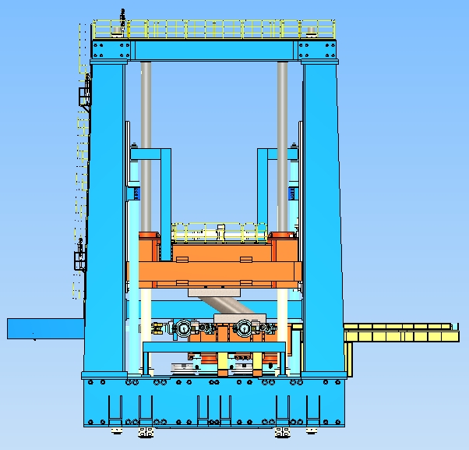
图2.1 中国建筑80MN多功能试验机—橡胶支座实验示意图
Picture 2.1 CSCEC 80MN multi function test rig - elastomer supporter test
2.1.1 单向高频试验。试件最大尺寸为2m（直径）×1m（高度），要求垂向（Z向）力40MN（保持不变），同时加4MN单向往复水平（Y向）力，水平（Y向）力加载频率为0.5Hz，完成6个满循环，加上开始时的半个循环和结束时的半个循环，共完成7个循环，水平方向（Y向）行程为±0.5米。
the max specimen dimensions are diameter 2 meterX1m height, the required force on Z direction is 40MN kept, in the mean time, 4MN single direction reversal Y direction force, Y direction force frequency is 0.5Hz， complish 6 full cycle, there are half cycle for start and half cycle for end, the total is 7 cycles, horizontal Y direction stroke is ±0.5m.

2.1.2 单向准静态、大位移试验。试件最大尺寸为2m（直径）×1m（高度），要求垂向（Z向）力为60MN（保持不变），同时加6MN单向往复水平（X向）力，水平（X向）力为准静态，水平方向（X向）行程为±1.5米。
elastomer supporter single direction quasi static, big displacement test ：the max specimen dimensions are diameter 2 meterX1m height, require 60MN vertical force kept, in the mean time apply 6MN reversal force on X direction. X direction force quasi static, stroke is ±1.5m
2.1.3 双向准静态试验。试件最大尺寸为2m（直径）×1m（高度），要求垂向（Z向）力为60MN（保持不变），同时加6MN往复水平双向（X向和Y向）力，水平双向（X向和Y向）力为准静态，水平双向（X向和Y向）行程为±0.5米。
Double direction quasi static test: The test conditions are as follows, the max specimen diameter 2m×1m( height). Require the vertical Z direction loading force is 60MN, in the meantime, 6MN reversal horizontal double direction force( X and Y direction), horizontal double direction ( X and Y direction) forces are quasi static force, double direction ( X and Y direction) stroke is ±0.5

2.2 结构构件实验 structure components test
80MN多功能试验机主要用来做大型结构构件的单向和多向准静态试验，其实验研究对象主要是钢构件、钢筋混凝土构件、钢和钢筋混凝土组合构件等，例如巨柱（参图2.2）、大型剪力墙（参图2.3）、梁柱节点（参图2.4）、复杂空间节点（参图2.5）等。具体实验要求描述如下：
80MN multi function test rig is mainly for the big structure single and double direction quasi static test, the main specimen are steel structure, strengthen concrete structure, steel and steel bar concrete combination structure, such as giant column( picture2.2), big shear wall( picture 2.3), beam and column node ( picture 2.4),, space complicated node l( picture 2.5), the detailed requirements are as follows,
2.2.1 巨柱单向压缩试验。试件最大尺寸为2m×2m×10m（高度），要求垂向（Z向）力最大加载能力不小于80MN。
giant column single direction compression test
The max specimen dimensions are 2m×2m×10m(height), require the vertical Z direction loading force not less than 80MN
2.2.2 巨柱压剪实验（单向剪切）。试件最大尺寸为2m×2m×10m（高度），要求垂向（Z向）力为60MN（保持不变），同时加6MN往复单向（X向或Y向）力，水平向（X向或Y向）力为准静态，水平向（X向或Y向）行程为±0.5米。
giant column shear test ( single direction shear)
The max specimen dimensions 2m×2m×10m( height). Require the vertical Z direction loading force is 60MN, in the meantime, 6MN reversal horizontal double direction force( X and Y direction), horizontal double direction ( X and Y direction) forces are quasi static force, double direction ( X and Y direction) stroke is ±0.5m
2.2.3 巨柱压剪实验（双向剪切）。试件最大尺寸为2m×2m×6m（高度），要求垂向（Z向）力为60MN（保持不变），同时加6MN往复水平双向（X向和Y向）力，水平双向（X向和Y向）力为准静态，水平双向（X向和Y向）行程为±0.5米。
giant column shear test ( double direction shear)
The max specimen dimensions 2m×2m×6m( height). Require the vertical Z direction loading force is 60MN, in the meantime, 6MN reversal horizontal double direction force( X and Y direction), horizontal double direction ( X and Y direction) forces are quasi static force, double direction ( X and Y direction) stroke is ±05m.

2.2.4 巨柱压、剪、扭、转实验。试件最大尺寸为2m×2m×10m（高度），要求柱底端部在水平双向（X向和Y向）位移为±0.1米时，柱底端部同时具有绕水平轴（X、Y轴）转动角度为±5°，绕垂直轴（Z轴）扭转角度为±10°的能力。
gaint column compression, shear, twist, rotation test
The max specimen dimensions2m×2m×10m(height), at the bottom of the column double direction (X and Y direction) ±0.1m dispplacement, at the bottom the column there is also ±5° rotation angle around horizontal axises( X and Y axis), twist angle ±10°around the vertical axi
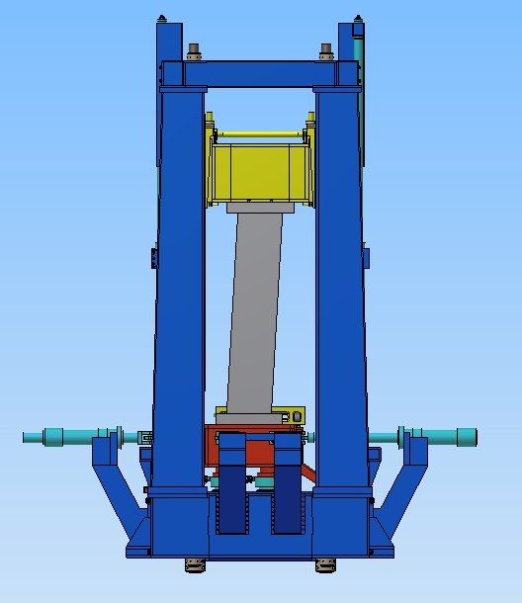
图2.2 中国建筑80MN多功能试验机—巨柱实验示意图
Picture 2.2 80MN multi function test rig-giant column test
2.2.5 大型剪力墙压剪实验。试件最大尺寸为1m×6m×10m（高度），要求垂向（Z向）力为60MN（保持不变），同时加6MN单向往复水平（X向）力，水平（X向）力为准静态，水平方向（X向）行程为±0.5米。
Big size shear wall test: the specimen dimensions are 1m×6m×10m(height). Require the vertical Z direction loading force is 60MN, in the meantime, 6MN reversal horizontal X direction force. X direction force is quasi static, X direction stroke is ±0.5m.
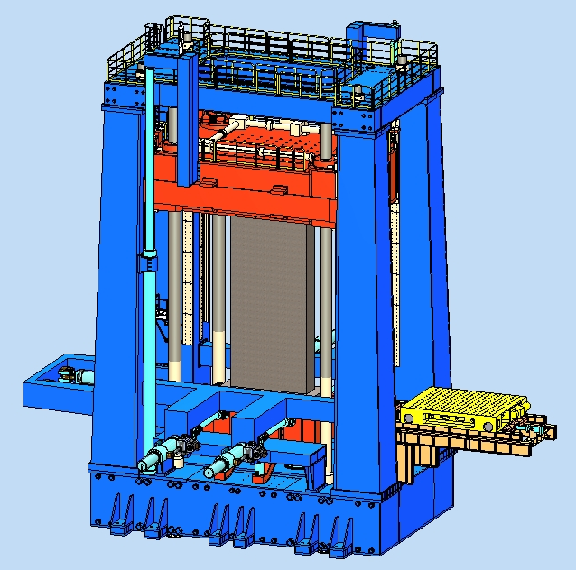
图2.3 中国建筑80MN多功能试验机—大型剪力墙实验示意图
Picture 2.2 80MN multi function test rig-shear wall test
2.2.6 梁柱节点实验。要求柱端部垂向加载能力不小于80MN，同时梁的四个端部垂向加载能力不小于±2MN。
beam column node test: at the bottom of the column the loading force shall not be less than 80MN, in the meantime, the end of the beam vertical loading force shall not be less than ±2MN.
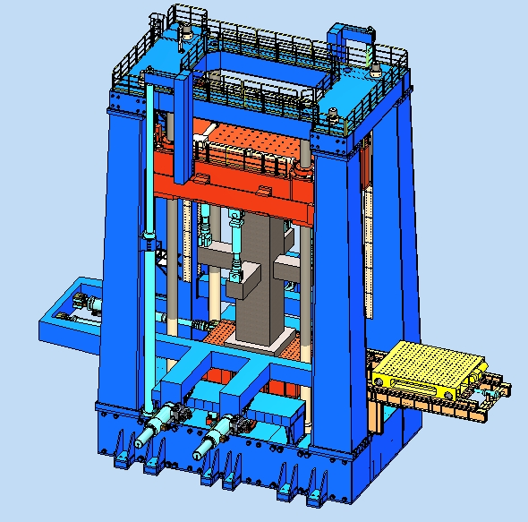
图2.4 中国建筑80MN多功能试验机—梁柱节点实验示意图
Picture 2.4 80MN multi function test rig-beam column node test
2.2.7 复杂节点实验。要求柱端部垂向加载能力不小于80MN，同时其他构件端部的轴向加载能力不小于±2MN。
complicated space node test: at the bottom of the beam the loading force shall not be less than 80MN, in the meantime, the end of other structure axle loading force shall not be less than ±2MN.
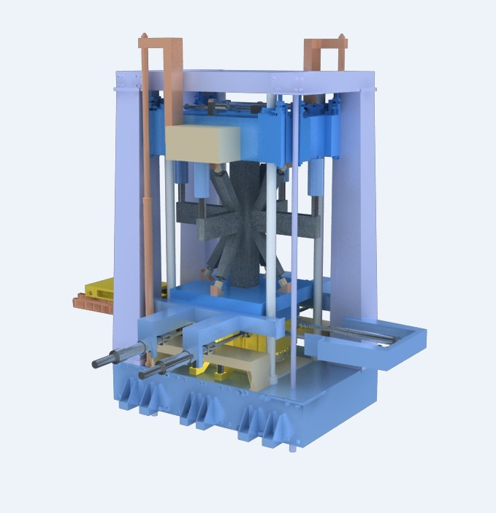
图2.5 中国建筑80MN多功试验机—复杂空间节点实验示意图
Picture 2.5 80MN multi function test rig-complicated space node test

2.3 试件示意图 specimen illustration
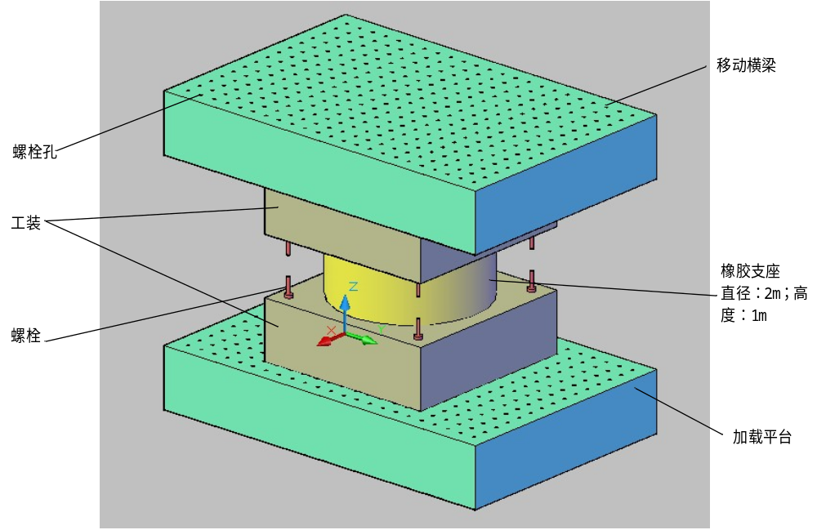
图2.6橡胶支座试件示意图
Picture 2.6 elastomer supporter
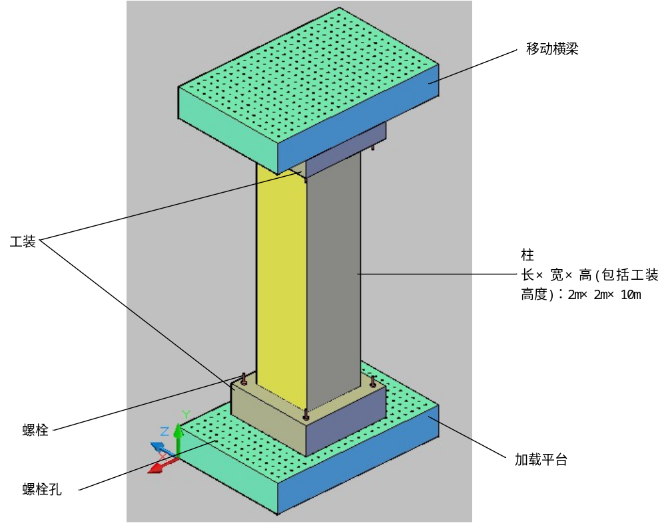
图2.7巨柱试件示意图
Picture 2.7 giant column
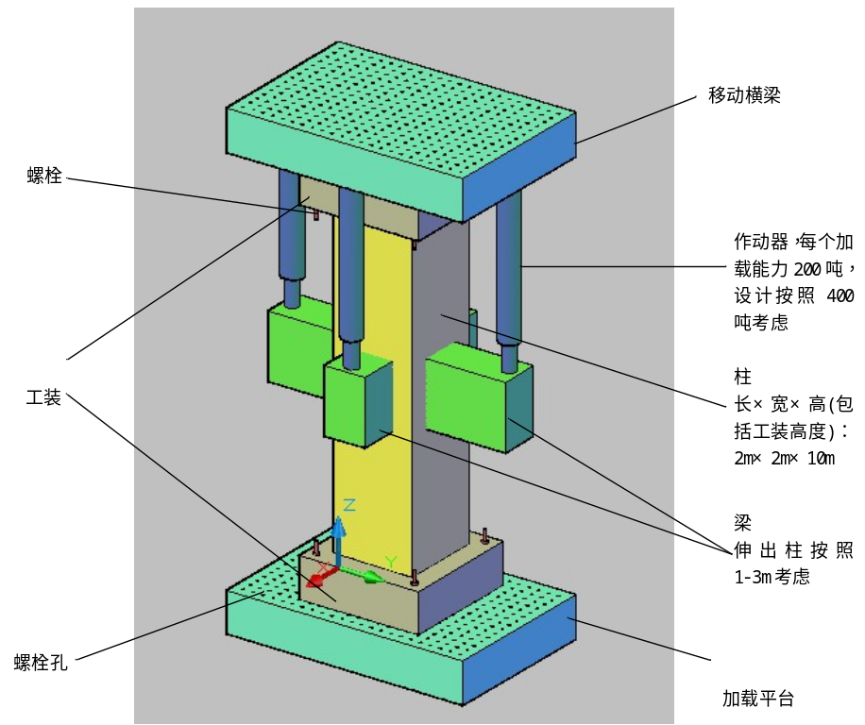
图2.8空间十字节点试件示意图
Picture 2.8 space cross node
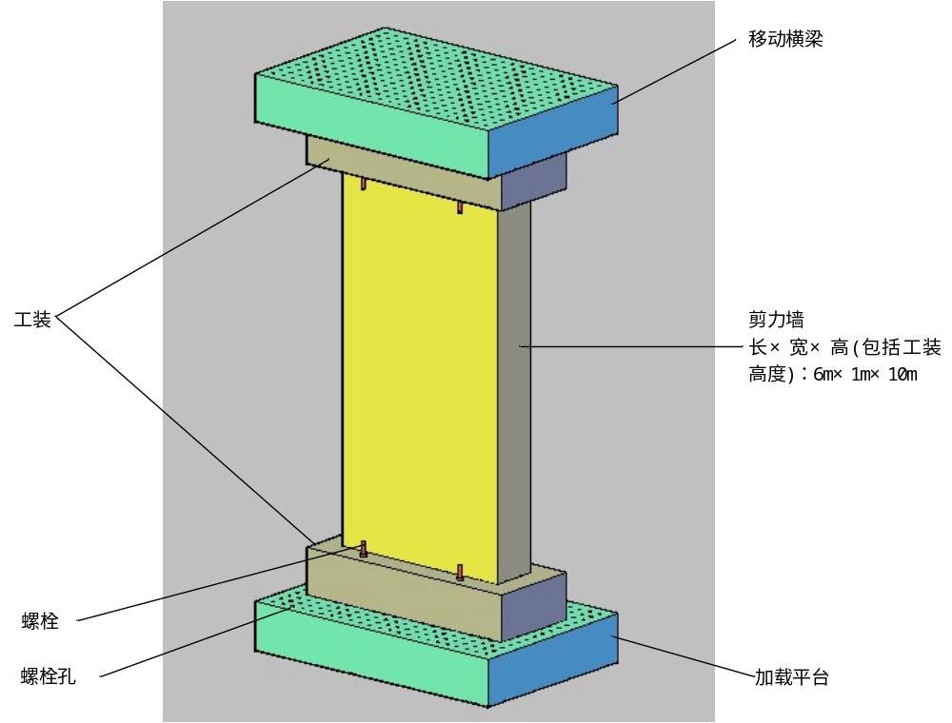
图2.9剪力墙试件示意图
Picture 2.9 shear wall

3. 80MN多功能试验机加载框架技术要求
80MN load frame requirement

3.1 基本要求 basic requirement
3.1.1 80MN多功能试验机加载框架与液压和控制系统一起，满足条款2 “80MN多功能试验机基本功能要求介绍”中的有关规定。80MN multi-function test rig load frame and the hydraulic and control system perform together, meeting clause 2 specification of 80MN multi-function test rig basic function requirement.
3.1.2 80MN多功能试验机加载框架主要包括：可移动横梁、横梁移动机构、加载平台、外框架立柱、外框架底座等（参图1.1、图3.1）。
The 80MN multi-function test rig load frame mainly includes moveable cross beam, cross beam drive structure, load platform, outer frame column, outer frame base.
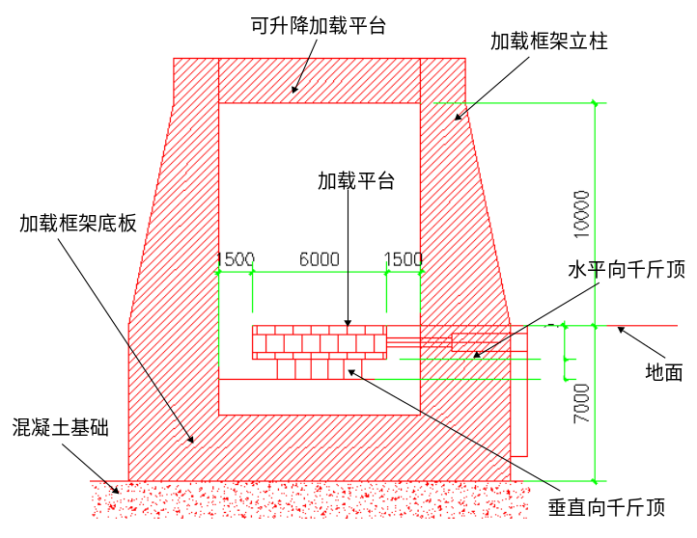
图3.1 中国建筑80MN多功能试验机—加载架尺寸示意图
Picture 3.1 80MN multi-function test rig-load frame
3.1.3 在方案设计时，可移动横梁、横梁移动机构、加载平台、外框架立柱、外框架底座等形成一个封闭的内力自平衡体系。
When design the solution, the movable cross beam, cross beam drive system, platform, outer frame column, outer frame base shall form a close internal force balance system.
3.1.4 加载框架的设计应考虑超载和试件突然发生脆性破坏时对整个加载架的冲击影响以及应对措施；加载框架的设计应保证超载10%以内或试件发生突然脆性破坏时，本系统不受损坏，尚能安全使用。
When design the load frame, the overload, specimen crisp break conditions shall be taken into consideration, the whole load frame impact influence shall be taken into consideration and have the count measures. The load frame design shall guarantee 10% overload or specimen sudden crisp break, the system won’t be damaged and still safe to be used.
3.1.5加载架设计时应考虑对周围环境的影响，特别是动态试验时对周围建筑和设备的影响，避免共振或振动过大对周围建筑、设备和工作人员造成伤害；假若投标方认为需要采取隔震减震措施，需提供详细分析方案和设计图纸以及报价。
The load frame design shall take the influence to surroundings into consideration, especially for the dynamic test. Avoiding the resonance and vibraiton damages to the building, equipment and persons. If the bider think there shall be vibration isolation measures, detailed solutions and design drawings shall be delivered with quotation.
3.1.6加载框架的设计应考虑基础不均匀沉降的调平方案：由于基础不均匀沉降可能会造成整个80MN多功能试验机的倾斜，80MN多功能试验机加载框架的投标方应该给出其调平方案或应对措施。
The laod frame shall take the base uneven settlement adjustment solution, because the uneven setttlement of the baes may cause the 80MN muti-function test rig tilt. The bidder shall deliver the leveling solution and measures.
3.1.7加载架设计时应考虑与地基基础的连接方式并提出详细的设计方案与图纸。
When design the load frame, the reaction base connection shall be considered and come up with detailed solution and drawings.
3.1.8投标方应当根据规定要求的动态性能进行计算分析。在计算加载平台的动态性能时，加载平台自重由投标方根据设计方案自行确定；动态试验时橡胶支座试件最大重量按照30吨计算；静态结构试验时试件最大重量按照200吨计算。
The bidder shall calculate and analyze according to the dynamic performance. When calculating the dynamic performance, the weight of the platform shall be decided by the bidder according to its design. The max weight of the dynamic test specimen is about 30 ton, the static structure specimen max weight is 200ton

3.1.9在进行橡胶支座和结构构件的试验时，运送试件的小车移出，橡胶支座和结构构件直接固定在加载平台上。但是投标方应该给出实验结束后，测试后的橡胶支座和结构构件移出实验设备的详细方案。
During the structure test of elastomer supporter test, the trolley trasporting specimen move out, the elastomer supporter and structure mounted on the platform directly. But bidder shall deliver the elasotomer supporter and structure components move out methods after the test.
3.1.10 结构试验大厅设有两台50吨吊车可以使用。对于重200吨的试件，需要在试验大厅现场制作。投标方需要给出同时制作两个重量200吨、尺寸分别为4米*4米*10米（高）试件的方案，包括：试件制作的平面位置、试件运送到试验机进行实验的方案、试件进行完测试后移出试验机的方案等等。
There are two 50 ton crane in the test hall. For the 200 ton specimen, it shall be made in the hall. The bidder shall provide solution of made two 200 ton specimen, the dimensions are 4 mX4mX10m, including specimen manufacture plane position, specimen transport to the test rig solution, moving the specimen out of the test rig solution after test.
3.1.11 运送试件的小车、小车轨道、试件装卸机构等也属于分项2应该承担的内容。
Specimen transportation trolley, rail, loading and unloading mechanism shall be delivered in item 2.
3.1.12 投标书必须有解决方案的详细计算书和图纸。
Detailed calcualtion and drawing must be provided in the bidding document.
3.1.13 结构试验大厅预留25米*25米*9米（深）基坑，坑下为桩基，坑底承载力为45吨/m²，具体位置参“附图1：总平面图”、“附图2：结构实验大厅地下室布置图”和“附图3：结构实验大厅一层布置图”。
The pit reserved in the test hall dimensions are 25mX25mX9m pit. Under the pit it is pilling, the base of the pit bearing capacity is 45 ton/ m^{2,} for the detailed position, refer to attachment 1 overall plane drawing, attachment 2, structure test hall basement layout drawing, attachment 3 structure test hall first floor layout drawing.

3.2 刚度控制指标 controlled parameters of stiffness
3.2.1 加载框架设计时应充分利用整个加载框架体系的强度和刚度。在满足条款2的每种实验工况下，其刚度要求为：移动横梁处外框架柱的水平向最大位移不大于加载时试件总高度的1/2000，移动横梁的垂向最大位移不大于加载时试件总高度的1/2000。
When design the load frame, the stiffness and strength of th whole load frame shall be considered. While meeting the test conditions in clause 2, the stiffness requriement are as follows, at the movable cross beam, the outer frame horizontal displacment shall not be more than 1/2000 loading specimen total height. Moving beam vertical max displacement shall not be more than 1/2000 loading specimen total height.
3.2.2 在满足条款2的每种实验工况下，底部加载平台的变形和外加载架底座的变形控制指标由投标方自己决定，必须在投标书中说明。但是两者的平面外变形需同时满足不大于其跨度1/2000的要求。
While meeting the requirement in clasue 2， the deforamation of the load frame base and outer load frame base etc controlled parameters shall be decided by the bidder, which must be explained in the bidding materail. But the deformation out of the plan shall not be more than the 1/2000 of span.

3.3 加载空间 loading clearance
加载空间净尺寸为：9米*5米*10米（X向*Y向*Z向）。
The clearance of the load frame shall be ：9m*5m*10m（X*Y*Z）

3.4 可移动横梁 movable cross head
3.4.1 可移动横梁可以实现从0.5米–10米连续无级调节，与底部加载平台一起，形成一个可以实现从0.5米–10米连续无级调节的加载空间。
The move head shall be from 0.5m to 10m stepless adjustable, with the base of the load frame form a load space from 0.5m to 10m stepless adjustable.
3.4.2 可移动横梁与加载框架一起承担条款2中各种实验工况下所产生的内力，可移动横梁与外框架立柱之间必须有可靠的紧密连接。
The movable beam and the load fram will bear the internal force caused by various tests in clause 2, the movable beam and outer frame column connection must be raliable and tight.
3.4.3 可移动横梁预留螺栓孔，孔径Φ80mm，间距500mm，螺栓直径M72，间距500mm，设置方案由投标方根据计算确定。
There shall be bolt holes on the movable crosshead, the diameter is 80mmm distance is 500mm, the bolt diameter is M72, distance is 500, the design shall be calcuated and decided by the bidder.
3.4.4 可移动横梁由投标方设计，包括：可移动横梁结构、可移动横梁升降方式、可移动横梁与加载框架的连接方式等等。
The movable cross head shall designed by the bidder, including, structure of movable crosshead, movable crosshead lift and decrease mode, connection of movable crosshead and load frame.

3.5 横梁移动机构 crosshead drive system
控制可移动横梁实现从0.5米–10米连续无级调节的机构，方案由投标方自行设计。
The move head shall be from 0.5m to 10m stepless adjustable, the design shall be decided by the bidder.

3.6 加载平台基本要求 platform basic requirement
3.6.1 加载平台尺寸：6米*4米（X向*Y向），Z向厚度根据要求由投标方确定。
Platform dimensions 6mX4m(X *Y), the thickness of Z direction shall be decided by the bidder.
3.6.2 加载平台位置：加载平台顶标高与室内地面标高一致。
Platform position: the top of the work platform shall on the same level as the ground.
3.6.3 加载平台与垂向作动器关系：垂向作动器固定在加载平台上，与加载平台一起运动（参图3.2）。
The relationship between platform and vertical actuators: vertical actuators shall mounted on the platform, move together with the platform.
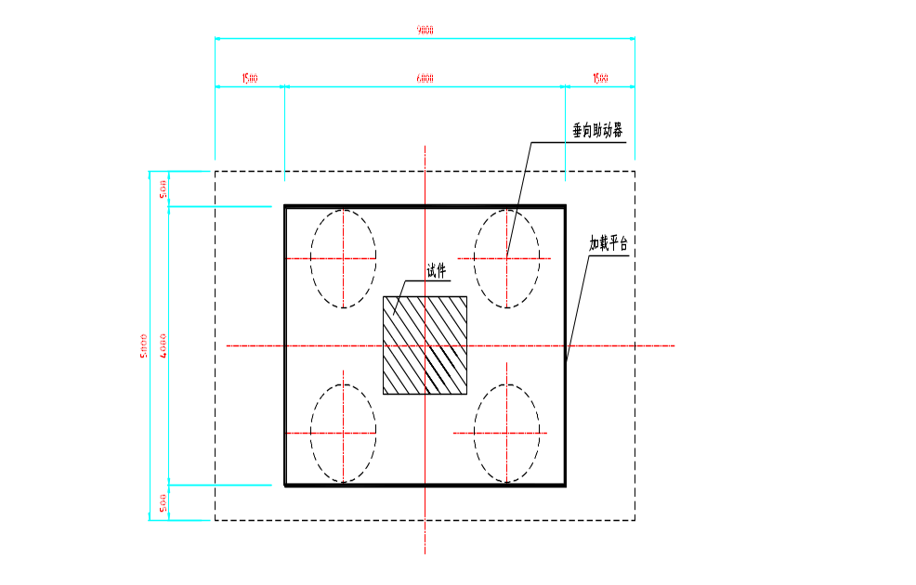
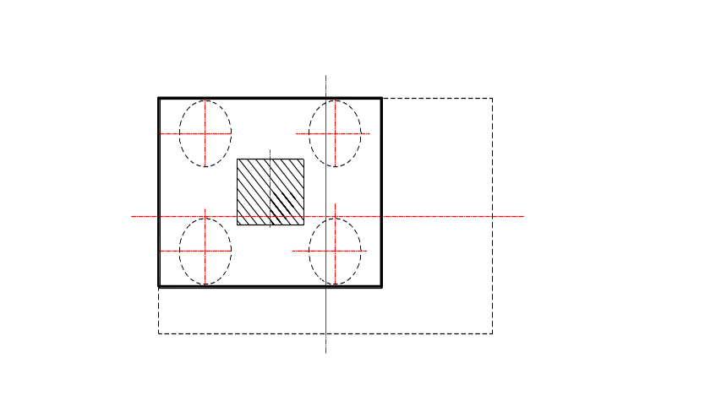
图3.2加载平台与垂向做动器关系示意图
Picture 3.2 the relationship between platform and vertical actuator
3.6.4 加载平台平面外刚度：在满足条款2的每种实验工况下，底部加载平台的刚度控制指标由投标方自己决定，必须在投标书中说明，但是平面外变形需同时满足不大于其跨度1/2000的要求。
Out of plane Stiffness of platform: under the condition of meeting various test conditions, the controlled parameters of platform base shall be decided by the bidder which must be explained in the bidding materail. But the deformation out of the plan shall not be more than the 1/2000 of its span.
3.6.5 加载平台平台力矩补偿：① 加载平台围绕X轴力矩补偿：在垂向力为3MN时，力矩补偿为3MN·M； ② 加载平台围绕Y轴力矩补偿：在垂向力为3MN时，力矩补偿为5.25MN·M。
Platform Moment Compensation (about X axis): 3 MN-Meters at 3 MN vertical axial force.
Platform Moment Compensation (about Y axis): 5.25 MN-Meters at 3 MN vertical axial force

3.6.6 试件在加载平台上的固定方式： ① 加载平台上布置螺栓孔，螺栓孔车牙，螺栓直径M48，螺纹深不小于3倍直径，孔洞间距250mm，孔轴线垂直度优于0.1%，设置方案由投标方根据计算确定。
Specimen mounting on the platform 1) bolt holes on the platform, the holes are threaded, bolt diameter is M48， the thread depth is not less than 3 times of diameter, holes distance is 250mm, the verticality of holes shall be better than 0.1%, it shall be designed by the bidder through calculation.
3.6.7 其他：miscellaneous
● 加载平台表面上，需设置尺寸标志，中心标志，以保证试件中心和系统中心一致，表面硬度满足现有试验机技术规范相应规定。
On the surface of the platform, there shall be dimension marks, center mark to guarantee the specimen center and system center comply. The hardness of the surfae shall meet current test rig technology specifications.
● 仅有竖向荷载作用时，施加荷载的中心与承载平台中心的偏差不大于5mm。
When there is only vertical load, the load center deviatation with the platform center shall not be more than 5mm.
● 平台承载面平整度：承载平台上表面平直度优于0.1%（1mm/m），粗糙度6.3。
The eveness of the the platform: the surface eveness shall be better 0.1%（1mm/m），coarsenes 6.3

3.7 加载平台运动方式 platform motion
3.7.1 基本要求：basic requirement
● 加载平台应能实现6个自由度的移动方式（X、Y、Z三轴线位移，绕X、Y、Z三轴的角位移），彼此独立，互不干扰。
The platform shall realize 6 DOF motion, (XYZ three axis displacement and aroud XYZ axis angle displacement , indepedant from each other without interference.
● 仅做单向（X轴或Y轴）水平线位移（主位移）加载时，非主位移水平向（Y轴或X轴）在平台中心处的线位移不应超过主位移1/500，或也不大于±0.1mm，竖向线位移（Z）不大于±0.05mm，平台绕三轴的转角不大于±0.00015rad。
For single direction motion ( X or Y axis) horizontal main displacement, the other axis, Y and X axis, the linear displacement about the center line shall not more than 1/500 of main displacement and not more than ±0.1mm,vertical linear displacmeent Z direction shall not be more than ±0.05mm, the angle around three axis shall not be more than ±0.00015rad
● 仅作竖向（Z轴）线位移加载时，平台中心位置的水平双向线位移均不大于1/300，或0.1mm，平台绕三轴的转角均不大于±0.0003rad。
When only Z axis is linear displacement loading. The horizontal two direction linear displacement shall not be more than 1/300, or 0.1mm, the platform around 3 axis rotation angle shall not be more than ±0.0003rad

3.7.2 加载平台水平向（X方向）运动要求： X direction motion of platform
● X向承受的总的最大水平力：±6 MN静态力。
X direction total horizontal force : ±6 MN static force
● X向最大行程：±1500mm。
X direction max displacement: ±1500mm
● X向移动速度：静态到最大75mm/s。
X direction motion speed: static to 75mm/s max
● X向移动频率：主要是静态。
X displacement frequency: mainly static

3.7.3 加载平台水平向（Y方向） 运动要求：Y direction motion of platform
● Y向承受的总的最大水平力：±6MN静态力，±4MN动态力。
Y direction total horizontal force : ±6 MN static force, ±4MN dynamic force
● Y向最大移动距离：±500mm。
Y direction max displacement: ±500mm
● Y向移动速度：动态时最大可以达到1500mm/s。
Y direction motion speed: up to 1500mm/s
● Y向移动频率：0到0.5Hz。最大动态性能的动态循环是以0.5Hz和± 0.5米行程运行6个满循环，并且包括开始1/2个循环，结束1/2个循环以完成平稳过渡（总共7个循环）。
Y direction motion frequency: 0 to 0.5Hz。 max dynamic performance is 0.5Hz, ± 0.5 stroke, 6 full cycle, include start 1/2 cycle, end 1/2 cycle to transmit smoothly, total 7 cycles

3.7.4 加载平台垂向（Z方向）运动要求：Z direction motion of platform
● Z向承受的总的最大垂向力：静态垂向力不小于80MN；垂向做动器的设置应同时满足条款2中各种实验工况的要求。
The total vertical force of Z direction: static vertical force not less than 80MN, the configuration of the vertical actautor meet the work condition of clause 2
● Z向最大行程：不小于250mm。
Stroke of Z: not less than 250mm
● Z向移动速度：垂向作动器伺服阀应当能运行0.5Hz的Y轴纵向循环的试验，同时补偿6-7mm垂向轴承变形量，此时的垂向力40MN，Y轴行程为± 0.5米。
Z direction speed: The vertical Actuator servovalves must be sized to permit 0.5 hertz cyclic testing in the Y Longitudinal axis while compensating for 6-7 mm vertical bearing deflection under 40 MN vertical force at +/- 0.5 meter stroke in the Y axis.
● 摩擦系数：作动器的设计和安装布置必须满足低摩擦水平下的多轴同时测试，滑动轴承的摩擦系数小于0.25%。
Friction co-efficiency: the actuator design and installation must meet the low friction multi axis test, the friction co-efficiency shall be less than 0.25%
3.7.5 加载平台转动（包括扭转）：加载平台在水平双向（X向和Y向）位移为±0.1米时，同时具有绕水平轴（X、Y轴）转动角度为±5°，绕垂直轴（Z轴）扭转角度为±10°的能力。
The rotation of work platform( including twist) when the work platform move on both horizontal direction( X and Y direction) displacement is 0.1m, in the meantime rotation angle around horizontal axis ( X and Y axis) rotation angle ±5°, around Z axis twist angle capacity is ±10°

3.8 外框架立柱 column of outer frame
3.8.1 外框架立柱与可移动横梁、外框架底座等一起，共同承担条款2中描述的各种实验工况。
Column of outer frame and movable crosshead, outer frame base carried out various test condition in clause 2.
3.8.2 投标方在进行方案设计时，应考虑可移动横梁与外框架立柱之间可靠的紧密连接，严格避免实验过程中可移动横梁与外框架立柱之间由于存在缝隙而产生冲击。
During the design, the reliable connection between movable beam and outer frame shall be considered, avoiding the seam and impact during test between movable crosshead and outer frame column.

3.9 外框架底座 base of outer frame
3.9.1 外框架底座与外框架立柱、可移动横梁等一起，共同承担条款2中描述的各种实验工况。
The outer frame base and outer frame column, movable beam carry out various test condition in clause 2.
3.9.2 外框架底座直接承受加载平台向下传递的垂向力，其强度和刚度要求由投标方自行确定，必须在投标书中说明，但是平面外变形需同时满足不大于其跨度1/2000的要求。
The base of the outer frame bear the vertical force form platform directly. Its strength and stiffness requirement shall be decided by the bidder and must be explained in the bidding materail. But the deformation out of the plan shall not be more than the 1/2000 of its span
3.9.3 外框架底座表面与垂向作动器地面之间的摩擦系数小于0.25%，其解决方案由投标方自行设计，必须在投标书中详细说明（参考：底座与主作动器接触面的平整度控制指标为：每0.25平方米范围内的平整度为0.03mm，整个表面的平整度为0.8mm，表面粗糙度0.4~0.8Ra）。
The friction co-efficiency between the outer frame base and vertical actuator shall be less than 0.25% the solution shall be decided by the bidder and must be explained in the bidding materail.( note: the eveness controlled parameter between base and main actuator shall be eveness 0.03mm with in 0.25 square meters, eveness is 0.8 for the whole surface, the coarsness of the surface is 0.4~0.8Ra.
3.9.4 安全防护（防尘措施）：由于垂向作动器随着加载平台一起在外框架底座上滑动，试件破坏时的碎片、灰尘、落物等会对外框架底座表面造成破坏，投标方应提出预防措施和详细的解决方案。
Safety protection ( anti dust): because the vertical actuator is sliding on the base of the outer frame with platfrom, the debris, dust, falling matrails of specimen break may damage the surface of the base of the outer frame, the bidder shall come up with protection measures and detailed solutions.

3.10 复杂节点实验要求 complicated node test requirement
80MN多功能试验机加载框架的设计应考虑空间梁柱节点（参图2.5）和复杂空间节点（参图2.6）的拉压实验，其具体方案由投标方设计。
The design of Load frame of 80MN multi-function test rig shall take consideration of the space beam and column node and complicated space node ( refer to picture 2.6) tension and compression test, the detailed solution shall be delievered by the bidder.

3.11 其他 miscellaneous
3.11.1 其他未尽事宜请参照条款1中的说明。 Any issue has not been specified, please refer to clause 1.
3.11.2 招标文件技术要求中未列明内容，但为系统正常运行所需要的，为投标方应该承担的责任，应当包含在投标文件及价格中。
Any issue not be specified in the bidding requirement but is necessary for the system normal operation shall be the bidder responsibility and shall be included in the bidding materials and quotation.

4. 80MN多功能试验机液压和控制系统技术要求
80MN hydraulic and control system technology requirement

4.1基本要求 basic requirement
4.1.1 80MN多功能试验机液压和控制系统与加载框架一起，满足条款2 “80MN多功能试验机基本功能要求介绍”中的有关规定。80MN multi-function test rig hydraulic and control system and the load frame perform together, meeting clause 2 specification of 80MN multi-function test rig basic function requirement.
4.1.2 80MN多功能试验机液压和控制系统包括液压作动器、油源、液压蓄能器、分油器和数字伺服控制器及软件等（参图1.2、图1.3）。80MN multi-function test rig hydraulic and control system includes hydraulic actuator/power/distribution and control system
4.1.3 液压作动器、油源、液压蓄能器、分油器和数字伺服控制器及软件等系统必须能够满足橡胶支座测试和结构构件测试的双模式运行要求，而不用重新配置加载框架或者作动器。The hydraulic actuator, hydraulic power, hydraulic distribution and digital control system must be capable of satisfying both modes of operation (Bearing Testing System and Multi-Axis Structural Loading System) without reconfiguring the Load Frame or Actuators.
4.1.4 投标方不论是同时选择分项1和分项2独立进行竞标，还是选择与其他合作公司联合进行竞标，都需要在报价书中清楚显示出作动器的布置、期望的运动范围、和外加载框架部件及加载平台之间的关系。投标方应当确保作动器的配置在满足条款2中规定的各种实验工况情况下，不会与外加载框架部件发生冲突。同时提供3D设计模型来进行验证。
No matter the bidder is bidding on item one or item 2 or joint bid with other partner. The supplier shall determine a viable kinematic configuration of the proposed actuators to provide the desired range of motion in all degrees of freedom without actuator interference to the Loading Frame components or other Actuators. The bidder shall guarantee the actuator configuration meet the clause 2 specified work conditions and won’t interfere with outer frame components and provide 3D design models to verify
4.1.5 投标方应当根据规定要求的动态性能进行计算分析。在计算加载平台的动态性能时，加载平台自重由投标方根据设计方案自行确定；动态试验时橡胶支座试件最大重量按照30吨计算；静态结构试验时试件最大重量按照200吨计算。
The bidder shall calculate and analyze according the dynamic performance. When calculating the dynamic performance, the weight of the platform shall be decided by the bidder according to its design. The max weight of the dynamic test specimen is about 30 ton, the static structure specimen max weight is 200ton
4.1.6 试验系统力值精度等级：I级；投标方应该给出设备的标定（测量）方式，以便证明提供的方案满足招标文件中的规定要求。
The force accuracy in the test system is I class. The bidder shall provide the system calibration methods to prove the solution meet the bidding requirements.
4.1.7 控制方式：各通道单独和多通道组合的力、位移闭环控制，并能实现实时切换，提供便于用户编程的外环控制功能。
Control mode: each channel can be signle or combined force, displace close loop control and real time switch, providing the use program and outer loop control fucntion.
4.1.8 操作方式：手动操作和计算机控制。
Control mode: manual control or computer control.
4.1.9 液压和控制系统的设计应考虑超载和试件突然发生脆性破坏时对整个系统的冲击影响以及应对措施，保证超载10%以内或试件发生突然脆性破坏时，本系统不受损坏，尚能安全使用。
The hydraulic and control system design shall take the overload and specimen crisp break condition impact to the whole system into consideration and figure out the management measures, guaranteeing 10% overlaod or specimen sundden crisp break, the system won’t be damaged and be used safely.
4.1.10 80MN多功能试验机在结构试验大厅中的位置以及油源室的布置请参“附图2：结构实验大厅地下室布置图”。
80MN test rig locatin and HPU room see the attachment 2. Basement of structure test labe
4.1.11 投标书必须有详细的油源、液压蓄能器、作动器等方案的计算书和图纸。
The shall be detailed HPU, accumulator, actutor solution and calcutlation and draiwng in the bidding materail.
4.1.12 系统设计时，用电容量按照2000KVA考虑。
The power capacity of 2000KVA shall be take into consideration

4.2 加载平台作动器配置要求 platform actuator configuration
4.2.1 基本条件：加载平台尺寸6米*4米（X向*Y向），Z向厚度根据要求由投标方确定。在计算加载平台的动态性能时，加载平台自重由投标方根据设计方案自行确定；动态试验时橡胶支座试件最大重量按照30吨计算。静态结构试验时试件最大重量按照200吨计算。
Basic condition: the platform dimension is 6Mx4M (X direction XY direction) Z direction is the thickness and shall be decided by the bidder. When calcualting the dynamic performance, the weight of the platform shall be decided by the bidder. the dynamic test specimen is about 30 ton, the static structure specimen max weight is 200ton
4.2.2 加载平台运动的基本要求： platform motion basic requirement
● 加载平台应能实现6个自由度的移动方式（X、Y、Z三轴线位移，绕X、Y、Z三轴的角位移），彼此独立，互不干扰。
The platform can realize 6 DOF motion( XYZ linear motion, around XYZ, three angle displacement, indepedant and without interfereance.
● 仅做单向（X轴或Y轴）水平线位移（主位移）加载时，非主位移水平向（Y轴或X轴）在平台中心处的线位移不应超过主位移1/500，或也不大于±0.1mm，竖向线位移（Z）不大于±0.05mm，平台绕三轴的转角不大于±0.00015rad。
For single direction motion ( X or Y axis) horizontal main displacement, the other axis, Y and X axis, the linear displacement about the center line shall not more than 1/500 main displacement and not more than ±0.1mm,vertical linear displacmeent Z direction shall not be more than ±0.05mm, the angle around three axis shall not be more than ±0.00015rad
● 仅作竖向（Z轴）线位移加载时，平台中心位置的水平双向线位移均不大于1/300，或0.1mm，平台绕三轴的转角均不大于±0.0003rad。
When only Z axis is linear displacement loading. The horizontal two direction linear displacement shall not be more than 1/300, or 0.1mm, the platform around 3 axis rotation angle shall not be more than ±0.0003rad
4.2.3 加载平台水平向（X方向）作动器配置要求：
Work platform X direction actautor configuration
● X向承受的总的最大水平力：±6 MN静态力。
X direction total horizontal force : ±6 MN static force
● X向最大行程：±1500mm。
X direction max displacement: ±1500mm
● X向移动速度：静态到最大75mm/s。
X direction motion speed: static to 75mm/s max
● X向移动频率：主要是静态。
X displacement frequency: mainly static
● X向作动器数量：≥2套（单边布置）。
X direction actuator quantity ≥2 sets ( one side configuration)
● X向作动器要求：静压轴承作动器。
X direction actuator requirement: hydrostatic bearing actuator
● 水平测力传感器：精度优于0.1%FS。
Horizontal force transducer: accuracy better than 0.1%FS
● 内置位移传感器：量程不小于±1500mm，分辨率优于5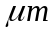，精度优于0.1%FS。
Internal displacement transducer: range not less than ±1500mm, resolution better than 5, accuracy better than 0.1%FS
● 伺服阀：MOOG阀，流量与作动器运行速度匹配。
Servovalve: moog valve, flow match actuator speed
● 作动器两端球铰型式：万向转动，转角不小于±10°。
Swivel type on both sides of actuator : universal, rotation angle not less than ±10°
4.2.4 加载平台水平向（Y方向） 作动器配置要求：
Platform Y direction actuator configuration requirement
● Y向承受的总的最大水平力：±6MN静态力，±4MN动态力。
Y direction total horizontal force : ±6 MN static force, ±4MN dynamic force
● Y向最大移动距离：±500mm。
X direction max displacement: ±500mm
● Y向移动速度：动态时最大可以达到1500mm/s。
X direction motion speed: up to 1500mm/s
● Y向移动频率：0到0.5Hz。最大动态性能的动态循环是以0.5Hz和± 0.5米行程运行6个满循环，并且包括开始1/2个循环，结束1/2个循环以完成平稳过渡（总共7个循环）。
Y direction motion frequency: 0 to 0.5Hz。 max dynamic performance is 0.5Hz, ± 0.5 stroke, 6 full cycle, include start 1/2 cycle, end 1/2 cycle to transmit smoothly, total 7 cycles
● Y向作动器数量：≥4套（双边布置）。
Y direction actuator quantity ≥ sets ( both sides configuration)
● Y向作动器要求：静压轴承作动器。
Y direction actuator requirement: hydrostatic bearing actuator
● 水平测力传感器：精度优于0.1%FS。
Horizontal force transducer: accuracy better than 0.1%FS
● 内置位移传感器：量程不小于±500mm，分辨率优于5，精度优于0.1%FS。
Internal displacement transducer: range not less than ±500mm, resolution better than 5, accuracy better than 0.1%FS
● 伺服阀：MOOG阀，流量与作动器运行速度匹配。
Servovalve: moog valve, flow match actuator speed
● 作动器两端球铰型式：万向转动，转角不小于±10°。
Swivel type on both sides of actuator : universal, rotation angle not less than ±10°
4.2.5 加载平台垂向（Z方向）作动器配置要求：
Platform Z direction actuator configuration requirement
● Z向承受的总的最大垂向力：静态垂向力不小于80MN；垂向做动器的设置应同时满足条款2中各种实验工况的要求。
The total vertical force of Z direction: static vertical force not less than 80MN, the configuration of the vertical actautor meet the work condition of clause 2
● Z向最大行程：不小于250mm。
Stroke of Z: not less than 250mm
● Z向移动速度：垂向作动器伺服阀应当能运行0.5Hz的Y轴纵向循环的试验，同时补偿6-7mm垂向轴承变形量，此时的垂向力40MN，Y轴行程为± 0.5米。
Z direction speed: The vertical Actuator servovalves must be sized to permit 0.5 hertz cyclic testing in the Y Longitudinal axis while compensating for 6-7 mm vertical bearing deflection under 40 MN vertical force at +/- 0.5 meter stroke in the Y axis.
● Z向作动器数量：≥4套。
Z direction actuator quantity: ≥4 sets
● Z向作动器要求：Z向作动器固定在加载平台上，可以随加载平台一起运动；Z向作动器的设计和安装布置必须满足低摩擦水平下的多轴同时测试，Z向作动器下表面与加载平台下部外加载框架底座之间滑动轴承的摩擦系数小于0.25%。
Z direction actuator requirement: Z direction actautor is mounted on the platform, and move with the platform, Z direction Actuator design and mounting configuration must allow Multi-Axis testing simultaneously at low friction levels where the friction coefficient on the sliding bearings must be less than 0.25%
● 作动器端部球铰（万向）：可转动角度不小于±5°。
Swivel at the end of the atuator: roation angle not less than ±5°
● 总刚度：不小于100000kN/mm。
Total stiffness: not less than 100000kN/mm
● 测力传感器：应具有两种满量程传感器，15000kN/作动器数量与60000kN/作动器数量，精度优于0.1%FS。
Measurement transducer: two types of full scale transducer, 15000kN/actuators qty and 60000KN/actuator qty. accuracy better than 0.1%FS
● 位移传感器：量程不小于300mm，分辨率优于5，精度优于0.1%FS。
Displacement Transducer: range not less than 300mm, resolution better than 5, accuracy better than 0.1%FS
● 伺服阀：MOOG，流量与作动器运行速度匹配。
Servovalve: moog valve, flow match actuator speed
4.2.6 加载平台转动（包括扭转）：加载平台在水平双向（X向和Y向）位移为±0.1米时，同时具有绕水平轴（X、Y轴）转动角度为±5°，绕垂直轴（Z轴）扭转角度为±10°的能力。
The rotation of work platform( including twist) when the work platform move on both horizontal direction( X and Y direction) displacement is 0.1m, in the meantime rotation angle around horizontal axis ( X and Y axis) rotation angle ±5°, around Z axis twis angle capacity is ±10°
4.2.7 加载平台平台力矩补偿： work platform moment compensation
● 加载平台围绕X轴力矩补偿：在垂向力为3MN时，力矩补偿为3MN·M。
Platform Moment Compensation (about X axis): 3 MN-Meters at 3 MN vertical axial force.

● 加载平台围绕Y轴力矩补偿：在垂向力为3MN时，力矩补偿为5.25MN·M。
Platform Moment Compensation (about Y axis): 5.25 MN-Meters at 3 MN vertical axial force
4.2.8 Hold Down作动器配置要求：为了避免试件突然断裂等极端情况，投标方根据需要可以考虑设置Hold Down作动器，具体方案由投标方设计。
Hold down actuator configuration requirement: to avoid the specimen sudd break extrem condition, the bidder shall take the configuration of hold down actautor into consideration, the detailed solution shall be delivered by the bidder.

4.3 空间梁柱节点附加设备 space beam and pillar node accessory equipment
系统应能够进行复杂空间节点的多向加载，比如说加载平台的六自由度运动加上梁端4个独立作动器施加载荷。伺服控制的硬件和软件应当包含在报价中，但四个另外的作动器应当在选项中单独报价。这些作动器的力的额定值是2.0 MN，行程为600mm，包括位移传感器、力传感器、球铰头和球铰座。
The system shall be able to do the complicated space node multi direction loading, such as the 6 DOF motion of the platform with 4 independent actautor on the end of the beam to load. Servo control hardware and software shall be included into the quotation, but 4 indepedant actuators shall be quoted separately. The rated force of these actuators are 2.0 MN, stroke is 600mm, including displacement transducer, force transducer, swivel head and base.

4.4 数字控制系统 digital control system
控制系统包括数字控制系统、个人电脑和控制软件。
Control system include digital control system , PC and control software.
4.4.1 数字控制系统的基本要求：the basic requirement of the digital control system
● 控制精度：力控制精度优于0.1%FS，位移控制精度优于0.1%FS 和0.10mm。
Control accuracy: force control accuracy is better than 0.1%FS, displacement control acccuracy is better than 0.1%FS and 0.10mm。
● 控制器通道数：不小于作动器数量，且应留4个以上的备用作动器控制通道。
Control channels: not less than the quantity of the actuators and reserve more than 4 for spare actuators control channel.
● 控制方式：各通道单独和多通道组合的力、位移、闭环控制方式，并具备实时力—位移切换功能。
Control mode: each channel can do the independent and combined multi channel force, displacement close loop control, with the real time force displacement switch function.
● 设备操作方式：手动和计算机控制。
System operation mode: manual and computer control
● 信噪比：90db。
Signal and noise ration: 90db
● 实时采集和显示各通道或多通道组合数据，力（kN）、位移（mm）、转角（rad），分辨率分别为1kN，0.001mm，0.0001rad，并具有同步触发外设采集系统启动信号。配置8个备用采集通道，采样频率5kHz。
Real time data collect and display each channel or multi channel combined data, including force, displacement, rotaion angle, resolutions are 1kN，0.001mm，0.0001rad, with the sychronized trigger peripheral dat collection start signal and 8 spare colllection channel, the sampling rate is 5KHz。
● 信号发生器：具有方波、斜波能力、正弦以及随机波发生能力。
Signal generator: rectangle, ramp, sine and radom signal generation
● 报警功能：力、位移、转角超限报警，以及其他非正常报警，严重超限自动安全停机。
Alarm function: force, displacement, rotation angle over limit alarm and other abnormal alarm, if there is sever over limit, the system shall stop automatically.
● 油源控制功能：泵组开/停，高低压切换，油源非正常报警。
HPU control function : HPU group start and stop, high low pressure switch, HPU abnormal alarm.
● 计算机接口：设计算机高速数据传输控制接口。
Computer interface: there is computer high speed data transmit control interface.
4.4.2数字控制器的整体性能要求：液压伺服闭环控制由数字控制器完成，包括伺服环路控制、数据采集和函数发生系统。
Servo hydraulic closed loop control shall be provided by the use of the digital controller and shall include control of the servo-loop, data acquisition, and function generation systems.
● 所有硬件的调整和设置通过软件的设置来进行控制。All hardware adjustments and settings are to be controlled through software settings
● 控制系统的软件及应用软件应当运行在多任务的视窗操作系统中。The software that controls the system and all applications software shall run under a multitasking Windows operating system
● 系统软件应当提供定制的桌面，包括屏幕位置记忆、控制器设置的保存等。The system software shall provide a customized desktop that includes screen position memory and saved settings for the controllers.
● 传感器的信号调节模块应当能够容纳所有作动器上的任何传感器，这些调节器应当完全整合到控制系统中；传感器的量程、传感器的归零、传感器的激励和△K（Delta K）等都能够被计算机所控制；至少每个传感器应当有一个信号调节通道。Transducer signal conditioning modules shall be provided to accommodate all transducers with all actuators. These conditioners shall be fully integrated into the control system and have the capability for computer control of ranging, transducer zero, transducer excitation, and Delta K. At a minimum, one conditioner channel must be provided for each transducer supplied.
● 控制环路更新速率至少1KHz,可平稳生产波形和进行闭环回路控制。The control loop update rate shall be at a minimum of 1 kHz to allow for smooth waveform generation and closed loop control.
● 数字控制器应包含一个数字示波器，最少能够同时实时显示两个信号，信号应当能够以时间、频率或者相位(X-Y)域的形式显示。The digital controller shall incorporate a digital oscilloscope capable of displaying a minimum of two signals simultaneously in real time. Signals shall be able to be displayed for time, frequency or phase (X-Y) domains.
● 数字控制器应当包含用于显示信号电流值的数字仪表，可以显示其最大、最小量程和达到的波峰、波谷数值。The digital controller shall also include digital meters for displaying the current value of a signal, its maximum and minimum achieved values and its peak and valley achieved values.
● 数字控制器应当包括时间和日期状态标签日志来记录所有机器的运行情况、操作错误记录等，日志应当保存在硬盘上可随时查看。The digital controller shall also incorporate a time and date stamped status log to maintain all machine operations, limit detector trips, etc. The log shall be maintained on disk allowing review at any time.
● 应包括32通道的模拟输出，以便从任何传感器中读取以下信号：激励和传感器高水平输出，输出信号能够进行+/- 10伏单端输出。Thirtytwo (32) channels of analog output shall be available to read the following signals from any conditioner: excitation and high-level transducer output. Output signals shall be capable of +/- 10 volts single ended output.
- ● 最少包含16个高水平的模拟输入通道来连接外置传感器，这些模拟数字转换通道的分辨率应当是16位，采样频率（同时采样和保持）可达1KHz，这些输入应当允许 +/- 10伏的差分输入。A minimum of sixteen (16) high level analog inputs channels shall be available for connection to externally conditioned transducers. Resolution of these A/D channels shall be 16 bits and sampling rates (simultaneous sample and hold) of up to 1kHz shall be possible. These inputs shall allow +/- 10 volt differential inputs.

● 控制器应当能够指派操作和/或只用于检测，这些操作应当包括关闭、指示、终止程序和关闭液压等，这些操作应由用户通过系统软件设置。一旦设置，该操作可以保存和调用。The controllers shall have the capability to assign actions and/or for detection only. The actions shall include off, indicate, program abort and hydraulics off. These actions shall be set up by the user in the system software. Once set up, the actions can be saved and recalled.
4.4.3 在（X, Y, Z）线性自由度情况下，系统软件和硬件应能够实现力和位移控制模式的手动转换；控制模式的转换通过操作人员的干预来实现；能够实现任何载荷和位移的组合控制。旋转（翻滚、前倾、横摆）的自由度控制只能是位移控制。The system software and hardware shall be capable of manual mode switching between load and stroke control on the translational (X, Y, Z) degrees-of-freedom only. Control mode transitioning is accomplished by operator intervention. Any combination of load and stroke control is allowed. The rotational (Roll, Pitch, Yaw) degrees-of-freedom are in displacement control only.
4.4.4伺服阀控制器应当包含所有以下调节模块：作动器位移和载荷传感器的试验控制、伺服阀的控制、液压油源的控制和液压分油系统的控制和辅助的数据采集。The ServoController shall include conditioning modules for all actuator stroke and load transducers for test control, for controlling the servovalves and for controlling the hydraulic pumping and hydraulic oil distribution system and for auxiliary data acquisition.
⑴ 交流和直流调节器。AC DC conditioner
投标方应当采用最新的信号调节技术，倾向于采用交流和直流传感器都适用的通用调节器。调节器应当具有以下特性：The supplier shall utilize the latest technologies in signal conditioning with preference toward a Universal Conditioner that can be used for AC or DC transducers. Such conditioners shall have the following features:
● 为了调节所有的力和位移信号，每个作动器的力和位移通道需要设置一个通用调节器。For conditioning of all force and stroke signals, one Universal Conditioner shall be provided for each actuator channel for load and stroke where appropriate.
● 为了进行空间梁柱节点的静力试验，附加的四个作动器需要另外8个附加的调节器。调节器和软件应当包含在基本的系统中。8 additional conditioners shall be provided for four optionally quoted actuators for conducting static structural testing on “space node specimens”. The conditioner and software must be included with the base system.
● 每个调节器都应当能够侦测激励损失和进行极限侦测的计算机控制，以保证操作人员和系统的安全。Each conditioner shall have the capability to detect excitation loss and have computer control of limit detection for operator and system safety.
- ● 通用调节器可以提供从0到20V的直流激励电压。在10到500Hz内，激励信号的噪声应当峰到峰小于0.25 mv；调节信号噪声应当峰到峰小于1毫伏（0.1到10Hz范围内）和峰到峰小于10毫伏（10到500Hz范围内）,相对一个参考输出，两者的增益都是5000。The Universal Conditioners shall supply excitation voltages from 0 to 20V DC. The excitation signal noise shall be less than 0.25 mv peak to peak at frequencies from 10 to 500 Hz. Conditioned signal noise will be less than 1 millivolt peak to peak (0.1 to 10 Hz) and 10 millivolts peak to peak (10 to 500 Hz) both at gains of 5,000 relative to a reference output.

● 通用调节器应当包含一个16位的数模转换器用于传感器信号的零抑制。The Universal Conditioners shall include a 16-bit D/A converter for zero suppression of transducer signals.
● 为了达到高分辨率和精度，通用调节器应当加入增强的数学算法，更新采样，以达到24位的高分辨率。For higher resolution and accuracy, the Universal Conditioners shall incorporate an enhancement algorithm that up-samples to provide higher resolution capabilities up to 24 bits.
⑵ 伺服阀驱动模块。Servovalve drive module
伺服阀控制器应当包含系统所有作动器的及选项中的4个辅助作动器的伺服阀驱动模块。The ServoController shall include valve driver modules for all system actuators provided and for four (4) optional auxiliary actuators.
● 为了达到所需的动态性能，每个作动器都需要配置阀驱动器去支持此类型的伺服阀。For each actuator, the required valve drivers shall be provided to support the type of servovalve required for the dynamic performance level.
● 到伺服阀驱动器的数模输出的分辨率最小应是16位。The D/A output to the servovalve driver shall be a minimum 16 bit resolution.
● 颤振振幅和频率应当是计算机控制的，颤振频率应当可达500Hz，振幅峰到峰可达到5V。The dither amplitude and frequency shall be computer controlled. Dither frequency shall be up to 500 Hz and amplitudes up to 5 V peak to peak shall be possible.
● 为了保证精确的阀平衡，每个单独的伺服阀驱动器应当具有阀平衡计算机控制，阀平衡可达±满量程。To ensure accurate valve balance, each individual valve driver shall have the valve balance computer controlled. Valve balance up to ± full scale will be possible.
⑶ 液压控制模块。Hydraulic control module
伺服控制器应当包括所需的液压控制模块，安全地管理液压油的流动。投标方应当提供所需的液压电子界面来开关液压油源，管理本地液压分油器、蓄能系统等。伺服控制器应当包含互锁能力来安全地监控所有超限的测试条件，安全地关闭液压油源，将系统置于一个计划好的关闭状态。包括：The ServoController shall include the necessary hydraulic control modules to safely manage the flow of hydraulic oil. The Supplier shall include all of the required hydraulic interface electronics to turn hydraulic power supplies on/off and to control any local hydraulic service manifolds, accumulation systems, etc. as required by the supplier. The ServoController shall include interlock capabilities to safely monitor any out of tolerance test conditions to safely shut down the hydraulic power supplies and bring the system to a planned shut down state. This includes
● 油源的动力供应。Hydraulic Power Supplies
● 蓄能器逻辑操作。Hydraulic Accumulation Logic
● 分油器。Hydraulic Service Manifolds
● 液压电磁阀来将液压油导向恰当的试验室区域。Hydraulic Solenoid Valves to direct the flow of hydraulic oil to the appropriate laboratory areas.
⑷ 辅助数据采集要求。Auxiliary data acquistion requirement
伺服控制器应当包含另外40个通道的数据采集，以供用户使用。The ServoController shall include 40 additional channels of Data Acquisition for customer use.
● 信息应当整合到伺服控制器的作动器性能数据文件中，以相同时钟周期采样，以便有共同的数据文件信息。Information shall be integrated with the servocontroller actuator performance data files and sampled at the same clock ticks for common data file information
● 数据采集的模数转换器的分辨率应当最小是16位。The resolution of the data acquisition analog to digital converters shall be a minimum of 16-bit resolution
● 所有通道的数据采集速率应当最小是1KHz. The data acquisition rate shall be a minimum of 1 kHz on all channels.
4.4.5 投标方应当提供高性能台式电脑和至少24英寸的大型液晶屏幕，一台个人电脑用来运行数字控制系统。个人电脑应当是工业标准并且容易买到的，操作系统应当是Windows XP或者Windows 7，根据投标商的操作环境而定。所有的控制、波形发生、数据采集和分析软件应在此电脑中进行，应当界面友好、菜单驱动的程序格式。最低配置包括：The Supplier shall provide a high performance desktop Computer and large screen LCD monitor with a minimum size of 24 inches. A personal computer (PC) shall be provided to operate the Digital Control System. This PC shall consist of the industry standard and of the current family of processors available at the time near shipment of the system. The operating system shall be Windows XP or Windows 7 depending on the Suppliers operating environment. All control, wave form generation, data acquisition, and analysis software shall be performed with this computer using a user-friendly, menu-driven program format. A minimum configuration is as follows:
● Intel Core 2 Duo ES400 Processor or Higher （英特尔酷睿2双核ES400处理器或者更高）。
● 4 GB DDR Memory, Keyboard, Mouse （4 GB DDR内存，键盘、鼠标）。
● 100/100 TX PCI Ethernet Adapter（100/100 TX PCI以太网适配器）。
● 2 x 250 GB Hard Drive or better （2个250G硬盘或者更高）。
● 24-inch UltraSharp Flat Panel Monitor （24英寸平板显示器）。
● 16X DVD+RW+R drive with 48x CDROM （16XDVD+RW+R驱动，带48XCDROM）。
● Windows operating system with Microsoft Office （Windows操作系统，微软office软件）。
4.4.6 伺服控制器应当安装在空调柜中，应当有不间断电源用于电力备份，以便在断电时按照计划的控制顺序关闭系统。The ServoController shall be mounted in an air conditioned console and shall include an uninterrupted power supply for temporary electric power backup to allow a planned control sequence for system shutdown in the event of a power outage
4.4.7 从控制台到测试设备所有的系统电缆应当由投标方提供，买方估计电缆的长度为60-70米。在合同签订后确定最终的长度。All system cables from the control console to the test machine shall be provided by the Supplier. CSCEC estimates cable length to be approximately 60-70 meters. Final lengths to be confirmed after award of order.

4.5 控制软件要求 control software requirement
4.5.1 系统应当在Windows XP 或Windows 7下运行。The system shall operate in a Windows XP or Windows System 7 environment depending on the Suppliers offerings.
4.5.2系统软件和硬件应能够在载荷控制和位移控制之间进行动态的模式转换。The system software and hardware shall be capable of dynamic mode switching between load and stroke control.
4.5.3为了能进行复杂的结构静态试验，伺服阀控制器应包含“混合模式”的控制方式，允许独立的操作人员定义不同的轴向加载是载荷控制还是位移控制。比如一种试验情况是：垂向需设置为载荷控制，以模拟重力载荷；XY向需设置为独立的位移控制，以施加各种剪切力；而倾斜和扭转可以独立编程为力控制，可以模拟各类力矩和扭矩。To allow complicated static structural testing applications, the servocontroller shall include “Mixed Mode” control allowing independent operator defined axes of control in load or stroke for various axis. An example and required test state is to allow programming of the vertical axis in load control (to simulate gravity loading) while the X and Y axes can be programmed independently in stroke control to impose varying shear conditions and where the roll, pitch and yaw axis can be programmed independently in force to simulate various moment or torsional conditions.
4.5.4系统伺服控制软件应具有编程能力，可以模拟准静态荷载、往复周期荷载、地震时程曲线记录文件的读取等，以便用于橡胶支座等的实验。The system servocontrol software shall include the ability to program static, cyclic and time history earthquake record file playback for the elastomer supporter test applications.
4.5.5系统伺服控制软件应当包括控制另外4个通道的能力，可以与加载平台的其他作动器同时协调操作，生产复杂的力和运动，比如用于空间节点试验等。The system servocontrol software shall include the ability to control up to 4 additional channels that can be operated simultaneously with all of the table platform actuators to create various complex forces and motions on a test article such as a Space Node application.
4.5.6投标方应当提供高级混合模型实验软件，以便买方能通过实验研究大型单一结构构件，同时通过数值分析模拟整个复杂结构。这种先进的测试解决方案将能够全面提升买方进行全尺寸建筑物测试的能力。The Supplier should include advanced hybrid modeling software capabilities that allow model-in-the-loop quasi-static testing capabilities that would allow CSCEC to physically test large scale structural single element components at a machine testing level while modeling the full scale complex structure numerically. Such advanced testing solutions will fully leverage the testing capabilities at CSCEC as applied to full scale building.

4.6 液压油源和分油系统 HPU and hydraulic distribution system
4.6.1 液压油源：投标方应当根据需要的动态测试要求来计算对液压系统的需求。最大力/最大频率试验条件要求是：40MN垂向力，4MN纵向力，0.5Hz ，6个满循环，加上1/2个开始循环和1/2个停止循环，行程为+/- 0.5米。
The Supplier shall calculate the required hydraulic power to perform the dynamic testing requirements stated. “The maximum high force/high frequency test condition requires a 40 MN Vertical Force with 4 MN Longitudinal Force at 0.5 hertz for 6 full cycles plus ½ start cycle and ½ stop cycle at a stroke of +/- 0.5 meters
4.6.2投标方应当提出经济有效的液压油源和蓄能器组结合的方案，来达到要求的动态性能。橡胶支座的动态试验中规定：在40MN垂向力，4MN纵向力，以+/- 0.5米行程，0.5Hz的速度进行6个满循环，并且包括1/2个开始循环和1/2个停止循环，试件垂向变形量为6-7mm。这种实验工况对液压油源需求最大，液压油源和蓄能器应当按照此要求配置。The Supplier shall propose a cost effective solution utilizing hydraulic power supply units and hydraulic accumulator banks for supplemental hydraulic oil if required to achieve the stated dynamic performance. As stated in the Bearing Testing specification, the hydraulic power shall be sized to conduct a test under 40 MN vertical load with 4 MN longitudinal load at a stroke of +/- 0.5 meters and a frequency of 0.5 hertz for a total of 6 full cycles with a ½ start and ½ stop cycle with anticipation of 6-7 mm of specimen vertical deflection under full load. This condition is the maximum dynamic condition that the hydraulic power and distribution system should be sized around.
4.6.3投标方应当在报价中详细给出液压油源的配置方案，包括：液压油源的类型、数量、预计的总流量、总功率和水冷要求等。（注：买方提供的电力为380V、3相、50Hz；单相为240V、50Hz；所有的油源同时运行时最大功率不超过2000KVA。）The Supplier shall clearly define their planned approach in their offering defining the type of hydraulic supply units, the number of units, the anticipated total flow rates, including total power and water cooling requirements, etc. Note that CSCEC available electric power is: 380 volt, 3 phase, 50 hertz power and single phase 240 volts, 50 hertz. Maximum power is limited to 2,000 KVa for all pumps running simultaneously.
4.6.4投标方提供的液压油源系统应当是完整的，包括足够容量的油箱，以满足所有油泵的需求；同时也为蓄能器提供必需的流量，以满足峰值测试的要求。The hydraulic power supply system as furnished by the supplier shall be complete and shall include adequate hydraulic oil reservoir volume for the necessary pump demands as well as necessary volume for any accumulators provided for peak test conditions.
4.6.5液压油源系统还包括水冷换热器，超温互锁装置来确保液压流量的温度维持在38 – 52摄氏度区间，以取得最佳的液压油寿命。The hydraulic power supply system shall also include water cooled heat exchangers and over-temperature interlocks to maintain the hydraulic fluid temperatures at operating ranges of 38 – 52 degrees C for optimum fluid life.
4.6.6 液压油需采用美孚DTE 25，以易于维护和延长使用寿命。The hydraulic power supply units shall operate on Mobile DTE 25 hydraulic fluid for easy maintenance and long term performance.
4.6.7 液压油源基本要求：the basic requirement of the HPU
● 油泵类别及数量：恒压变量泵，压力与作动器匹配（考虑油管阻力），宜多台泵并联工作，可控分组开启。
HPU type and quantity: constant pressure variable flow pump, pressure matches with the actuators and the resistance of pipe shall be taken into consideration, it is prefered that multi-pump and work jointly, controllable gourp start.
● 油源控制功能：泵组开/停，高低压切换，油源非正常报警。
HPU control function: pump group start and stop, high low pressure switch, HPU abnormal alarm.
● 噪声：不大于90db。
Noise: not more than 90db

4.7 蓄能器 accumulator
4.7.1 蓄能器的设计按照如下实验工况（橡胶支座高速实验）：40MN垂向力，4MN纵向力，0.5Hz的速度进行6个满循环，并且包括1/2个开始循环和1/2个停止循环，+/- 0.5米行程。The Supplier is to determine the volume of accumulation required to satisfy a typical elastomer supporter test as described: “The maximum high force/high frequency test condition requires a 40 MN Vertical Force with 4 MN Longitudinal Force at 0.5 hertz for 6 full cycles plus ½ start cycle and ½ stop cycle at a stroke of +/- 0.5 meters.
4.7.2 由于电力限定在2000 KVA，所以需要大量的蓄能器来完成实验要求，投标方应该清楚介绍蓄能器的配置方案，包括：总的蓄能器用量、工作压力等，以便买方审查。It is known that a significant volume of accumulators will be required since the electric power is limited to 2,000 KVA. The Supplier should clearly state the total volume of accumulation that they will provide and the planned operating pressures for buyer review.
4.7.3 实验大厅有一个16米宽50米长的油源房，另外在试验机旁边有一个辅助房间，如需要可作为另外的蓄能器放置房间。 The facility includes a large hydraulic power supply room approximately 16 meters in width by 50 meters in length and an auxiliary room near the location of the testing system for additional accumulator storage if required.

4.8 液压分油系统要求 hydraulic distribution system requirement
4.8.1投标方应设计提供液压分油管道系统用来把液压油从油源室输送到各个作动器。买方希望把蓄能器组件尽量放置在距离试验机近的地方，以取得最佳的性能。投标方应在报价中提供配置方案。The Supplier shall determine and supply the hydraulic distribution piping system to supply hydraulic oil from the hydraulic power units to all actuators required for the high force bearing testing frame. CSCEC assumes that the accumulator banks will be located in as close of a proximity to the testing system for maximum performance. A proposed configuration solution shall be provided with the Supplier’s proposal.
4.8.2油源室在地下室，如买方给出的平面布置图所示。投标方设计并提供管路布置的最有效方式。 The location for the hydraulic power supply room will be at the basement level and will be as shown in buyer facility prints. The Supplier shall determine and shall supply the most efficient layout of piping required.
4.8.3投标方应根据“附件4：结构实验大厅地下室—预留洞、预埋件布置图”中预留的孔洞和预埋钢板设计液压管路。所有的混凝土工作由买方的建筑商完成，投标方负责提供所有的吊装、固定硬件、支架、地脚螺栓和安装硬管道的人工。The Supplier shall specify the sizing of the hydraulic lines and any recommended trenches, penetrations or tunnels as required to run the distribution piping from the pump room to the test area according to the structure test lab basement-reserved holes and pre-buried components configuration drawing. All concrete work will be constructed by CSCEC building contractors. The Supplier will be responsible to provide all hangers, mounting hardware, brackets, anchoring and installation labor for hardline piping sections.
4.8.4 对于小于60mm的管路，液压分油管路应当采用不锈钢钢管；大于60mm的采用碳钢管。液压分油管路应当是非焊接的，机器加工法兰、管路阀口。只允许有限的焊接管道和接头，大多数应当是非焊接的。投标方应当明确应用的密封方法并提供之前安装的类似系统的参考。所有的管路应当根据用途用颜色表示，或者清楚地标明高压油、回油和泄油。如果使用焊接接头，一定要在受控的车间环境进行，在组装前进行检查和清洁。Hydraulic Distribution Piping shall be either Stainless Steel Tubing for pipe sizes <60 mm or shall be carbon steel for pipe sizes >60 mm and shall be of a weld free, machined mechanical flange/manifold piping system. Only a limited amount of welded pipe and welded joints will be permitted. The majority of joints shall be non-welded type. The supplier is to identify the sealing mechanisms used and shall provide references for similarly installed systems. All piping shall be color coded or clearly marked for pressure, return, and drain lines. If any welded fittings are planned, they must be performed in a controlled shop environment and inspected and cleaned prior to assembly.

4.9 液压管路系统要求 hydraulic piping requirement
4.9.1 液压管道的尺寸应能满足从油泵和蓄能器系统到各个作动器的流量需求。投标方应提供从油源/蓄能器到试验机的油管配置图纸，并提供报价。液压油应当通过ISO 16/13/9规范要求，以保护所有高性能伺服阀，保证液压部件的长寿命。投标方应当安装后清洁整个系统，以达到此规范。The size of the pipe shall meet the requirement of flow demand from HPU and accumulators to each actuators.
The bidder shall provide the pipe route drawing from HPU and accumulator to test rig. The hydraulic oil shall be tested to ISO 16/13/9 specifications to protect all high performance servovalves and to ensure long life of the hydraulic components. The supplier shall clean and flush the system after installation to these specifications.
4.9.2 液压分油系统的设计应能够将液压油从油源和蓄能器导向大型加载系统或反力墙、反力地板测试区域，或者两者都同时能得到有限的流量。在大型加载框架上进行橡胶支座的高速动态试验时，所有的液压油将被此测试系统消耗，不能同时提供给反力墙和反力地板任何流量。
The Hydraulic Distribution System shall be designed to allow the hydraulic oil from the HPS units and the Accumulators to be directed to either the Large Scale Loading System or to a future Strong Floor/Strong Wall Structural Testing area of the laboratory or to both for limited flow conditions. CSCEC understands that when performing dynamic testing on the Large Scale Loading System, all of the oil will be consumed by the testing system so it would not be possible to run tests simultaneously in both testing areas.
4.9.3 投标方应提供所需的隔离阀和硬件以整合大型加载系统分油系统和将来的结构测试试验室的分油系统。隔离阀需要是电磁开关控制，并带手控阀，以便在控制间进行控制。反力墙和反力地板的分油系统不包括在本招标中，但必须的隔离阀和堵头包含在本招标中。The Supplier shall provide all necessary isolation valving and hardware to allow integration of the Large Scale Loading System distribution system with the future distribution system of the Structural Testing Laboratory. Isolation valving is preferred to be electric solenoid controlled versus manual valves with operation from the Control Room if at all possible. The distribution piping system for the Strong Floor/Strong Wall Testing Area is not included in this tender document, but the necessary isolation valving and blocking ports to allow the future addition is required under this tender document.
4.9.4 液压分油管道应当至少与下面最低标准或同等标准一致：Hydraulic Distribution piping shall be in accordance to the following minimum standards or their equivalents:
● 管道设计标准应当按照ANSI标准或者生产国同等标准。Design criteria for piping shall be in accordance with ANSI Standards or equivalent for country of manufacture.
● 管道应当是非焊接的。如需要焊接，管道焊接应当按照ASME B31.1或者生产国同等标准由具有资格的焊工完成。Piping assemblies should be a non-welded solution. If welding is required, the piping shall be welded in accordance with ASME B31.1 or equivalent for country of manufacture by certified welders.
- 买方希望供应商的管道在供应商工厂预制，用化学清洁剂酸洗，用干燥剂清洁管道，用油进行本地保护，用木塞塞住，然后保存和运输。不希望现场制作和生产。The buyer prefers Supplier piping to be prefabricated at Suppliers factory and prepared by acid washing with chemical cleaning agents, pipe cleaning by drying agents and localized protection with oil and plugging for storage and shipping. On-site fabrication and manufacturing of the piping distribution system is not the preferred solution.
- 管道应当满足以下最小压力要求：Piping shall conform to the following minimum pressure ratings:
○ 压油管道：210 bar (3,000 psi)主系统管道。Pressure Line Piping: 210 bar (3,000 psi) main system piping
○ 回油管道：50 bar (700 psi)。Return Line Piping: 50 bar (700 psi)
○ 泄油管道：20 bar (300 psi)。Drain Line Piping: 20 bar (300 psi)
- 如果运行压力高于以上所述，投标方应当在报价中说明哪个部件是在更高压力下运行，预期的运行压力是多少。If operating pressure is higher than stated, the supplier should identify which components will operate at higher pressures in their offering and the anticipated operating pressure.
- 管道材料应当符合以下推荐的通用尺寸：Piping materials shall conform to the following general sizing recommendations:
○ 压力、回油和泄油管道：OD<60mm应当是不锈钢；OD>60 mm应当是碳钢。OD < 60 mm should be stainless steel. OD > 60 mm should be carbon steel
- 大于60mm的碳钢硬管道的的油漆标准：Painting Criteria for carbon steel Hardline Distribution Piping > 60 mm
○ 压油管应当油漆成红色。Pressure Line Piping shall be painted Red
○ 回油管应当油漆成蓝色。Return Line Piping shall be painted Blue
○ 泄油管应当油漆成蓝色。Drain Line Piping shall be painted Blue
○ 安装支架应当油漆成黑色。Mounting Brackets shall be painted Black
- 夹具和支架的空间：由于大型分油管路的高应力和载荷，夹具间距应当按照推荐的工业液压间距。Spacing for Clamps and Brackets: Due to heavy stresses and loads for large distribution piping, the spacing for clamps will be done according to Industrial Hydraulic Distance recommendations.
- 管路和软管的连接法兰要求：210 bar 的按照SAE J518C 第 61款连接，210 到 345 bar 的按照SAEJ518C 第 62款；或者按照生产国的相应标准。Flange connections of piping and hose connections shall be in accordance with SAE J518C Code 61 for 210 bar connections and SAEJ518C Code 62 for pressure ratings from 210 to 345 bar or according to country of origin standards for pipe spacing.

4.10 液压软管连接 hydraulic hoses requirement
柔性的液压管路应当是金属丝加强的、高压类型的软管，由氯丁（二烯）橡胶或者丁纳橡胶制作。柔性软管的制造商额定值压力不小于系统运行压力，安全系数为4。接头应当是用于软管的专用接头，由软管生产商推荐。Flexible hydraulic lines shall be wire-reinforced, high pressure type hose made of neoprene or Buna N. Flexible hoses shall be rated by the manufacturer for a working pressure not less than the system operating pressure with a factor of safety of 4. Fitting shall be specifically designed for use with the hose selected and shall be as recommended by the hose manufacturer.

4.11 液压油 hydraulic oil
买方希望采用美孚DTE 25液压油或者同等产品。
The buyer prefers Mobile DTE 25 hydraulic oil or equivalent

4.12 液压分油系统压力测试 hydraulic oil distribution system pressure test
投标方应当完成全部硬管道安装，应当对分油系统进行1.43倍工作压力的验证性试验。在完成后，提交给买方签署的验收记录。The supplier shall complete the full installation of the hardline piping system and shall conduct proof testing to 1.43 times the working pressure for the distribution system. After completion, a written inspection record will be provided to the buyer
投标方应当对全部的液压分油系统进行冲洗，使得液压油的清洁度满足ISO 16/13/9的颗粒水平要求或者更好。The supplier will also perform a thorough flushing of the hydraulic distribution system such that the oil cleanliness level satisfies a particle count of ISO 16/13/9 levels or better.
最终的油品特性分析应当满足以下范围要求：Final oil analysis characteristics should be in the range as identified below:
Characteristics 特性 | Normal 正常
Viscosity at 38 degrees C, (100 F) 38摄氏度时的粘度 | 215-240
Particle Count颗粒数 | ISO 13/9
Water, % by Weight含水量（按重量） | < 0.05
Iron, ppm 含铁量（ppm） | <30
Silicon, ppm含硅量（ppm） | <15
Copper, ppm含铜量（ppm） | <15

