Geometry Formula Reference

Circle

Equation of Circle: (x-h)² + (y-k)² = R²

Area A = πR² Circumference C = 2πR = π * Diameter = πD

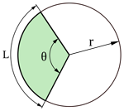

Length of Arc Defined by Angle θ (radians) L = Rθ

If Angle in Degrees L = Rθ$\frac{π}{180}$

Area of Sector of Circle (green) Defined by Angle θ (radians) A = 1 R²θ
2
If Angle in Degrees A = $\frac{1}{2}$ R²θ $\frac{π}{180}$
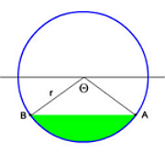
Area of circle Segment (green) Defined by Angle θ (radians) A = $\frac{1}{2}$ r²(θ – sin(θ))
If Angle in Degrees A = $\frac{1}{2}$ r²(θ$\frac{π}{180}$ – sin(θ))

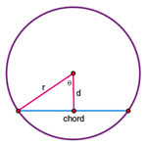
Length of the Chord L = 2*$\sqrt[2]{r^{2}^2-d^2}$
Or
L = 2r * sine(θ)

Circle

Theorems for Lines Intersecting a Circle

Theorem of Intersecting Chords

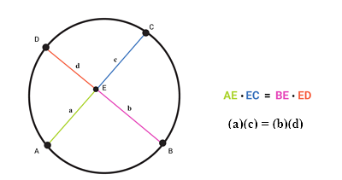

The intersection of 2 chord lines inside a circle result in 4 line lengths for the intersections at point E. The sub-divisions of each chord are always in the same product ratio. The line AE with length a times line EC with length c = line BE with length b times line ED with length d.

The 4 lengths are therefore related by the equation:

ac = bd

Theorem of Intersecting Secants
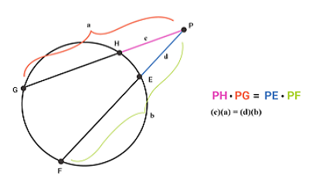
This theorem relates the 2 secant lines intersecting the circle. Note that secants always start outside the circle and intersect 2 points each. This time the relationship is to the outside segment and whole segment of each secant. The outside segment PH of length c times the entire length of PG = the outside segment PE of length d times the entire length of PF.

The 4 lengths are therefore related by the equation:

ca = db

Circle

Theorems for Lines Intersecting a Circle

Theorem of Intersecting Secant & Tangent
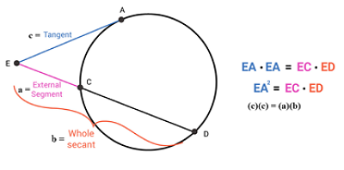

This time, the 2nd line is a tangent which only intersects with the circle at one point, so the secant product ratio is satisfied by the square of the tangent.

The 3 lengths are therefore related by the equation:

c² = ab

Parabola

Equation of Parabola: y = a(x-h)² + k or x = a(y-k)² + h

Vertex at (h,k)

Regular Form: y = ax² + bx + c

Then h = $\frac{-b}{2a}$ k = 4ac – b²/4a

Focus is at (h,k+p) or (h+p),k) where p = $\frac{1}{4a}$

Directrix is at y = k – p or x = h - p

Ellipse

Standard Equation

With the center of the ellipse at (h,k) With the center of the ellipse at (h,k)
and the major axis parallel to the x axis: and the major axis parallel to the y axis:
a > b a < b
(x-h)² + (y-k)² = 1 (x-h)² + (y-k)² = 1
a² b² b² a²

Length of major axis = 2a Length of major axis = 2a

Major Axis Vertices are at (h±a, k) Major Axis Vertices are at (h, k±a)

Length of minor axis = 2b Length of minor axis = 2b

Minor Axis Vertices are at (h±b, k) Minor Axis Vertices are at (h, k±b)

The Foci are at (h±c, k), where c²=a²-b² The Foci are at (h, k±c), where c²=a²-b²
Distance between Foci = 2c Distance between Foci = 2c
Also c = εa (eccentricity*a), see below Also c = εa (eccentricity*a), see below

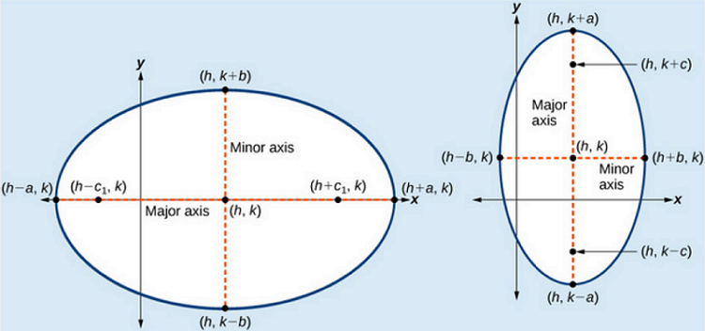

X & Y Major Axis Ellipses

The area of the ellipse: A = πab The perimeter of the ellipse: P = 2π $\frac{\sqrt{a^{2}+b^{2}}}{a}$

The eccentricity of ellipse: ε = $\frac{ c }{a}$ (εa = c) The directrices are at x = {h±a²/c, k), for a>b
y = {h, k±b²/c), for a<b
The length of Latus Rectum: L_{lr} = 2b²/a

Ellipse

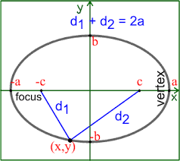

For any ellipse, 2 lines from each focus to a single point on the ellipse will have lengths d₁ and d₂ where the sum will always have d₁+d₂ = 2a for all points on the ellipse.

Hyperbola

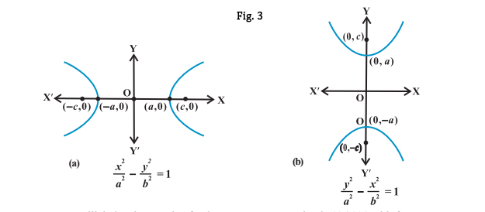
For a>b For a<b

For any center <> origin, the standard equations become:

For a>b For a<b

(x-h)² – (y-k)² = 1 (y-k)² – (x-h)² = 1
a² b² a² b²

Transverse Axis: y = k Transverse Axis: x = h
Conjugate Axis: x = h Conjugate Axis: y = k
Center at (h,k) Center at (h,k)

Focus to Origin Distance: c²=a²+b² Focus to Origin Distance: c²=a²+b²
Also c = εa (eccentricity*a), see below Also c = εa (eccentricity*a), see below

Foci at (h±c, k) Foci at (h, k±c)

Vertices at (h±a, k) Vertices at (h, k±a)

Slopes of Asymptotes = ±$\frac{b}{a}$ Slopes of Asymptotes = ±$\frac{a}{b}$
Asymptote Equations: Asymptote Equations:
y = + $\frac{b}{a}$(x-h)+k & y = -$\frac{b}{\begin{aligned} \\ a\end{aligned}}$ (x-h)+k y = + $\frac{a}{b}$(x-h)+k & y = -$\frac{a}{\begin{aligned} \\ b\end{aligned}}$ (x-h)+k

Eccentricity: ε = $\frac{c}{a}$ Eccentricity: ε = $\frac{c}{a}$

Direction of Opening = Left & Right Direction of Opening = Up & Down

The length of Latus Rectum: L_{lr} = 2b²/a The length of Latus Rectum: L_{lr} = 2b²/a

Directices: y = ±a² /c = ±a²/$\sqrt{a^{2}+b^{2}}$ Directrices: x = ±a² /c = ±a²/$\sqrt{a^{2}+b^{2}}$

Hyperbola

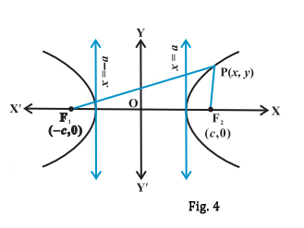

For any point, P(x,y), on either part of a hyperbole, the distance to the opposite focus (PF1) minus the distance (PF2) to the closest focus shall always = 2a.

