Commentaries on Seismic System Engineering, Part III-B
January 24, 2017

In the work with seismic table systems, there are some equations and rules of thumb that are quite valuable. These “hacks” are not difficult to apply and give an engineer a pretty good idea of what is going on or make life easier. These items are presented here in no particular order of importance or usefulness.

- The hydraulic velocity coefficient, otherwise known as the gpm-to-kip ratio.

Of course, you could use the velocity capability, but that takes more computation and is difficult to do in one’s head. Therefore, this coefficient is easy to compute and also is usually < 10.

To compute this coefficient divide the 1000 psi gpm rating of the servo-valve(s) used by the 3000 psi force rating of the actuator in 1000s of pounds (kip). This number then represents the relative ability to control the actuator for dynamic displacement response. Any gpm/kip ratio > 8.0 is trouble. At 10.0, you are in real trouble unless you are very good at what you do. For example, let us consider what the gpm/kip ratio is for several situations.

What are the typical problems that show up with high gpm/kip ratios? You mention that there are control problems for the actuator in displacement control – can you expand on what those control problems are and how they are caused (or related to) the gpm/kip ratio?

Mainly, when the ratio gets too high, you cannot get good response because the proportional gain is way too low. Yes, feed-forward still works, but w/o decent feedback control, real tests are extremely difficult. The response gets very sloppy and is affected by poor disturbance rejection. Getting the system even turned on can be dicey. With the 469D having poor to awful deltaP stabilization and a complete lack of rate stabilization feedback, general use of a shaking table with high ratio is virtually impossible.

- General use load frames
These systems usually have a 10 gpm valve on something like a 100,000 pound actuator. The gpm/kip ratio = 10/100 = 0.1
This is definitely not a control problem in displacement control.
- Structural test actuator
This can have a 180 gpm 3-stage valve on a 100,000 pound actuator. The gpm/kip ratio is 180/100 = 1.8. Again, this is not much of a problem.
- Large and fast (2+ meters/sec) shaking table actuator
These can have gpm/kip >= the 8 range. For the M.O.C. (PWRI) shaking table, each actuator has 1600 gpm (2 – 800 gpm servo-valves) on a 200 Kip actuator. The gpm/kip ratio = 8.0. You do have to be careful around this machine.

Here are some more:

NIED Horizontals (2300 gpm * 3)/1000 = 6.9
NIED Verticals (2300 gpm)/1000 = 2.3 (puppy dogs vs. horizontals)
NIED Servo-valve 167 gpm/21 = 7.95
C.E.R.L. Horizontals 360 gpm/50 = 7.2
C.E.R.L. Verticals 360 gpm/75 = 4.8

To arrive at a displacement gain that is reasonable for a 469D Controller, divide 16 by the gpm/kip ratio. Therefore, a ratio of 8 results in a gain = 2.0.

Most modern shaking tables now have maximum velocities above 2 meters/second and therefore, the gpm/kip ratio will always be hovering around 6-9. It behooves operators of such machines exercise great care in their operation. But, these ratios are benign compared to what’s coming for building damper test equipment. I have already experienced equipment that has capabilities around 4-5 meters/second. This type of equipment requires a completely different approach to controls than normal. More will be said on this topic later when I cover bearing test machines and building damper test equipment.
Commentaries on Seismic System Engineering, Part III-B
January 24, 2017

- The formula for the frequency domain definition of the Q (magnification) of a given resonant specimen is necessary to calculate what frequency resolution would be required by a transfer function to adequately compensate for a high Q mechanical resonance. The time history version of the equation for Q in 2nd-order systems is:

Q = 1 / (2 * ξ) where ξ = damping ratio %

The frequency domain version for the Q equation is:

Q = F₀ / ∆F where F₀ = natural frequency and ∆F = frequency band between
the ½ power points of the resonance.

This 2nd equation is not taught very often in universities any more – not sure why. However, it is absolutely necessary for compensation of highly resonant seismic specimens.

Therefore, ∆F = F₀ / Q. Measure the Q and the natural frequency to find the ½ power
point band. Assume that you will need 5-10 frequency points in that band to get good compensation results.

Have you ever had an experience where the specimen (or table + specimen) had two different natural frequencies very close to each other, such that you cannot accurately pick out the half power points because of the interaction of the resonances? Or do most specimens have one pretty discernable mode?

Of course you can have multiple frequencies on top of each other. Actually, it is quite common with building models because they have 4 corners. The corner support pillars have closely identical natural frequencies that are the lowest for the specimen. That is why my rule is 10 points across the ½ power points. If you have multiple resonances, you will quickly find them and might have to increase the frame size, but the 10 points will get you close. If you use less, you might miss too many peaks and then get quite bad results. If, in the limit, you only get 1 point near the peak, then the RMS error can actually increase. The following plot shows this multiple resonance phenomenon:

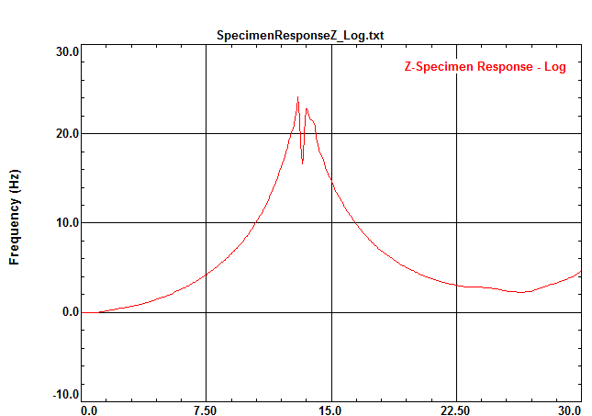

This is the vertical response using a specimen accelerometer for the following specimen:

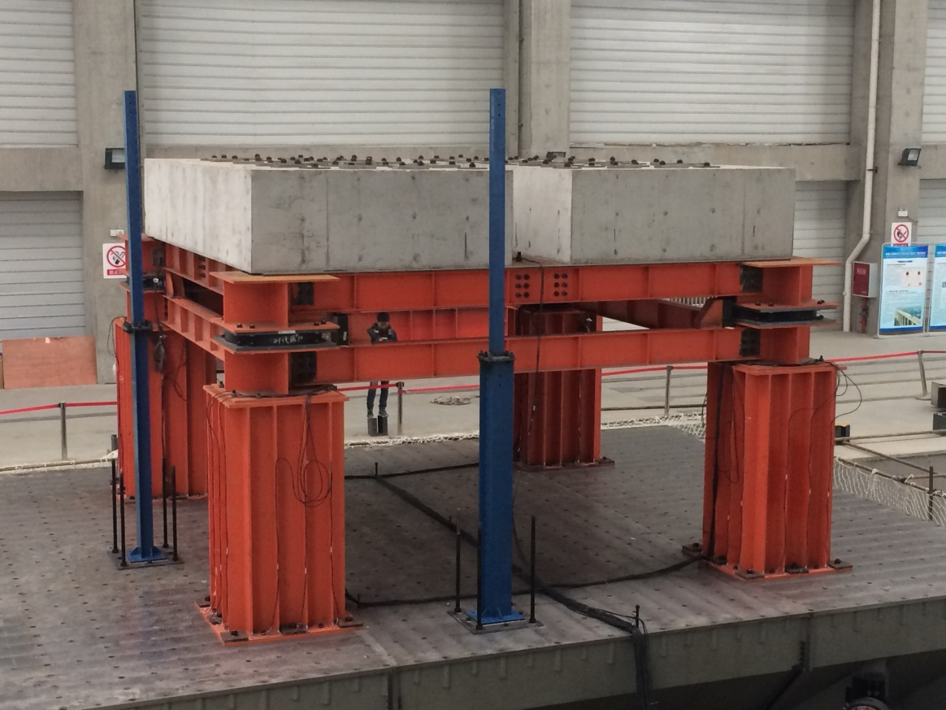
The 4 columns are not quite identically the same or placed on the table.
The specimen is not quite centered and that produces the 2 peaks shown in the plot. But, E-Z-Tune (AIC/OLI) still got very good results. The rubber dampers on the specimen kept the Q low enough to where Stex Pro also got decent results.

I am assuming you are picking off the points of the frequency response function when exciting the system with band limited random excitation. What is your typical ∆F when you are running this FRF? I am assuming that a larger ∆F can be used to determine the half power points because this really just is giving us a method of figuring out what our frame size will be for FFT calculation for iterations.

This is true, but you have to be careful about multiple resonances. I usually use about 1024 or 2048 frame size

Have you ever performed impulse response inputs and measured the damping from the time history oscillations? Or is a random excitation the preferred method?

If you have a relatively isolated specimen resonance, of course this can work. However, I have usually found that multiple resonances and table resonances can wreak havoc with the waveform that makes damping estimation difficult.

For example, the Kajima specimen from hell had a natural frequency of 18.0 Hz and a Q of 125. Therefore, the ∆F = 18/125 = 0.144 Hz. For good results we need a 0.0144 Hz frequency resolution in a transfer function measured at a 512 Hz sample rate. Therefore, we need a FFT frame size of 256 Hz / 0.0144 = 17,777. Since a power of 2 is required, a frame size of 32K was required.

At Xian, the specimen has a natural frequency of 3 Hz and a Q = 50. The ∆F = 3/50 = 0.06 Hz which means a 0.006 resolution or 256 / 0.006 = 42,666 lines or with power of 2 means a frame size of 64K.

As you can see, any resonant specimen of any reasonable Q below 10 Hz requires a large frame size. The typical 8K frame size of FFT analysis is woefully inadequate.

It got a bit crazy at Shimizu where the specimen had 5 resonant frequencies on top of each other (it was an X-Y slinky essentially). The resonant frequency was about 1.0 Hz and the Q was about 20. Therefore, the frame size is 51,200 or 64K again but with multiple resonances. But, we were able to obtain < 3% RMS JMA Kobe Earthquake Error after only 6-7 iterations using AIC/OLI. The starting RMS Error was > 25 %.

What is the maximum frame size that the 469D controller will allow?
E-Z-Tune is a time convolution approach which is similar to design of a digital filter, so we really have to talk about coefficients instead of frequency lines. AIC is designing a digital filter; therefore, the # of coefficients has more to do with fit than ∆F Usually, the 8 second impulse response uses 8,000 coefficients; therefore, that is enough to do most high-Q specimens. I would like a 16 second impulse response, but that makes settings files huge (AIC coefficients are saved in settings files). So, I have to settle for 0.125 Hz as the lowest frequency that can be reproduced. 1/(impulse response time) is the minimum E-Z-Tune frequency compensated. Otherwise, the coefficients tend to group around high changes in transfer fcn.

Have you ran into a situation where you weren’t allowed to excite the specimen to get the Q value prior to running a test? Or maybe a situation where the system was nonlinear enough that the measured Q value or damping (with low excitation amplitude) was different from the damping at higher excitation frequencies? Maybe a discussion for later when we get into the topic of methods for simulating earthquakes/iteration techniques.

There are quite a few specimens that fit this category. The most often is the soils box. To study liquefaction, researchers use large boxes full of sand and water They build things like soil dams, etc that can take almost NO earthquake. Some specimens, like antenna towers and bridges are fragile as well. You do the best you can, but I recommend that if possible the best way to run such specimens is:

Before test, find and or construct mounting plates that can be used to get ALL specimens to the same total weight. This reduces a lot of work in tuning, etc. Also, run a whole bunch of iterations with dummy specimens that will take earthquakes and get the good waveform. Then, put the real specimen on and run once. This is the ideal set. Many think it is too expensive in time and $$$, so they cut corners. Remember, most researchers think that a 10-20% test is good enough. All in all, I think that about 1/3 of specimens are fragile. The rest are quite robust and the researchers are more interested in how good they really are – 200% Kobe, etc. or interested in the building infrastructure (electrical, water, HVAC, furniture). Most deaths and injuries are in wood houses and 4-5 story buildings. But, there are deaths even in skyscrapers even though the building withstands the earthquake quite well. The furniture and office equipment can kill. I have some movies of NIED tests that show office copiers and printers that roam around a room injuring people (potentially). They weigh several hundred pounds and are on wheels.

Commentaries on Seismic System Engineering, Part III-B
January 24, 2017

It is also helpful to know the general Q values for different types of structures. First, the oil column resonance usually is about 6%. It can be lower if the system has very low friction. Then, it can approach 3%. Most systems, however, fall in the 6% value. The following table shows the typical Q values for some structures:

Wood Structures 4 - 8%
Reinforced Concrete 3%
Concrete Roadway Piers 2%
Steel 0.5 – 1.0 %
Steel Towers/Antenna 0.3 – 0.5 %

Most seismic specimens are concrete or even wood. It has been found that most deaths due to earthquakes in the world are from wood or brick structures, typically less than 4 stories tall. Steel structures, as can be seen, are difficult specimens. This is especially true of multi-story (tall) steel specimens. The worst I have seen is at NCREE North, Taipei, Taiwan that is used there as a training tool for new shaking table operators. The specimen is a 4m x 4 m x 16 m tall 4 story building frame. There are lead weights for each floor to simulate weight. The Q is well over 100.

- There are several useful conversion factors and special names for engineering units that are common to servo-hydraulics and seismic applications and should at least be mentioned.

1 gpm (gallon/minute) = 3.85 in³/second

1 gallon = 231 in³ = 3.785 liters

1 kiloNewton (kN) = 224.8 pounds force

1 Metric ton = 2,204.6 pounds = 1000 kilograms

1 cm/sec velocity = 1 kine

1 cm/sec² acceleration = 1 gal

1 G acceleration = 980.7 gal (cm/sec²)

3000 psi = 20.68 MegaPascals (commonly 21 MPa)
= 206.84 Bar (commonly 210 Bar)

Commentaries on Seismic System Engineering, Part III-B
January 24, 2017

- Accumulators are often used on seismic systems for flow averaging and blow-down applications. All of these uses involve the Ideal Gas Law:

PV = nRT where P = pressure, V = volume, n = # of moles, R = universal gas
Constant, and T = temperature (Kelvin)

Using this Ideal Gas Law as a basis, the general isothermal accumulator equation is:

V_{D} = (e * P₁ * V₁) / P₂ – (e * P₁ * V₁) / P₃ where

V_{D} = volume of fluid discharge (in³)
e = system efficiency (typically 0.95)
P₁ = Pre-charge pressure (psi)
P₂ = System pressure after volume V_{D} has been discharged (psi)
P₃ = Maximum System pressure at full accumulator pressure (psi)
V₁ = Rated accumulator gas volume (in³)

Obviously, this equation only holds for isothermal operation. When charging accumulators, the gas temperature will go up causing less oil to be in the accumulator. Allowing the gas to cool to the ambient temperature allows more oil to enter the accumulator. However, that is not always possible. Therefore, for line averaging accumulators, a 5-10% extra volume is required to allow for gas temperature rise.
This effect can be clearly seen on blow-down systems where even a few minutes can add a considerable amount of oil to the charge.

- One of the hard things to do on a seismic system is to measure the oil column resonance natural frequency for the different axes. Of course, the main problem is to NOT go unstable while trying to do this measurement. This is because method # 1 (of 3) requires letting the oil column resonate >> 1 on the closed loop transfer function to the point where an accurate measurement of the peak amplitude’s frequency using the open loop transfer function can be accomplished. Reducing the damping due to deltaP compensation or a notch filter depth to allow more oil column response is fraught with danger of system instability. This is not so horrible for bare table situations, but certainly cannot be allowed when a valuable specimen is mounted on the shaking table. If such measurements are the only option, I recommend that the operator does NOT go > 3.0 on the closed loop transfer function gain of the oil column peak. The open loop transfer function measurement may not be very accurate, but the danger of instability forces this measurement error. The other 2 methods of measurement are far safer. Both of these measurements take advantage of the actual properties of the oil column resonance.

Does the oil column frequency change much with excitation amplitude in your experience? That is, if the closed loop transfer function shows an amplitude of 1 at the oil column frequency, how much does the oil column “shift” (on the open loop plot) when the amplitude gets bumped up to 3 or 5?

Oil column frequency is determined by the oil spring and the mass of table+specimen+1/2*actuator weight. The main change comes from stroke change. Near the end caps of the actuators, the oil column stiffness rises. The longer the cushions, the smaller the stiffness change. The oil column stiffness is shown by the following equation:

K_{oil} = ( β * Area of Piston ) / ( L/2 – x) + ( β * Area of Piston ) / ( L/2 + x)

Where L = stroke length.

At the center of the stroke, we get the well-known formula of K_{oil} = 4 * β * Area of Piston / L. So, w/o cushions, the oil spring rate goes to infinity (NIED), but with most systems the cushions are about 5% of the ½ stroke length. So, a 1 meter actuator has about 2 inch cushions (or more). This would make a spring rate 10x the center at the cushion. But, the frequency change is the square root which is 3.2x oil column frequency. But, as expected, the earthquake doesn’t spend a lot of time near max stroke; therefore, we don’t see much effective change in RMS for the entire earthquake due to mis-tuning oil column. With notch filters, we do see about 10-20% changes. However, if ΔP really works, then there is not any real change at all. That is why ΔP is so much more important that notch filters.

Commentaries on Seismic System Engineering, Part III-B
January 24, 2017

The 2nd method uses the simple fact that oil column resonance is a 2nd-order oscillating response. At the oil column resonance natural frequency, there is an inherent 90 degree point which is mid-way to the 180 degree lag found at frequencies >> oil column natural frequency. This 90 degree point can be found quite easily if the system has 3-stage servo-valves. If these valves are not present, then this method cannot be used. Because the 3rd-stage spool valve opening is proportional to oil flowing in to or out of the actuator, it is a representation of velocity, particularly at lower frequencies. By observing the sine wave spool position response vs. actuator force (deltaP) response, the oil column natural frequency can be found. At low frequency, the spool position and actuator force will be 90 degrees out-of-phase (acceleration and velocity phase relationship). As the excitation frequency increases, the phase difference shall approach zero. At the zero phase point = the oil column natural frequency. Now, it should be recognized that this still has a measurement problem. Anyone familiar with dynamics knows that the 90 degree point of a 2nd-order system response that is damped does not equal the zero-damped natural frequency. But, if the system has good deltaP compensation that works properly, then it can be assumed that the damping on the 2nd-order system is near critically damped or slightly under-damped. A square-wave response of 10% overshoot is about a 0.6 damped system and the frequency adjustment for damping can be computed. Now, it should be recognized that the 469D does NOT have adequate deltaP compensation even at 2 KHz sample rate. So, even this method is not entirely accurate because the actual damping is not known accurately.

What is the 469D implementation of deltaP compensation? Why is it not adequate – just because of the controller rate?

NO, it is really delay. It turns out looking like sample rate because of the way the 469D does things. It takes a full sample rate period to output ΔP correction. I personally would not do it that way - even jamming out ΔP as soon as possible would be better. Of course, I would prefer analog ΔP. Then you can get over-damped response. Also, I would not use the averaged pressure but individual pressures for each actuator’s ΔP. So much has been lost to the ages. In the 70s analog controllers we did not use averaged pressures except for force balance.

The 3rd method relies on the fact that oil is not an incompressible fluid. The actuator requires extra flow in to and out of the actuator to accommodate oil compressible flow. This extra flow allows the operator the opportunity to find the oil column frequency in the most accurate manner. If the system is excited with a sine wave that is constant acceleration over the frequency range of interest, the actuator velocity will then be kinematically proportional to 1 / (excitation frequency). This means that the servo-valve flow will also be proportional to 1/frequency. This causes the servo-valve spool opening to get smaller as the frequency is increased from well below the oil column natural frequency. Because oil is compressible, there is a need to flow extra oil to compress or release the oil pressure in the actuator. This compressible flow is proportional to frequency. It rises with increasing frequency. So, in the actuator we then have a situation where the kinematic flow is decreasing and the compressible flow is increasing. Where do you think these two curves intersect? Of course, it is at the oil column natural frequency. The spring rate of the oil (bulk modulus) is why the oil column exists. Therefore, by watching where the servo-valve flow reaches a minimum is where the oil column natural frequency is. This method is less affected by actual control damping.

This is an interesting method. How is this test set up? Just a constant accel sine wave with manual incrementing of frequency? How “good” does the tuning need to be to utilize this method?

I just manually adjust frequency for a minimum – tuning can be pretty bad, but then you have to mess around with amplitude until you get close to oil column because of roll-off in response. So, I usually only measure oil column after doing some tuning.

It is this 3rd method that leads one to the realization of why a notch filter of the proper depth and bandwidth could be used to help get a flat transfer function without the use of deltaP compensation. It should be noted, however, that notch filters do NOT remove the small oscillations that occur because of localized impulse responses in a given waveform. The notch filter is not a true damper; it mainly reduces the ability of the system to produce the large oil column response. The errors produced by small ringing responses are still there. These small oscillatory responses are not found in systems with true deltaP damping compensation ability. Using a notch filter to control oil column was forced by necessity by the low sample rate (1 KHz) on the 1996-era 469D Controller. DeltaP compensation does not work very well with any significant delay. Without a notch filter the original 1996-era 469D Controller did not have good bandwidth because of lack of positive control of oil column. Of course, the use of notch filters has been invaluable in the removal of amplitude variations in the system transfer functions due to the many imperfections of mechanical systems.

Commentaries on Seismic System Engineering, Part III-B
January 24, 2017

- One of the most difficult things to do when hooking up actuators is the problem of getting the actuator in displacement control without the actuator going out-of-control and rapidly ramming into an end cap (and perhaps hitting other things on the way). Most shaking table actuators can move very quickly and use multiple-stage (usually 3-stage) servo-valves. The polarity of the valve required for control depends upon the manifold design and the direction of valve orientation as well. It would seem that this would become a standard, but, unfortunately, MTS has not been able to do this. The polarity can even vary between mechanical designers. Therefore, great care has to be taken most of the time an actuator is first brought under control. There is a good hack that works 100% of the time if you can have the actuator near one end cap. If the actuator is not near an end cap, every effort should be made to make the actuator mechanically move towards one end cap. Once near (or in) an end cap, the actuator can safely be brought into control. The trick is to always command the actuator to move a small distance AWAY from the end cap. Use a small distance and make sure that the error signal is not very large. Usually, I like to have 0.2 to 0.3 volts error. If you are totally unsure of what displacement gain is safe, use a gain of 0.2 to 0.5. These values will still control and do not produce large error (high velocity) for correction. Then, if the polarity is wrong, the actuator will go into or stay in the end cap. If the polarity is right, it will move a short distance away from the end cap and stop.

If a separate pilot pressure supply can be used, then the servo-valve leakage might be enough to move the actuator. Then, the actuator cannot move quickly, but will slowly move to try to correct the error. This is not always possible and should not be counted on as a method to use every time.

Or, if possible, use a hand valve on the main pressure supply to severely limit the flow. This also helps with start-up safety. I try to use all of these methods if possible, but the primary idea of starting near the end cap is always a good way to get control safely
.
- Tuning deltaP on a shaking table is difficult just by using a transfer function. The amount of deltaP that can be used is NOT infinite. There is a place where the deltaP will make the shaking table to go unstable. There is not a lot of warning when using this method. Therefore, the deltaP is rarely, if ever, optimal. Ideally, an operator would like to use a displacement square wave to tune deltaP. However, on a shaking table that is highly undesirable. Accelerometers and other things on or near the table do not like square waves. This method is quite dangerous to accelerometers. Static lift cylinders don’t like it much either. So, in order to get a transient into the system that is controlled and small enough to not cause instability, we use a triangle displacement command. The turn-around on the triangle wave produces a force transient that will cause the oil column to ring. The displacement gain can be turned down to lessen the transient on the turn-around so that there is only a small ringing force response on the actuator. Now, as the operator increases the deltaP compensation, the ringing in the force at turn-around becomes smaller. If the system delay is small enough, the deltaP can be added to critically damp or over-damp the oil column response. Even if this is not possible, the maximum amount of deltaP that can be used on the particular system can be found. Something is better than nothing.

What is your opinion of using random excitation versus triangle wave command for looking at deltaP compensation?
I strongly prefer the triangle wave method, because you have no idea where you are in the damping regime with random. With the triangle wave, you get a ringing response – this is direct feedback on what’s going on and what will hurt you in an earthquake. Anyone who tunes deltaP with random is kidding themselves. You can usually find large transients in the response. Of course, the way deltaP is done on the 469D you cannot be optimal, but you can do a lot better than random on getting the deltaP up to where it needs to be.

Commentaries on Seismic System Engineering, Part III-B
January 24, 2017

- A way to minimize bumps or jerks when the shaking table starts up from pilot pressure to system main low pressure is to make sure that the vertical actuators lift off about 10-25 mm. This can be done manually before main pressure is applied. As the main pressure rises, a very soft rise will occur on the vertical actuators. This is not always even and can have some small rotations, but there is not much force involved because the forces are low. To make sure this happens all of the time, the 469D Controller software should be modified to automatically set this “liftoff” height when the low main pressure button is pushed. Then the rising pressure will lift the table out of the cushions enough to prevent any sharp jerks. This same process can be applied to lifting the table off of a parking frame without scraping the underside of the table by the table twisting as it lifts. This twisting motion is usually caused by servo-valve balance problems.

The following Alltalk code can be used to command a small lift for the vertical actuators:

METHOD liftoff IS
Lift the table slightly off the parking frame when pressure
turns on to prevent scraping the underside of the table.
VAR setpt
BEGIN
setpt := vm.tchan[vert].setpt
setpt.move[setpt.endLevel + setpt.units.max * 0.08] ! 20 mm = 8% of 250 mm
fgP.updateSetpt ! update setpoints
END METHOD

A setpoint move is used in this method to not produce a square wave step to the lift position.

I assume setpt.move utilizes the controller ramp rates. You are 100% correct.

Likewise, the shaking table park position should never push the actuators fully into the cushions. This could cause a bump going into the Park Position. The Park Setpoint(s) should be set to allow about 10 mm free drop after the main hydraulics are turned off. This drop will be gradual as the main pressure slowly decreases towards zero.

- Tailoring a specific earthquake to fit a shaking table that is too small in displacement, velocity, or acceleration capability is a problem for smaller earthquake simulators as well as older systems that did not require such capacity. Velocity and acceleration cannot be altered independently because that would radically change the power spectrum of the earthquake. The high velocity and acceleration bands of an earthquake are at the mid-range and higher frequencies. Such a spectrum change would detract from any conclusions that could be made about the specimen reaction to this particular earthquake. Therefore, to fit a big earthquake to a smaller machine for velocity or acceleration is usually done by direct scaling down the earthquake.

Displacement, however, is a different subject. The displacement is usually reduced by increasing the Reference Generator Cut-In Frequency. This high-pass filter can decrease the low frequency displacements without radical spectra changes. In order to test this change, the Cut-In Frequency can be raised and the earthquake can be played to the 469D Controller with the Data Player in PREVIEW mode. The hydraulics is not necessary to measure the peak displacement reference commands with digital meters. Once an acceptable Cut-In Frequency setting is found that gets the displacement peaks within the system’s capability, the program can be played for real to the system with this setting.

