Commentaries on Seismic System Engineering, Part II
January 21, 2017

This section shall deal with some of the diverse topics that do not fall in line of the implementation of a shaking table installation. These topics will not necessarily connect to one another, but can be lumped with similar discussions in the future. And with that, we begin:

- Pre-sale acceptance criteria

This topic shall deal with the items provided as possible for discussion. Other items are also included as spin-offs of the original list.

- What frequency range should MTS say we can get good response (fidelity) for different table sizes?

Of course, it should be noted that the frequency range depends a great deal upon the servo-valves used, the amount of actuator friction, the quality of swivels, and the table resonant frequencies. What will be listed here shall be the inherent, general frequency range found for shaking tables of various sizes:

3x3 meter up to 100 Hz
4x4 meter up to 100 Hz
5x5 meter up to 50 Hz
6x6 meter up to 40 Hz
8x8 meter up to 30 Hz
10x12 meter up to 30 Hz

What is the general criteria for these frequencies for seismic systems? For other systems, sometimes we usually the general rule of thumb of 1 decade or 6dB as an acceptable metric for frequency response for systems that use RPC. Other times we possibly use a coherence view or a signal to noise ratio to determine the “maximum” frequency response. For seismic systems is there anything special to take into account other than these typical tools?

I am sorry that I did not expand on this. It is an entire subject on its own what limits servo-hydraulic performance and especially seismic table performance. Therefore, I shall add an entire topic on this subject right here. But, to give you a short answer, there are several criteria that limit performance. None of these items will surprise you:
The overall criteria is the system high frequency limit is where the table will no longer faithfully reproduce waveforms with reasonable repeatability. When the acceleration signal gets so ratty that you cannot identify the signal – you have gone too far. To be more specific:

- Actuator stroke length limits oil column natural frequency AND produces a lower bowstring natural frequency that both limit how high you can reproduce data. The main high frequency limit caused by oil column natural frequency is compressible oil flow. Kinematically, for a flat acceleration response, the velocity ~ flow rolls off as 1/f. At the oil column frequency, compressible flow starts to dominate and increases ~ f. Now, every system has a pump sized for at or near maximum kinematic velocity. Therefore, you can reasonably expect that the high frequency limit will be near the point where the compressible flow is = pump flow. I know of no one except myself that calculates where that frequency is for every shaking table I see. It can be quite enlightening. Bowstring you already know about – you cannot do anything about it except anticipate it and design around it.
- The shaking table has resonances. They cannot be eliminated, only mitigated by design. For example, MTS was able to design and build a 3m x 3m shaking table that had NO natural frequencies < 300 Hz. That is not easy to do, but it can be done. The actual table’s lowest natural frequency was 277 Hz. This was the C.E.R.L. system that could work quite well to 250 Hz. Table resonances greatly limit certain systems. NIED has a waffle for a table. The lowest frequency is 30 Hz and is very high Q. The system will never be able to reproduce any waveform above 25 Hz EVER. Because it is a full-scale earthquake simulator, it does not matter. The highest frequency that you can even think about reproducing is 20-25 Hz. Most researchers would say 10-15 Hz. The NIED specifications say 15 Hz. There are things that users can to do minimize certain table problems. NIED has taken my advice on this subject. What I recommend is to put on the table (when possible) the heaviest and stiff-as-you-can-make-it baseplate to mount the specimen. This has a very prominent effect on “waffle” tables. It can also be used to make every specimen weigh the same (great benefits result from one tuning settings and possible use of previous iterations). At NIED, w/o the base frame, the maximum frequency that actually can be run is about 20 Hz (0.7 of F₀). With the frame, the system can be pushed all the way to 30 Hz because the bad table response can be knocked down with reasonable notch filters.
- Servo-valve pilot sizing has a lot to do with high-frequency performance. Yes, it does affect the valve closed loop gain, but it is usually worth the price. For example, on EPDC we had to go to 100 Hz but the 5 gpm pilot for the 256 valve was not enough. A 10 gpm Moog did not have enough flow at 100 Hz either because of lower frequency response than the 5 gpm valve. So…we used dual 10 gpm valves. The result was quite positive. The 256 valve was not really a control problem at all. The main problem was balancing the pilots. In the old days with voice coil pilots we did not have these problems. We had 6, 12, and 20 gpm voice coil pilots that had 600 Hz, 400 Hz, and 300 Hz natural frequencies. Getting full pilot flow at higher frequencies has mostly good effects. This is why we use 5 gpm pilots all the time.
- Another actuator parameter that helps is low friction. MTS uses a lot of hydrostatic actuators now in the longer lengths especially. Friction is the kiss of death for high frequency performance. The actuators at Shimizu can run really high frequencies that help the overall system performance. The main limitations at Shimizu are the table and the swivels.
- Swivels are another source of friction and backlash. Backlash is fatal to high frequency because you then get no response even when the actuator is moving ok. Hydrostatic swivels, at 1st, seem to be a good idea. However, it has been long experience that has shown that hydrostatic swivels are a pain in the ass and don’t really help. They are much, much heavier and they have an oil column of their own and they are complicated which violates the KISS principle (Keep-It-Simple-Stupid). MTS mechanical swivels are very good if they are set up right. However, in their infinite wisdom, MTS mgmt. got rid of the equipment and the guy that set up swivels prior to installation. MTS swivels need to be broken in. They have a plastic bearing material that needs time to wear into the best operation. Also, the backlash has to be exactly set by adjustments. MTS used to have a load frame set up downstairs to a) break in the swivel, and 2) set the backlash. Now it has to be done IN THE FIELD. For example, at Shimizu, I had to spend 3 man-weeks on-site to get the swivels set right. Requires 2 accelerometers per swivel and about one day per swivel. You do a 1/8 turn – measure – another 1/8 – another measurement…..slow, slow and expensive. At Kajima, we spent 2 months. AND, you are not down, doing it once. You have to test again near system acceptance testing because the swivels have some break-in. It should be done again after 1-2 years usage because break-in might be complete then.
- Actuators also have to be designed with a bowstring natural frequency at least 1.3-1.4 x highest operating frequency. As you already know you can really not do anything about bowstring but accept the consequences.

Sorry items not necessarily in order. Just wrote it as I thought of it.

As you noted elsewhere in your comments, loss of attention to detail cost EETI to make new actuators, Xian to have a crappy table, the wrong swivels, horrible pumping system, etc., NIED to get cables made in Mexico. NTT to get the worst actuator design in the history of MTS. This is really pathetic to me. It just illustrates what MTS has lost technologically. You cannot expect ANY servo-hydraulic system to work well w/o paying your dues by doing everything you can to minimize problems. I am going to have an entire section on using people who do not understand the problem designing equipment for vibration. MTS has only 2-3 people that have some understanding of high frequency vibration now. In 1975, MTS had a dozen people who knew what to do…….(it seems that you are learning, though, and that is a really good thing)

Any shaking table that runs above 50 Hz will require some special attention. As far as I know, only
5-6 MTS tables have ever been designed to run higher than 50 Hz. There might be some others back in the early years, but it is for sure that 100 Hz and above tables are difficult to achieve. MTS was the unquestioned leader of servo-hydraulic vibration back in the mid-70s. This is definitely no longer true. MTS no longer produces hardly any components capable of such high frequency operation. This means that MTS would, at this stage, have difficulty in producing any shaking table with capability beyond 50 Hz. The China EETI system had 100 Hz specifications, but I am not aware of the installation details at all; therefore, I cannot comment on this particular project. I have worked on 3 shaking tables that have performed > 50 Hz. One was the LRL 4-vertical actuator uniaxial system that went to 500 Hz (1970), another the 3m round 6 DOF EPDC underwater shaking table that went to 100 Hz (2000) and the 3rd one is the 3x3m biaxial C.E.R.L. project (1974) that went to 250 Hz.

Commentaries on Seismic System Engineering, Part II
January 21, 2017

It should also be noted that even the NIED 15m x 25m table can actually run to 30 Hz as well with a +/-2 DB magnitude accuracy. Time and Money can make some things happen.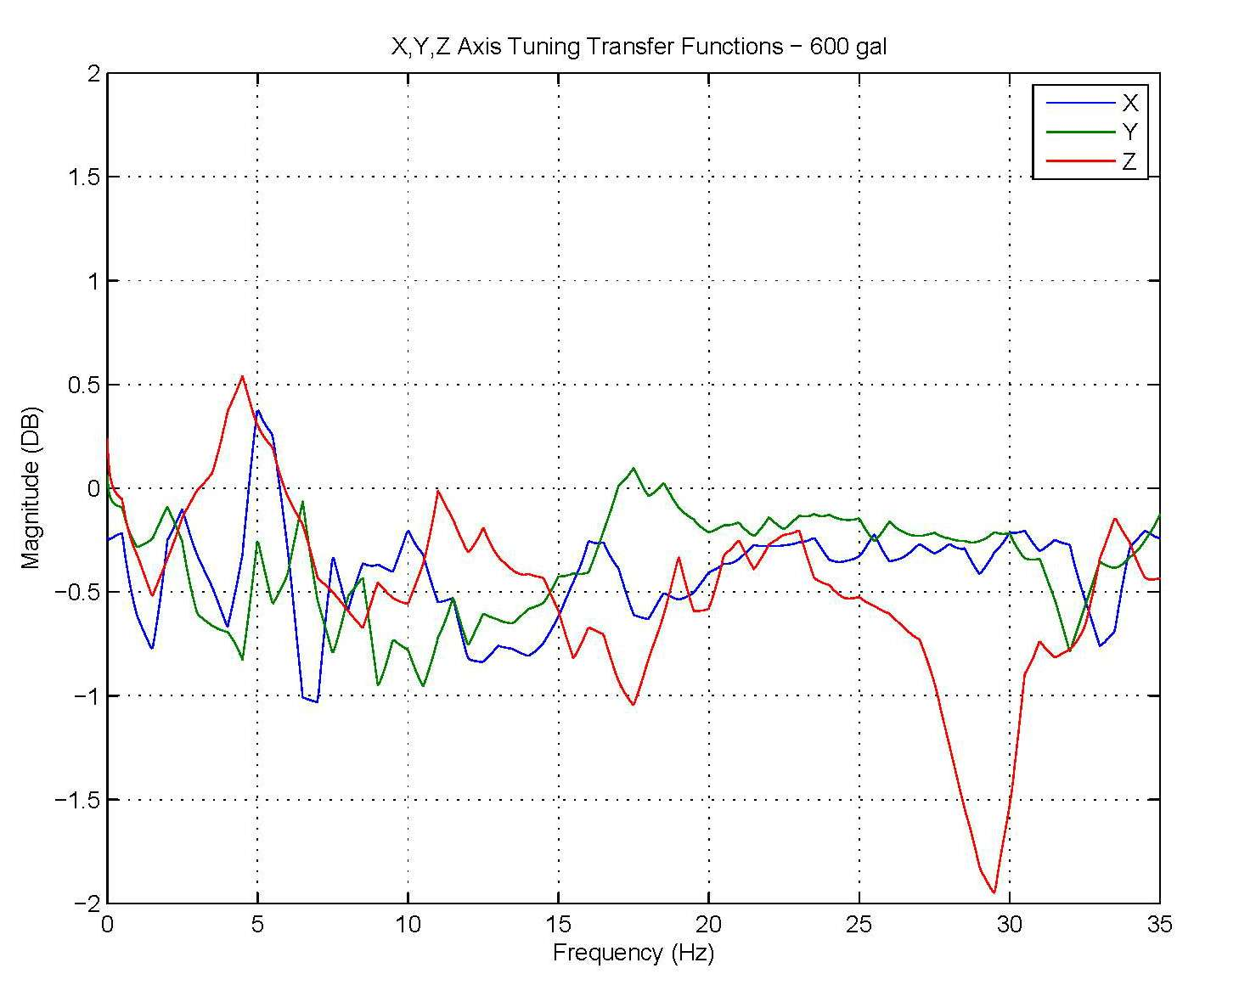
Figure 1: NIED Principal Axes Transfer Function at 150 gal RMS Random

The main limiting factors for high frequency operation are 1) actuator bowstring and 2) table and/or swivel resonant frequencies. It is very unwise to push the envelope of the bowstring natural frequency on the off-axis actuators. Excitation at bowstring frequencies can and will damage the actuators. There is no easy way to allow a system to drive off-axis actuators with the principal axis at full performance at the off-axis bowstring frequency. Actuator lateral motion dampers have been tried (M.O.C. PWRI – 1998) without great success. The MHI stationary actuators and swivel links system does reduce bowstring and would allow the NIED system to go to higher frequencies. Unfortunately, the low frequency table resonances preclude any real advantage from this design.

Not a question, but just a comment – EETI had pretty low bowstring frequency, right in the middle of the system operating band – something like 42-43 Hz. We tried a lot of things, but in the end we basically had to get completely new actuators manufactured that had a much higher stiffness and there was nothing we could do with the actuators that we had. 100% right !

Commentaries on Seismic System Engineering, Part II
January 21, 2017

- What Total Harmonic Distortion levels can MTS quote competitively?

A 5% acceleration THD specification was responsible for shutting out all of the opposition to MTS shaking tables in Japan for over a decade. Yes, now there are customers asking for tighter specifications. There have been some improvements in the Automatic Harmonic Canceller in the last few years. The 469D AHC can now regularly obtain < 3% Acceleration THD if there are not any significant mechanical resonances in the system that fall on a harmonic of a typical test frequency. I would not recommend this specification for any tests other than bare table. Also, the 3% specification on displacement was always too loose and could be regularly tightened to 1-2%.

Most operators only remove the odd harmonics as they are the largest ones. However, I have found that by cancelling the even harmonics, the resulting THD can be quite a bit lower. I tend to remove all of the harmonics up to about the 8th harmonic and then the odd ones after that 8th harmonic. So, I normally remove the 2,3,4,5,6,7,8,9,11,13,15,17… harmonics. I also try to not analyze the data past the 10th harmonic.

This may be a better question for a separate section, but while I am thinking about it, I will throw some in here. Do you have any trouble cancelling the even harmonics with the bandpass filters that AHC uses? In other words, if you cancel the 2nd and 3rd harmonics, is the filter rolloff designed such that they do not interfere with each other?

Even harmonics up to 8 can be eliminated pretty easily. Usually, there are no significant harmonics beyond that. However, you will get instabilities in the AHC process if you try to eliminate noisy, small random harmonics. AHC needs to have a low level limit which will not allow compensation of low level harmonics. You do get an exciting moment when you choose the 2nd-harmonic, especially if the table does not have static lift on vertical. Doing the 2nd harmonic on vertical can then get scary for a second or two. It always converges, but can result in large responses getting there. After doing the 3rd harmonic to make sure that AHC has a good model, then I do the vertical 2nd-harmonic with lower AHC gain to start. After that, there is no problem.

AHC in my understanding relies on a fairly well defined plant FRF. Have you had experiences where AHC did not work because the plant FRF did not model the non-linearities accurately? What did you do in this case (if you have experienced this)?

Actually, it works quite well on non-linear problems because it does track and optimize. I have never had a problem with that – especially friction which is highly non-linear (static friction is square wave). I have tested AHC by throwing in programmed harmonics & non-correlated signals and AHC will remove them. It does NOT, however, remove any response that is not at a harmonic frequency.

For example, the PWRI 8x8m table upgrade in 2013, I was able to achieve < 1.2 % Acceleration THD on X, Y, and Z axes.

However, the Shimizu table had trouble making 3% Acceleration THD because of some mechanical resonances and friction. The single-ended V horizontal actuator arrangement degrades the THD numbers horizontally. M.O.C. had an orthogonal double-ended actuator arrangement which usually produces the best THD measurements.

This points out the simple fact that the more actuators, the merrier. If you want LOW distortion and good performance, use LOTS of actuators. The C.E.R.L. project had nine (9) verticals and six (6) longitudinal actuators. The response was very, very nice indeed. M.O.C. had 6 actuators on the horizontals, but only 4 on the vertical. But, the actuators all had hydrostatic bearings. Low friction helps THD a lot.

In the end, I would stick with 5 % Acceleration THD for a V actuator arrangement, but go to 3 % Acceleration THD if there is an orthogonal actuator arrangement.

The one item that prevents AHC from becoming a truly worthwhile addition to the 469D is the fact that the process is too slow for use with sine sweep. AHC does work with sine sweep but the sweep rate cannot be in any useful range for actual tests because the compensation is way too slow. Since this technology is quite old (20-30 years), it is likely that a revisit to the application could improve performance considerably. On the other hand, Automatic Amplitude and Phase Control is already quite good for sine sweep applications. Servo-hydraulics is not the best choice for sine sweep acceleration tests because of distortion. Making good sine sweeps would open new testing markets that already exist in both commercial and government testing requirements.

In your experience what do customers use sine sweeps for? Are they looking for mode shapes of the table/their specimens? What is the advantage of a sine sweep versus a shaped noise excitation for the seismic application? Higher possible amplitudes at specific frequencies?

Yes, seismic researchers use sine sweeps to identify specimen resonances. Some like the sine step function generation option to use for larger amplitude sines. All of them want AHC to work with both of those functions. Also, all shaking tables can be used for government or regulatory vibration tests. This can be an especially lucrative test contract source for shaking tables. Unfortunately, MTS has ignored this possibility in the 469D for many, many years. A few customers get equipment from vibration companies to assist such tests. Many tests, including gov’t transportation tests and, for example, some Bellcore tests use sine sweeps. It is just the name of the game to have sine sweeps. These criteria have been around for 40-50 years and will not be changed soon. Sine sweep tests are here to stay in vibration tests. MTS has chosen not to participate after being the leader of the pack in the 70’s. & 80’s. Today, it is even easier than it was then – now it is 100% software.

Commentaries on Seismic System Engineering, Part II
January 21, 2017

- Can we assess PSD/ASD response in answer to customer requests for equipment to meet certain PSD/ASD error bands?

This topic carries over from the last one in question B. Servo-hydraulics has difficulties with PSD/ASD spectrum matching because of oil column problems. The 3rd harmonic distortion produces too much oil column frequency response that may not be able to be suppressed because the harmonic is larger than the specified response at the oil column frequency. Even programming zero response at the oil column frequency does no good. The 3rd harmonic has resulted in test failure already. This is a well-known problem to anyone that has been around servo-hydraulic vibration applications. Unfortunately, very few (to none) at MTS are the slightest familiar with such problems. In the 1970s when MTS was heavily into the vibration market, MTS did evaluate the current PSD control systems available and found them to be inadequate to solve this problem. These “compressor” type systems that are still in use today for electro-dynamic shakers do not work to reduce harmonic distortion or oil column response to transient motions. However, it was found that RPC iteration techniques ARE applicable to such problems. The C.E.R.L. project used the 1st application of transfer function compensation and iteration to remove distortion to achieve zero-damped shock response spectra matching. In case the reader does not know, zero-damped shock response spectra are extremely sensitive to ANY distortion of an acceleration waveform. So….the ONLY way that a servo-hydraulic can adequately achieve any PSD/ASD error band is through RPC type iteration compensation. The extra oil column response is not due to just 3rd-harmonic response. A high-frequency excitation above oil column frequency will cause a ringing response in the oil column. For example, look at the acceleration time history shown in Figure 2 below:
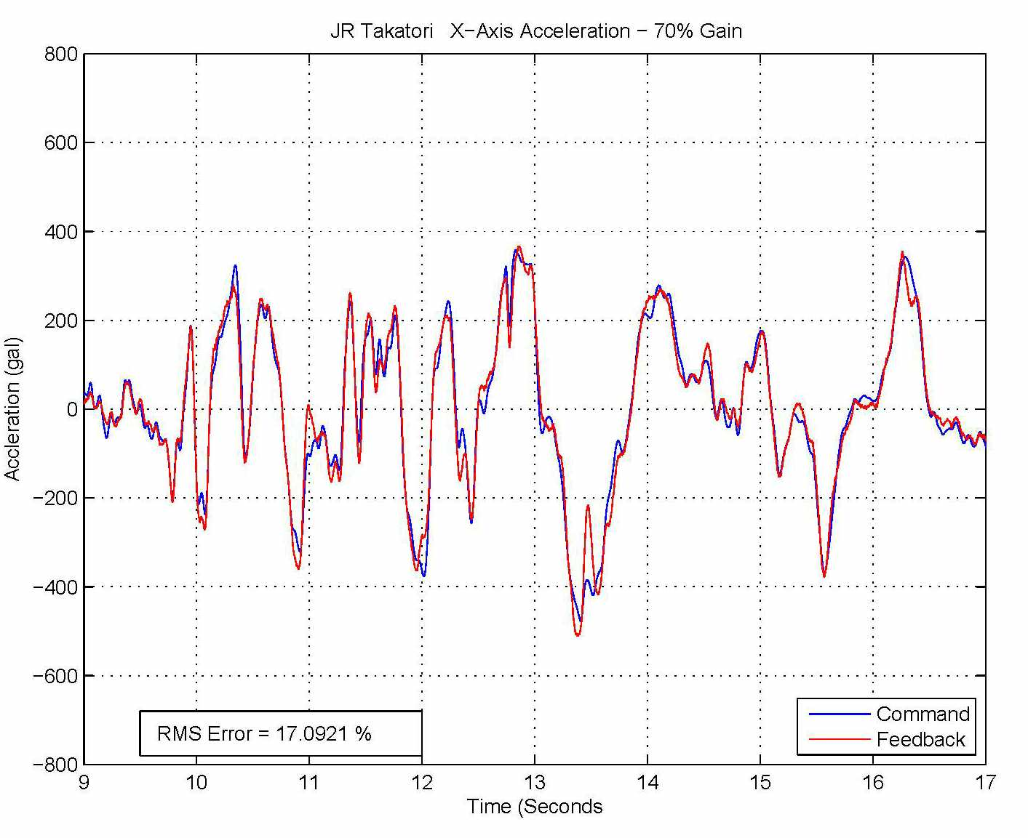
Figure 2: Ringing Oil Column Response due to Transient Input
Commentaries on Seismic System Engineering, Part II
January 21, 2017

In Figure 2, the large sharp acceleration change from +300 gal to -450 gal that occurs around 13 seconds in the JR Takatori earthquake response shows that the oil column rings at around 13.5 seconds from being excited by this large transient. This is the type of PSD/ASD error that can occur. The only way to stop it is to 1) aggressively dampen oil column and 2) use RPC iteration techniques to eliminate it. If either of these methods is not employed, then PSD/ASD error bands are quite difficult to achieve. It should be pointed out at this point that the 469D Shaking Table Digital Controller is quite bad at damping oil column. However, I, personally, have had good results in removal of oil column ringing using iteration techniques. RMS errors lower than 3% are possible with less than 5-6 iterations. This is, of course, all predicated upon the ability to repeatedly excite the specimen to remove the unwanted oil column response. There will be more information later about this problem when notch filters are discussed.

So, at the end, what can we say about PSD/ASD error bands? Unless we can use iteration techniques, MTS’ ability to succeed in this endeavor is not good. If we can use iteration, then 5-10% error bands are not impossible at all. I, personally, would not agree to < 10% error bands unless really, really pushed to do so and if the customer is willing to pay for such increased performance (which is unlikely).

