Commentaries on Seismic System Engineering, Part II
January 21, 2017

This section shall deal with some of the diverse topics that do not fall in line of the implementation of a shaking table installation. These topics will not necessarily connect to one another, but can be lumped with similar discussions in the future. And with that, we begin:

- Pre-sale acceptance criteria

This topic shall deal with the items provided as possible for discussion. Other items are also included as spin-offs of the original list.

- What frequency range should MTS say we can get good response (fidelity) for different table sizes?

Of course, it should be noted that the frequency range depends a great deal upon the servo-valves used, the amount of actuator friction, the quality of swivels, and the table resonant frequencies. What will be listed here shall be the inherent, general frequency range found for shaking tables of various sizes:

3x3 meter up to 100 Hz
4x4 meter up to 100 Hz
5x5 meter up to 50 Hz
6x6 meter up to 40 Hz
8x8 meter up to 30 Hz
10x12 meter up to 30 Hz

Any shaking table that runs above 50 Hz will require some special attention. As far as I know, only 5-6 MTS tables have ever been designed to run higher than 50 Hz. There might be some others back in the early years, but it is for sure that 100 Hz and above tables are difficult to achieve. MTS was the unquestioned leader of servo-hydraulic vibration back in the mid-70s. This is definitely no longer true. MTS no longer produces hardly any components capable of such high frequency operation. This means that MTS would, at this stage, have difficulty in producing any shaking table with capability beyond 50 Hz. The China EETI system had 100 Hz specifications, but I am not aware of the installation details at all; therefore, I cannot comment on this particular project. I have worked on 3 shaking tables that have performed > 50 Hz. One was the LRL 4-vertical actuator uniaxial system that went to 500 Hz (1970), another the 3m round 6 DOF EPDC underwater shaking table that went to 100 Hz (2000) and the 3rd one is the 3x3m biaxial C.E.R.L. project (1974) that went to 250 Hz.

Commentaries on Seismic System Engineering, Part II
January 21, 2017

It should also be noted that even the NIED 15m x 25m table can actually run to 30 Hz as well with a +/-2 DB magnitude accuracy. Time and Money can make some things happen.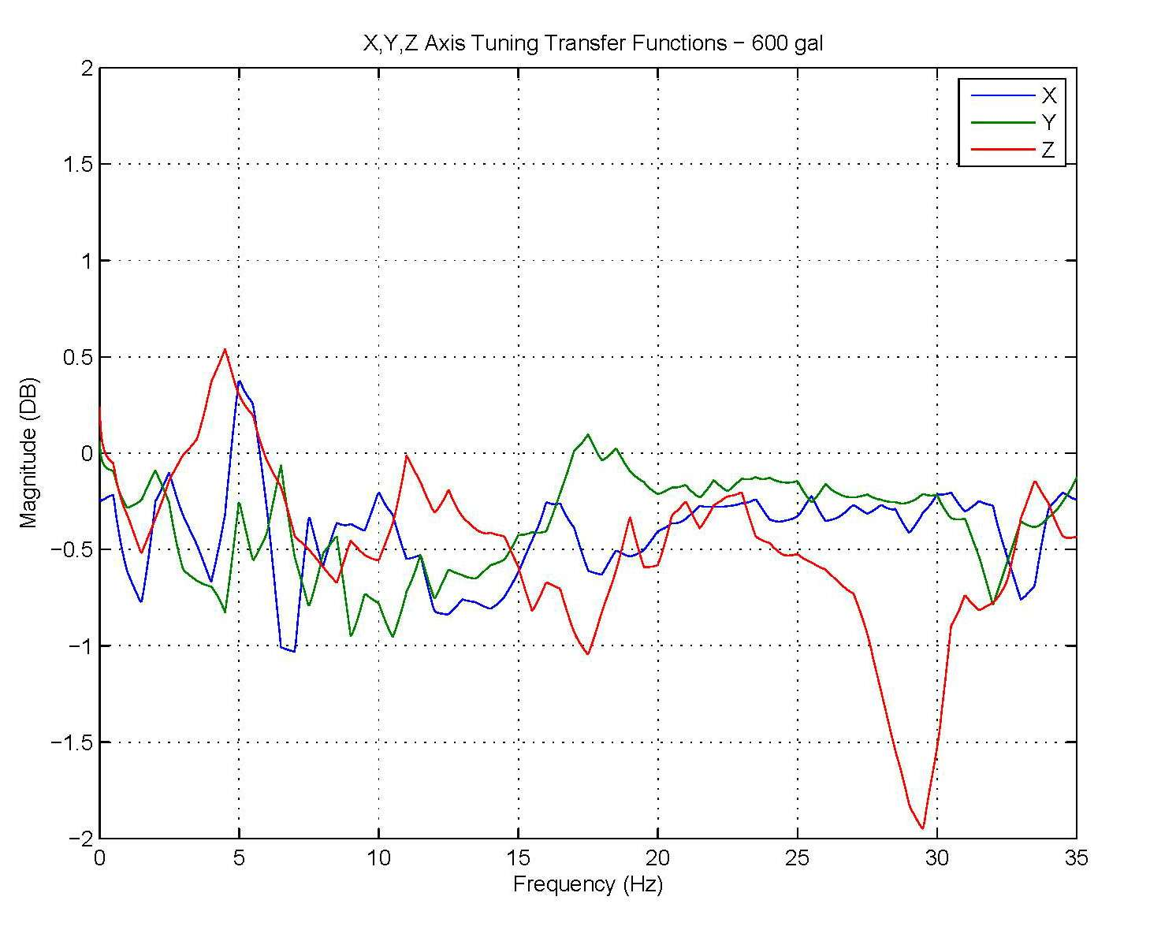
Figure 1: NIED Principal Axes Transfer Function at 150 gal RMS Random

The main limiting factors for high frequency operation are 1) actuator bowstring and 2) table and/or swivel resonant frequencies. It is very unwise to push the envelope of the bowstring natural frequency on the off-axis actuators. Excitation at bowstring frequencies can and will damage the actuators. There is no easy way to allow a system to drive off-axis actuators with the principal axis at full performance at the off-axis bowstring frequency. Actuator lateral motion dampers have been tried (M.O.C. PWRI – 1998) without great success. The MHI stationary actuators and swivel links system does reduce bowstring and would allow the NIED system to go to higher frequencies. Unfortunately, the low frequency table resonances preclude any real advantage from this design.

Commentaries on Seismic System Engineering, Part II
January 21, 2017

- What Total Harmonic Distortion levels can MTS quote competitively?

A 5% acceleration THD specification was responsible for shutting out all of the opposition to MTS shaking tables in Japan for over a decade. Yes, now there are customers asking for tighter specifications. There have been some improvements in the Automatic Harmonic Canceller in the last few years. The 469D AHC can now regularly obtain < 3% Acceleration THD if there are not any significant mechanical resonances in the system that fall on a harmonic of a typical test frequency. I would not recommend this specification for any tests other than bare table. Also, the 3% specification on displacement was always too loose and could be regularly tightened to 1-2%.

Most operators only remove the odd harmonics as they are the largest ones. However, I have found that by cancelling the even harmonics, the resulting THD can be quite a bit lower. I tend to remove all of the harmonics up to about the 8th harmonic and then the odd ones after that 8th harmonic. So, I normally remove the 2,3,4,5,6,7,8,9,11,13,15,17… harmonics. I also try to not analyze the data past the 10th harmonic.

For example, the PWRI 8x8m table upgrade in 2013, I was able to achieve < 1.2 % Acceleration THD on X, Y, and Z axes.

However, the Shimizu table had trouble making 3% Acceleration THD because of some mechanical resonances and friction. The single-ended V horizontal actuator arrangement degrades the THD numbers horizontally. M.O.C. had an orthogonal double-ended actuator arrangement which usually produces the best THD measurements.

This points out the simple fact that the more actuators, the merrier. If you want LOW distortion and good performance, use LOTS of actuators. The C.E.R.L. project had nine (9) verticals and six (6) longitudinal actuators. The response was very, very nice indeed. M.O.C. had 6 actuators on the horizontals, but only 4 on the vertical. But, the actuators all had hydrostatic bearings. Low friction helps THD a lot.

In the end, I would stick with 5 % Acceleration THD for a V actuator arrangement, but go to 3 % Acceleration THD if there is an orthogonal actuator arrangement.

The one item that prevents AHC from becoming a truly worthwhile addition to the 469D is the fact that the process is too slow for use with sine sweep. AHC does work with sine sweep but the sweep rate cannot be in any useful range for actual tests because the compensation is way too slow. Since this technology is quite old (20-30 years), it is likely that a revisit to the application could improve performance considerably. On the other hand, Automatic Amplitude and Phase Control is already quite good for sine sweep applications. Servo-hydraulics is not the best choice for sine sweep acceleration tests because of distortion. Making good sine sweeps would open new testing markets that already exist in both commercial and government testing requirements.

Commentaries on Seismic System Engineering, Part II
January 21, 2017

- Can we assess PSD/ASD response in answer to customer requests for equipment to meet certain PSD/ASD error bands?

This topic carries over from the last one in question B. Servo-hydraulics has difficulties with PSD/ASD spectrum matching because of oil column problems. The 3rd harmonic distortion produces too much oil column frequency response that may not be able to be suppressed because the harmonic is larger than the specified response at the oil column frequency. Even programming zero response at the oil column frequency does no good. The 3rd harmonic has resulted in test failure already. This is a well-known problem to anyone that has been around servo-hydraulic vibration applications. Unfortunately, very few (to none) at MTS are the slightest familiar with such problems. In the 1970s when MTS was heavily into the vibration market, MTS did evaluate the current PSD control systems available and found them to be inadequate to solve this problem. These “compressor” type systems that are still in use today for electro-dynamic shakers do not work to reduce harmonic distortion or oil column response to transient motions. However, it was found that RPC iteration techniques ARE applicable to such problems. The C.E.R.L. project used the 1st application of transfer function compensation and iteration to remove distortion to achieve zero-damped shock response spectra matching. In case the reader does not know, zero-damped shock response spectra are extremely sensitive to ANY distortion of an acceleration waveform. So….the ONLY way that a servo-hydraulic can adequately achieve any PSD/ASD error band is through RPC type iteration compensation. The extra oil column response is not due to just 3rd-harmonic response. A high-frequency excitation above oil column frequency will cause a ringing response in the oil column. For example, look at the acceleration time history shown in Figure 2 below:
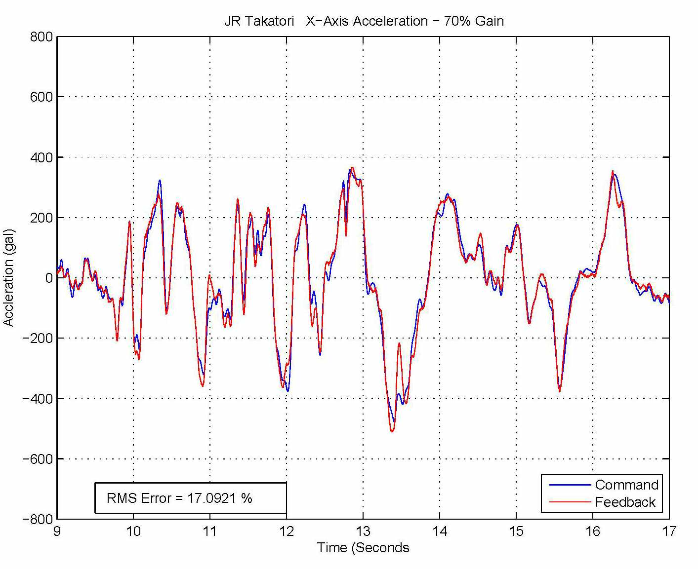
Figure 2: Ringing Oil Column Response due to Transient Input
Commentaries on Seismic System Engineering, Part II
January 21, 2017

In Figure 2, the large sharp acceleration change from +300 gal to -450 gal that occurs around 13 seconds in the JR Takatori earthquake response shows that the oil column rings at around 13.5 seconds from being excited by this large transient. This is the type of PSD/ASD error that can occur. The only way to stop it is to 1) aggressively dampen oil column and 2) use RPC iteration techniques to eliminate it. If either of these methods is not employed, then PSD/ASD error bands are quite difficult to achieve. It should be pointed out at this point that the 469D Shaking Table Digital Controller is quite bad at damping oil column. However, I, personally, have had good results in removal of oil column ringing using iteration techniques. RMS errors lower than 3% are possible with less than 5-6 iterations. This is, of course, all predicated upon the ability to repeatedly excite the specimen to remove the unwanted oil column response. There will be more information later about this problem when notch filters are discussed.

So, at the end, what can we say about PSD/ASD error bands? Unless we can use iteration techniques, MTS’ ability to succeed in this endeavor is not good. If we can use iteration, then 5-10% error bands are not impossible at all. I, personally, would not agree to < 10% error bands unless really, really pushed to do so and if the customer is willing to pay for such increased performance (which is unlikely).

